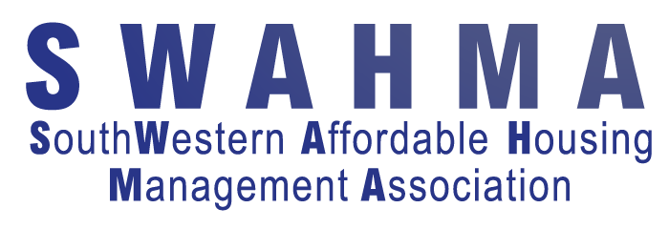

Little Rock Fall Conference
October 16th and 17th, 2018
DAY 1
Time Topic Presenter(s)
8:00am | Registration
9:00am | Welcome General Session
9:30am | Fort Worth HUB Department of Housing and Urban Development (HUD) | HUD: Christie Newhouse, Director  Jesse Villarreal, Branch Chief
 | Southwest Housing Compliance Corporation (SHCC) Panel – Open Discussion | SHCC: Michael Cummings, VP  Tammy Fotinos, Director  Ann Hittner, Director  Chris Petty, Manager
11:00am | HUD Office of the Inspector General (OIG) - Fraud Detection and Prevention: The Role of HUD-OIG | OIG: SA Jared Tauzier  ASAC Wyatt Achord
12:00pm | LUNCH
1:30pm | Workshop A: Panel Discussion – Title TBD  Hosted by Christian Church Homes (CCH) and moderated by Roy Cozart. A panel of industry experts, including Linda Hardway formerly of HUD. | Christian Church Homes: Don Stump
 | Workshop B: The Challenge of Managing Layered Properties  LIHTC/HOME/Section 8/RAD | Gwen Volk
 | Workshop C: Snake Charming – Psych Tools for dealing with difficult people  http://www.susanguzzetta.com/megan-johntz/ | Megan Johntz, Psychotherapist & Professional Speaker
3:30pm | Workshop A: PBCA Potpourri  A presentation by SHCC staff, with topics including Rent Comparability Studies, TRACS 203A, and more. | SHCC: Tammy Fotinos, Director  Ann Hittner, Director  John Chambers, Manager
 | Workshop B: Waiting List Management | Gwen Volk
 | Workshop C: Solving Revolving Doors – Psych tools for hiring and firing  http://www.susanguzzetta.com/megan-johntz/ | Megan Johntz, Psychotherapist & Professional Speaker
5:30pm–7:00pm Tradeshow, Cocktail Reception, and Networking
DAY 2
Time Topic Presenter(s)
9:00am | General Session, BEST SELF versus REAL SELF  Dozens of TV stations, American, European, and Canadian (CBC, CTV, BNN, Global) and US TV networks (ABC, CBS, CNN) have improved the human element of their programming by applying Nick’s recommendations. Having previously been the coach for ABC’s Good Morning America and a nighttime magazine program for the same network, Nick has had personalities in his coaching sessions ranging from the country’s best known political broadcasters to Jim Kelly (former quarterback for the Buffalo Bills). https://presentwithintent.com/about-us/ | Intentional Communication, Inc.:  Nick Dalley, President
12:00pm | LUNCH
1:30pm | Workshop A: Special Claims – Get up and get started! | Karon Arnold  SHCC: Lisa Muraida
 | Workshop B: MOR Need to Knows | SHCC:  Nick Vranes/Chris Petty, Managers
 | Workshop C: Fair Housing Essentials: What you don't know can hurt you! | Gwen Volk
Session Ends at 3:30pm

