December  2022 | 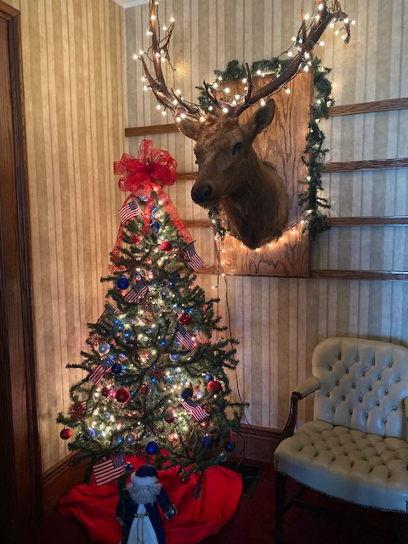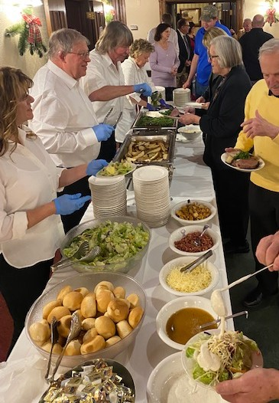
Sunday | Monday | Tuesday | Wednesday | Thursday | Friday | Saturday
 |  |  |  | 1 | 2 | 3
 |  |  |  | Toys for Tots Donations DUE TODAY  Pleasant View SLIDERS | Private Party – Lodge Room 4:00 PM  Smoked Turkey Tetrazzini Pasta Dinners | Private Party – Lodge Room 5:00 PM  OPEN 11:30 AM – 10:00 PM  Homemade Soup Saturday
4 | 5 | 6 | 7 | 8 | 9 | 10
Elks Memorial Day Services 12:30 |  | 7:00 Lodge Meeting  6:15 BOD Meeting  TACO Tuesday | Wild Wing Wednesday | Pleasant View SLIDERS | FISH FRY FRIDAY | Private Party – Lodge Room 3:00 PM  OPEN 11:30 AM – 10:00 PM  Homemade Soup Saturday
11 | 12 | 13 | 14 | 15 | 16 | 17
 | Private Party:  Entire Main Floor 5:00 PM | TACO Tuesday | Wild Wing Wednesday | Pleasant View SLIDERS | Guest Chef Night:  PRIME RIB DINNERS  Charlie & Lucas Bryant | OPEN 11:30 AM – 10:00 PM  Homemade Soup Saturday
18 | 19 | 20 | 21 | 22 | 23 | 24
 |  | TACO Tuesday | Wild Wing Wednesday | Pleasant View SLIDERS | Homemade Soup | Christmas Eve: CLOSED
25 | 26 | 27 | 28 | 29 | 30 | 31
CHRISTMAS DAY |  | TACO Tuesday | Wild Wing Wednesday | Pleasant View SLIDERS | Shredded Pulled Pork on Rolls w/Homestyle Baked Beans & Vintage Cole Slaw | 11:30 am – 1am: OPEN TO PUBLIC NEW YEARS EVE!  CITYWIDE NY Eve Party:  1-5 PM- Parking Lot  1-4 PM - Indoors  5-8 PM Homemade Spaghetti Sauce w/Meatballs Dinners  8-10 PM: “Special” Appetizers  8PM-Midnight LIVE BAND

