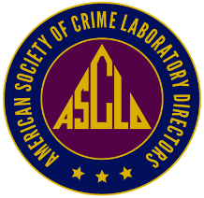

**AMERICAN SOCIETY OF CRIME LABORATORY DIRECTORS**

**ASCLD MEMBER OF THE YEAR**

NOMINATION FORM

NOMINATOR: The ASCLD Board desires to recognize the valued input and involvement of its members in the ongoing initiatives and activates of our Society. From the nominations received, one member will be recognized at the Annual Symposium Awards Banquet.

A more extensive endorsement of the nominee may be made by appending a letter of recommendation to this page, however, this form is sufficient for the purpose of the ASCLD Nominating and Awards committee. Please include your contact information, however this will not be shared with the nominee.

***************************************

Name of the Nominee: Click here to enter text.

Nominee’s Job Title/Position: Click here to enter text.

How long have you known them? Click here to enter text.

How do you know this individual?

How long have they been an ASCLD member? Click here to enter text.

In the past year, how do you feel that this individual has directly impacted ASCLD? (Include information regarding committed involvement, if known, and why you feel this individual is deserving of this recognition).

Click here to enter text.

Any other information you feel should be shared with this committee?

Name: Click here to enter text. Signature: ____________________________________

Phone: Click here to enter text. Email: Click here to enter text.