2022 ASCLD Board of Directors Candidate
Headshot as JP 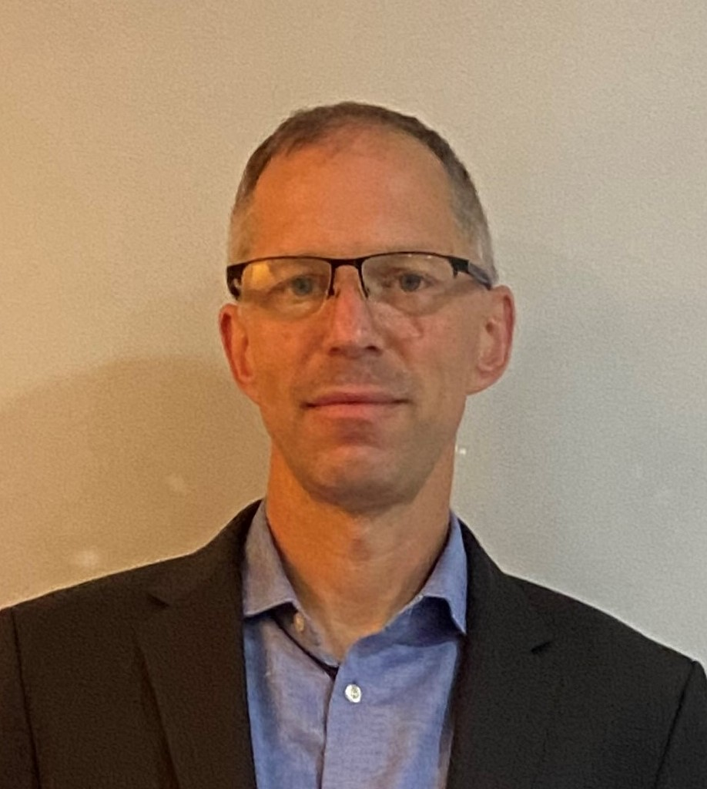EG or PNG file that is a minimum of 1MB
Candidate’s Name: Mike Cariola
Organization: Bode Technology
Address: 10430 Furnace Road, Suite 107
Phone Number: 703-646-9876
E-mail: mike.cariola@bodetech.com
Education:
BA Cornell University
MFS George Washington University
Employment experience:
2000 – 2022. Bode Technology
2012-2022. Chief Operating Officer, General Manager, President & CEO
2005-2012. Laboratory Director
2003-2007. Technical Leader, Forensic Casework
2000-2005. Manager, Casework
1997-2000. The Armed Forces DNA Identification Laboratory
1999-2000. DNA Analyst
1997-1999. Technician/Technologist

Prior ASCLD experience (previous Board member, committee member, meeting volunteer, etc.)
2020-2022. Committee Member - Member Resource Committee (MRC)
If elected, I am interested in working on the following ASCLD issues/committees:
Member Resource Committee (MRC). ASCLD includes organizations of all sizes and directors across the country and the world face many of the same issues – backlogs; employee wellness; implementing new standards and technology, to name a few. The MRC strives to leverage the collective experience of the community to assist all of its members, particularly new laboratory directors. Over the past 2 years, as a member of MRC, I have been involved with providing guidance on remote work, electronic case files and rapid DNA. As a member of the Board, I would like to increase my involvement to ensure that ASCLD is providing as many tools to its membership as possible.

Training and Education Committee. The most common thing I hear at every ASCLD meeting is the unique managerial training that only ASCLD can provide. Managers are starved for leadership training and every year ASCLD rises to the challenge by providing new content – often on timeless themes – and attendees become better leaders as a result.

Diversity and Inclusion. It is critical that ASCLD and leadership is reflective of the diversity of employees within the organization. This includes all types of diversity – ethnic, gender, experiential and background. As a Board member, I will support efforts to ensure ASCLD is more engaging; examines and promotes diversity and inclusion; and strives to be a more inclusive organization.

As a member of the Board, you may be asked to represent ASCLD at speaking engagements or develop written statements on behalf of the Board. How would you describe your ability to communicate ideas verbally and in writing?
As an executive for the past 10 years, I have presented numerous times to virtually every level – policy makers, laboratory directors, advocacy groups, media and Board members. This includes both verbal presentation and written statements.

How committed are you to serving on the ASCLD Board? What skills will you bring to the table?
I believe strongly in ASCLD as a community of equals and that the Board is critical in guiding the forensic community. The field of forensic science is ever-evolving and I believe my skills as a laboratory director and executive will help ASCLD successfully navigate through whatever challenges it may face in the future.
What role should ASCLD play in developing a strong future for forensic science laboratories?
ASCLD is THE primary organization representing forensic science laboratories. If ASCLD doesn’t provide the leadership, it’s future will be dictated to it. Successful companies and organizations must recognize that decisions by individuals determine its future and ultimately the ASCLD Board will have an outsize role in the forensic science laboratory of the future.

