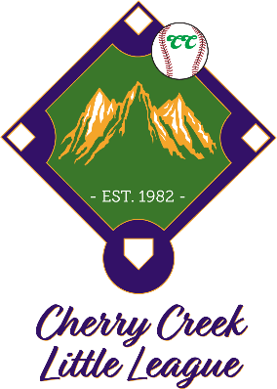

The Challenger division is an adaptive baseball program for players with special needs ages 7 - 15 years old.
This is NOT a competitive program and is designed to allow special needs players the opportunity to play the game of baseball.
The game is a combination of Coach-Pitch and Tee-Ball allowing every player on each team to bat and round the bases either with or without assistance of a "Buddy". The adaptive program also allows fielders to make defensive plays with or without the assistance of a "Buddy". We do not encourage outs to be recorded or score to be kept.
Parents and family are highly encouraged to participate as "Buddy's" in this program. The League will encourage player volunteers from our older divisions to assist as “Buddy’s” and seek other community programs to assist players that need help to participate.

Register online
WWW.CHERRYCREEKLL.COM

