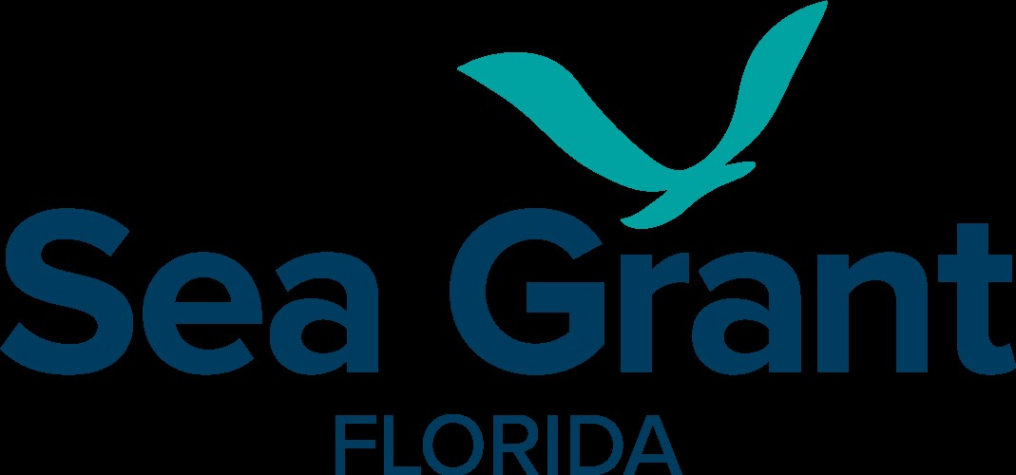
My Suggestions for Restoring American Seafood Competitiveness
NOAA Fisheries recently had an open comment period on Regulatory Reform, Seafood Industry Challenges, and Innovative Approaches in Response to the Executive Order Restoring American Seafood Competitiveness. The comment period was related to the Executive Order, "Restoring American Seafood Competitiveness," and sought suggestions to enhance the economic viability and competitiveness of American seafood. I provided input on several measures that I believe would benefit southeastern fishermen and U.S. fishermen more broadly. Below are the suggestions I shared. This list was not exhaustive; there are more changes that could improve American seafood competitiveness. I focused on several changes that I believe would be extremely beneficial to SFA members and the U.S. industry. If you’ve read my other Hotlines articles, you will recognize these suggestions.
My first two suggestions were both focused on improving resources available to fishermen following natural disasters. My first suggestion was to improve an existing program – adjusting the geographic scope of analysis for the federal Fishery Resource Disaster Assistance program to the county level. As SFA members are aware, not all hurricanes qualify for fishery disaster assistance, despite leading to significant losses in impacted areas. A major problem with the program is that disasters are measured at the ‘fishery level’ and hurricane impacts are often felt at the county level. Evaluating fishery disasters at the county level would lead to more fishery disasters qualifying for assistance and qualifying more quickly.
My second suggestion was to expand USDA agricultural insurance programs to commercial fishermen. As food providers, U.S. fishermen provide the same valuable service as farmers and would benefit from the programs available to farmers. Generally, rapid disaster recovery funds available to fishermen are limited to loan programs. There are currently USDA insurance options for farmers and aquaculture producers that pay producers if NOAA determines a hurricane or tropical storm hits the producer's county or an adjacent one. This insurance coverage, known as HIP-WI (Hurricane Insurance Protection – Wind Index), could be offered to fishermen with only minor changes to the program. I recently wrote a report for Florida clam growers who are currently eligible for the program on the costs and benefits of the program and how it would have paid off over the last 10 years (see report). The key takeaway was that for our hypothetical clam farmer, an annual premium of between $4,400 - $5,600, depending on the county, would pay out $72,000 if a hurricane struck and $36,000 if a tropical storm struck. I believe this program would enable fishermen to recover more quickly from hurricanes and tropical storms.
There are also several marketing programs, current and potential, that could be used to increase demand for U.S. seafood. The first is the USDA Agricultural Marketing Service (AMS) purchasing program, which purchases U.S.-produced and processed foods and distributes the food to American schools, food banks, and underserved households. While some seafood is purchased through the program, the amount is small, and the variety offered is very limited. Per a U.S. GAO report on the USDA’s National School Lunch Program (NSLP), seafood purchases only accounted for about 1.5% of total animal protein purchased by the program from 2014 to 2019. Increasing the percentage of seafood protein purchased by the NSLP to 15% would result in the USDA AMS purchasing approximately 55.7 million more pounds of U.S.-produced seafood per year. In addition to increasing the amount purchased, the program needs to increase the number of seafood products eligible for the program.
The last suggestion was to increase seafood marketing with the goal of encouraging more Americans to meet the dietary guidelines for seafood consumption. In 2022, American per capita seafood consumption was only 42% to 75% of the minimum recommended amount (depending on the type of diet followed). Increased marketing and educational campaigns highlighting the health benefits of consuming domestic seafood could lead to higher consumption and, consequently, increased demand for U.S. seafood. This would lead to improved nutrition and health for Americans, as well as enhanced economic viability of US seafood production.
While there is still much that can be done to restore American seafood competitiveness, I believe these changes would be a good start and could be implemented easily. If you have any questions or would like to learn more, please do not hesitate to reach out (aropicki@ufl.edu). Happy Holidays!

