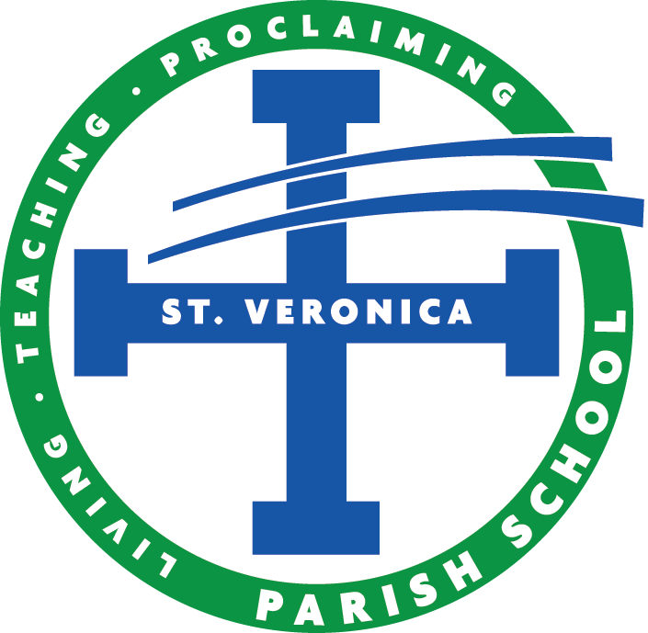

SAVE THE DATE!

Mark your calendars for these fun-filled events and volunteer opportunities sponsored by your PTO!

Walk-A-Thon – October 7th, 2022
Dad/Lad Event – November 5th, 2022
Mother/Daughter Event – November 12th, 2022
Secret Santa Workshop – December 2nd and 4th, 2022
Euchre Night – March 4th, 2023
Family Event – April 1st, 2023
Volunteer Appreciation Dinner – April 25th, 2023
Father/Daughter Dance – April 29th, 2023
Mother/Son Event – May 13th, 2022

