CA ACS CAN report for the period through November 4, 2021

Mission
- We have been meeting with state legislative offices and partners to explore introduction of biomarkers legislation for next year.
- The Baldwin Park (pop. 72,200) City Council adopted on second reading an ordinance to end the sale of all flavored tobacco, including menthol, cigars, flavored shisha, and flavored cannabis as well. We provided technical assistance to staff, actively lobbied council members and provided oral and written testimony in support over the past several months.
- The Novato (pop. 56,000) City Council enacted a revision to its tobacco retail ordinance to remove its exemptions of menthol cigarettes. This was the 12th instance that we have been able, through continued advocacy, to get a local jurisdiction to strengthen a previously passed flavored to bacco ordinance by removing exemptions for menthol or adult only stores or making it apply citywide.
- In another ongoing effort to strengthen a local flavored tobacco ordinance, our advocacy efforts helped push the San Leandro (pop 90,000) Rules Committee to move an amendment to the full city council to remove the exemption for menthol cigarettes that we (especially Denis Ducey and Bea Cardenas-Duncan) have been trying to eliminate for four years.
- After more than two years of ACS CAN work behind the scenes, the Pasadena (pop. 144,800) City Council finally heard an introduction and passed a first reading of a comprehensive ordinance to end the sale of all flavored tobacco. Past Chair of the ACS National and California Division Boards, Jeff Kean, testified in support of the measure as part of our advocacy. If the council passes ordinance in its current form, it will be the largest city in southern California to pass a flavored tobacco ordinance with no exemptions since passage of the state law in 2019.
- The Walnut Creek (Pop 71,000) City Council passed a first reading of flavored tobacco ordinance that unfortunately exempts hookah lounges even though the city currently has none. We did not find out about this until a couple of days before the hearing and will work to see if the exemption can be removed upon second reading.
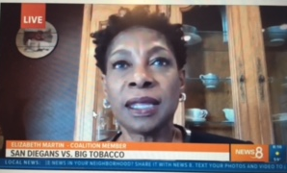
- We spoke at a coalition news conference launching to effort to pass an ordinance to end the sale of all flavored tobacco in San Diego which generated significant media coverage of the event and follow up reports. ACS CAN volunteer Elizabeth Martin and Government Relations Director Lynda Barbour were quoted ed in numerous TV and newspaper accounts. Chula Vista Today, CA: San Diego and Chula Vista are Cornered to Put an End to the Sale of Flavored Tobacco Products Media Director Priscilla Cabral-Perez was featured in several Spanish language TV reports. KSDY (Spanish), CA 7 1 other: Campaign to End the Sale of Flavored Tobacco.
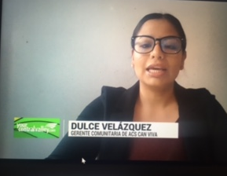
- We also participated in a news conference in Sacramento to launch a campaign to pass a flavored tobacco ordinance in the County of Sacramento. The City of Sacramento passed a strong ordinance in 2019.
- VIVA Community Engagement Manager Dulce Velazquez was featured in a news report on flavored tobacco on a Fresno Spanish Language TV station (from 4:00-5:20 in this clip): KSEE24 News, CA: Flavored Tobacco Products Lure Youth (Spanish)

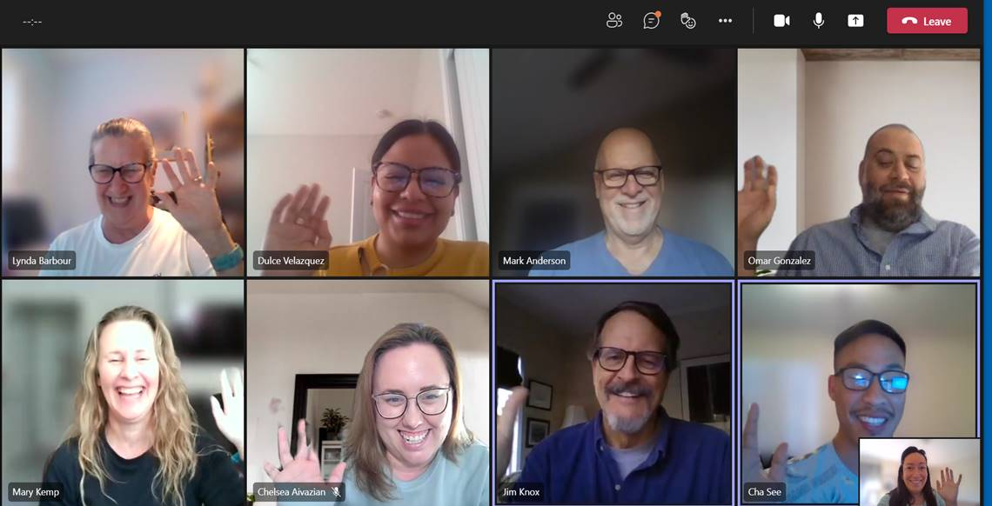
- We bid farewell To Dr. Cha See (bottom right) who has been the Program Manager for our VIVA Central Valley Rural Tobacco grant since its inception more than two years ago. Cha made a significant contribution to our work on tobacco control and health equity and will be greatly missed. We wish him the best in his new role starting up a new health equity office within the Merced County Department of Public Health.

Revenue
- We secured a $10,000 sponsorship from UC San Diego Moores Cancer Center for our November 18 policy event. This is a substantial increase in support from UCSD and a direct result of the work of the California Leadership Council. Total financial commitments to the event now exceed $75,000 on a goal of $50,000. The event will feature guest speaker Rep. Raul Ruiz (CA-36) and panelists from Cedars Sinai Cancer, USC Norris Cancer Center, UC San Diego, Gilead, Lazarex Cancer Foundation and UC Davis Health. “Cancer Research Through the Health Equity Lens” will take place on November 18 at 5:00 pm. You can register at: https://www.fightcancer.org/events/cancer-research-through-health-equity-lens.

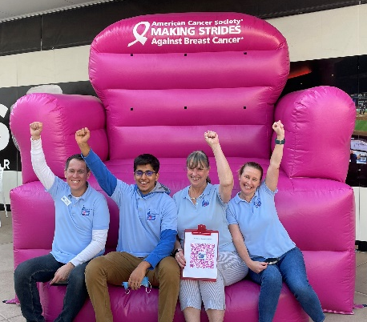
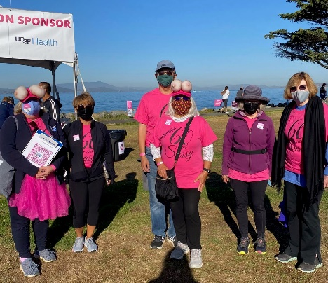
Volunteer engagement
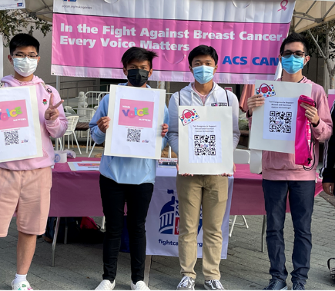
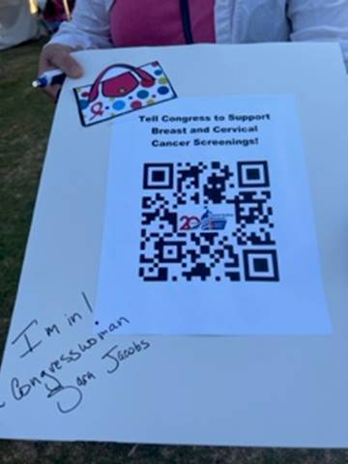
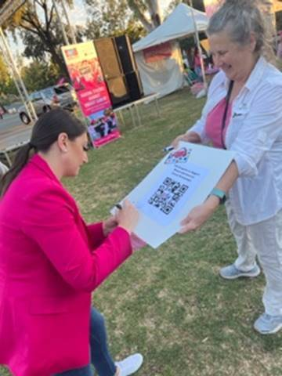
- Volunteers and staff actively promoted ACS CAN’s breast cancer advocacy work at Making Strides Against Breast Cancer events in Sacramento, San Jose, Los Angeles, Santa Monica, Orange County and San Diego. More than 600 signatures were collected in support of increased funding for the federal National Breast and Cervical Cancer Early Detection and Treatment Program. One of the signers (shown here) was San Diego Congresswoman Sara Jacobs (CA-53). Most of the signatures were gathered through QR codes, which allowed volunteers to share on social media on the spot. The collective efforts generated 10 new members, more than $300 and significant media attention.
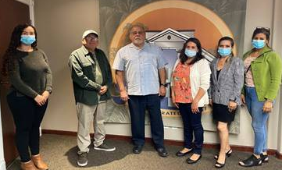
- VIVE Community Engagement Manager Brittny Bol coordinated a meeting with Colton (pop. 55,200) Mayor Navarro and Councilmember Suchill for three volunteers to discuss the project’s data on smoke-free multi-unit housing. Since the volunteers speak only Spanish, the meeting was conducted entirely in Spanish. It was agreed that a presentation to the full council will take place on November 16.
- A VIVE Trick or Treat Halloween post reached more than 21,000 people.
