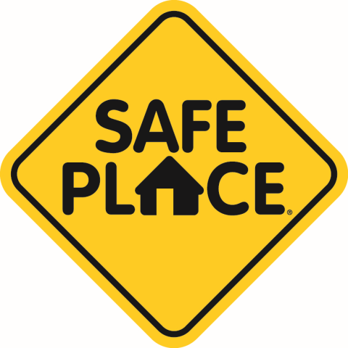

What is Safe Place?
Safe Place is a national youth outreach and prevention program for young people in need of immediate help and safety. As a community-based program, Safe Place designates businesses and organizations as Safe Place sites, making help readily available to youth in communities across the country. Locations may include: libraries, YMCA’s, fire stations, public transit, various businesses, and social service facilities.

National Safe Place Network Mission
Ensuring an effective system of response for youth in crisis through public and private partnerships at a local, state, and national level.

National Safe Place Network Vision
National Safe Place Network envisions a world where all youth are safe.

How it works:
When youth see the Safe Place sign on a building they know this is somewhere they can ask for help. When in need, they should enter the building and ask for help. They will be connected with a professional who can walk them through the crisis situation with the goal of having youth return home and getting families connected with supports and resources in the community.

How to get HELP:
- Call the Safe Place agency on-call at (765) 269-6454
- Walk in to a Safe Place site
- Call the National Runaway Safeline at 1-800-RUNAWAY or (800)786-2929
- TXT 4 HELP is a nationwide service offered by Safe Place to help teens connect to the closest location where they can get immediate help and safety. Text the word SAFE, along with your current location (address/city/state), to the number 69866.

