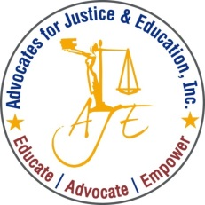

**PARENT-TO-PARENT LEADERSHIP INSTITUTE**

**Presented by:**

**Advocates for Justice and Education, Inc.**



**To Register:**

Contact Maria Blaeuer at [(202) 678-8060](tel:%28202%29%20678-8060),ext. 213 or [maria.blaeuer@aje-dc.org](mailto:maria.blaeuer@aje-dc.org)

Registration is required. Food will be provided.

**Location:** Advocates for Justice and Education, Inc.

25 E Street, NW, Washington, DC 20001

(Metro Accessible: Union Station-Redline)

**June 1, 2018 (12:00pm-5:00pm)**

* Overview of Laws Protecting the Rights of Students with Disabilities
* School Discipline: What Parents Need to Know
* Parent Engagement: Why Schools Value It and Needs it

**June 2, 2018 (9:00am-2:30pm)**

* Tools for Effective Parent Advocacy
* Special Issues Facing Girls/Young Women of Color in School
* Parents: How To Prepare for Life After School for Your Child with a Disability
* Transitioning from Pediatric to Adult Healthcare

**Presenters:** Advocates for Justice and Education, Charter Board Partners, National Women’s Law Center and National Health Care Alliance Parent Advisory Group

Join AJE for a two-day leadership training for parents and caregivers of children and youth with special needs and special health care needs. The goal of this interactive training is to empower parents to become effective advocates and informed decision-makers, and to be equipped to provide peer support to other families.