FOX RIVER ACADEMY OF MUSIC & ART
FALL ART WORKSHOPS 2016
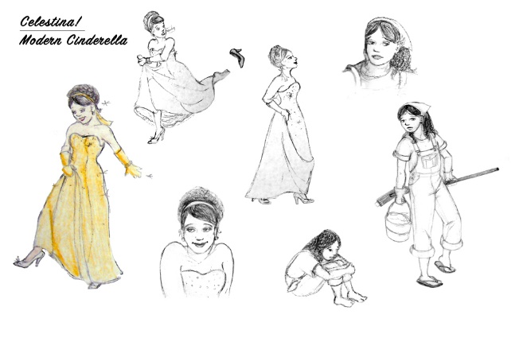
CHARACTER DESIGN
September 3rd, 2:00-4:00pm
Instructor: Jennifer Keller
Age Level: ELEMENTARY - HIGH SCHOOL
All great stories begin with great characters! Learn the technique of interpreting a character with your own vision from the inside out. Students will start with a basic concept and using character analysis combined with design elements they will create a complex visual character.
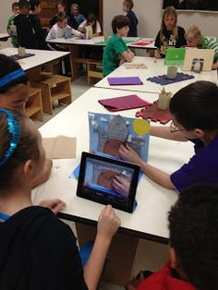
$28
INTRO TO CLAYMATION
September 17th, 10:00-12:00pm
Instructor: Tricia Frost
Age Level: ELEMENTARY & JR HIGH
Have you always loved watching Claymation movies like Nightmare Before Christmas, Wallace & Gromit, or Coraline? Then go behind the scenes and learn how to create your own beginner’s Claymation movie! Students will bring their own tablet device and will plan, design, and film a short movie.
$28
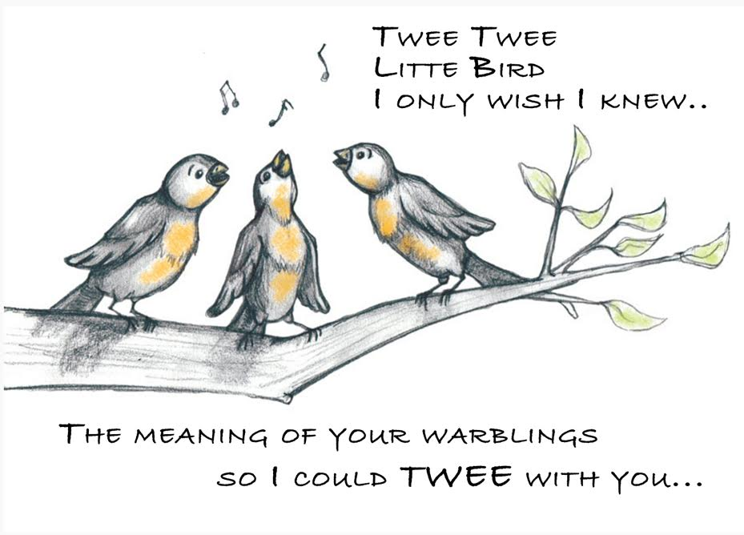
CHILDREN’S BOOK ILLUSTRATION 101
September 17th, 2:00-4:00pm
Instructor: Jennifer Keller
Age Level: ELEMENTARY - HIGH SCHOOL
Learn about the art and process of children’s book illustration. Students will interpret text of a classic nursery rhyme and/or children’s poem to fulfill a design space within the perimeters professional illustrators have while creating work for publication. Process will include starting with concept/thumbnail drawings leading up to a full color spot illustration with dry media.
$28
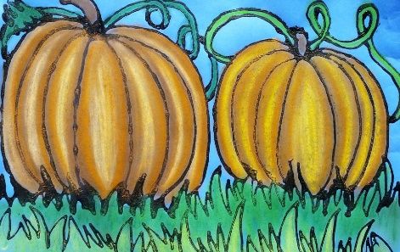
FALL PASTEL PUMPKIN PATCH
September 24th, 10:00-12:00pm
Instructor: Heidi Miller
Age Level: ELEMENTARY
In this pastel workshop, artists will create a vibrant pumpkin patch. Students will learn how to blend, layer, and add shading and tone with using chalk and oil pastels.
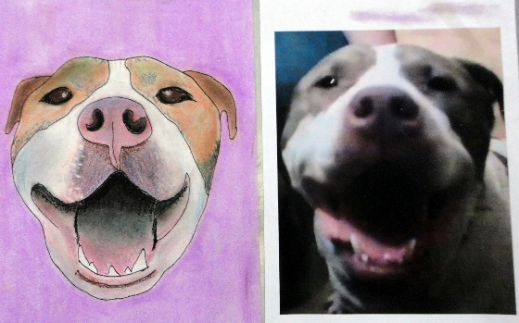
$28
PET PORTRAITS WITH PASTELS
September 24th, 1:00-3:00pm
Instructor: Heidi Miller
Age Level: ELEMENTARY through ADULT
In this workshop, students will create a keepsake portrait of their pet. Bring in a photo of your beloved pet to create with pastel medium.
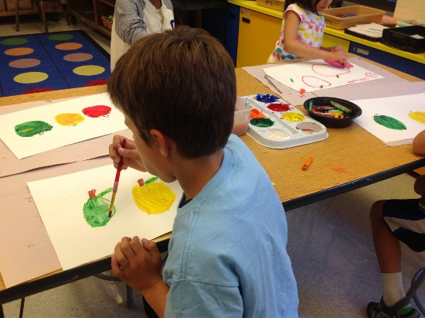
$28
AUTUMN STILL LIFE WITH ACRYLICS
October 1st, 10:00-12:00pm
Instructor: Lauren Tokar
Age Level: ELEMENTARY & JR HIGH
$28
MONSTER CREATURE DESIGN
October 1st, 2:00-4:00pm
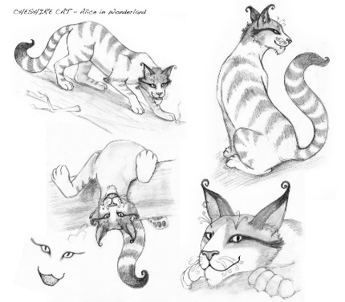
Instructor: Jennifer Keller
Age Level: ELEMENTARY - HIGH SCHOOL
It's that scary time of year...! Taking the rules of Character Design* a step further learn to create fantastical and magical creatures that could exist… somewhere! Learn how to combine animal/human anatomy into amazing creatures using practical techniques and your imagination. *Character Design is not required for this class but a helpful foundation if the classes are taken together
$28

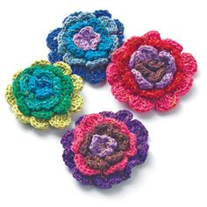
KNITTED FLOWER BROOCHES
October 8th, 10:00-12:00pm
Instructor: Chrissy Schoeberlein
Age Level: ELEMENTARY & JR HIGH
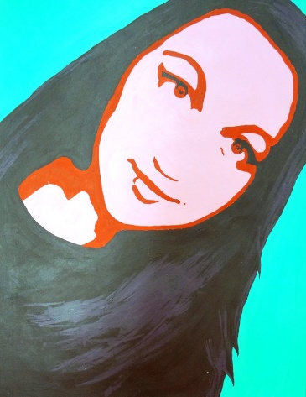
$28
SELF-PORTRAIT “SELFIES” PAINTING
October 8th, 1:00-3:00pm
Instructor: Chrissy Schoeberlein
Age Level: ELEMENTARY & JR HIGH
$28
CLAY MONSTER VASES
October 15th, 10:00-12:00pm
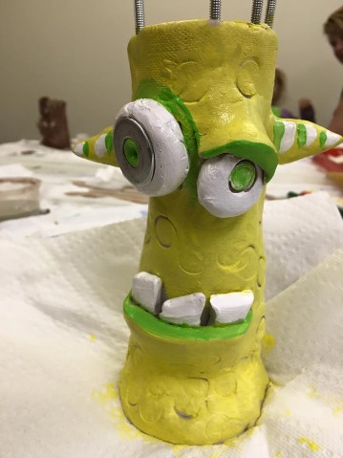
Instructor: Tricia Frost
Age Level: All Ages
Monsters do not have to be scary, at least not the ones in this class! We will be creating whimsy, goofy, one of a kind monsters. Using air dry clay and various clay techniques, we will be creating a vase featuring a monster’s face inspired by the artist James DeRosso. Recycled hardware like knobs, bolts, screws, keys, and handles will be added for extra fun. Clay will be brought home that day!
$28
HALLOWEEN GREETING CARD ILLUSTRATION
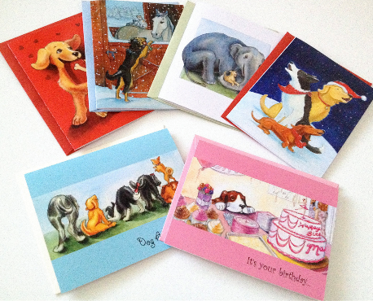
October 15th, 2:00-4:00pm
Instructor: Jennifer Keller
Age Level: ALL AGES
Design and create your own special greeting card with pictures and graphics relevant to a particular celebration or topic. Using different emotional qualities (humor, joy, love, etc.) you can illustrate using different techniques of dry media to convey your special message. Start with a concept and develop into thumbnails for a final piece.
$28
SPOOKY HOUSES WITH WATERCOLORS
October 22nd, 10:00-12:00pm
Instructor: Heidi Miller
Age Level: ELEMENTARY
Students will get into the Halloween spirit by designing a spooky old house. Student will also be trying fun painting techniques to make the eerie sky.
$28
PET PORTRAITS WITH PASTELS
October 22nd, 1:00-3:00pm
Instructor: Heidi Miller
Age Level: ELEMENTARY through ADULT
In our various “Pastel Workshops”, artists will learn how to blend, layer, and add shading and tone with using chalk and oil pastels. In this workshop, students will create a keepsake portrait of their pet. Bring in a photo of your beloved pet to create with pastel medium.
$28
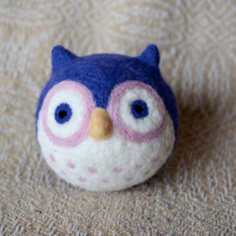
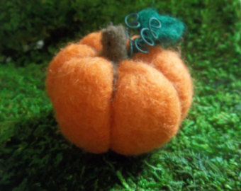
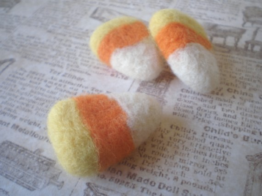
HALLOWEEN NEEDLE FELTING- OWL, PUMPKIN, OR CANDY CORN
October 29th, 10:00-12:00pm
Instructor: Lauren Tokar
Age Level: LATE ELEMENTARY & JR HIGH
$28
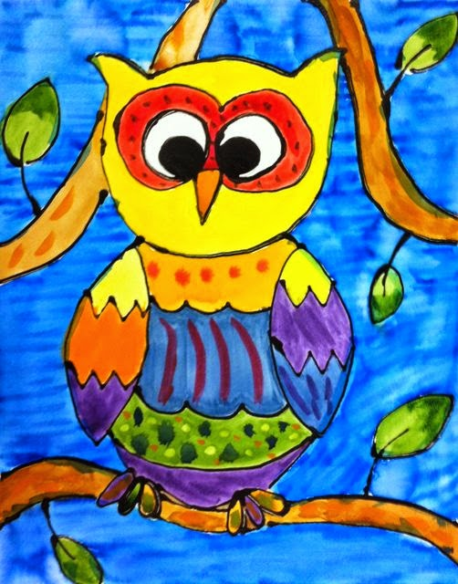
WATERCOLOR OWLS
November 5th, 10:00-12:00pm
Instructor: Tricia Frost
Age Level: ELEMENTARY
Students will learn how to draw a whimsy owl with lots of personality. They will also experiment with watercolor techniques to paint their owl in colorful ways!
$28

FAIRYTALE CHARACTER DESIGN
November 5th, 2:00-4:00pm
Instructor: Jennifer Keller
Age Level: UPPER ELEMENTARY - HIGH SCHOOL
All great fairytales can be reinvented…Learn the technique of interpreting a classic fairytale character with your own vision from the inside out. Students will start with a basic concept and using character analysis combined with design elements they will create a complex visual character. (Twist on Character Design workshop. Repeat students welcome!)
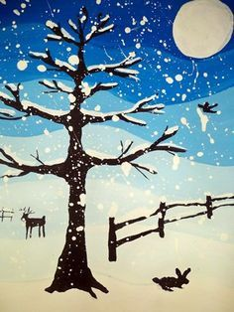
*Character Design is not required for this class but a helpful foundation if the classes are taken together
$28
WINTER LANDSCAPE PAINTING WITH ACRYLICS
November 12th, 10:00-12:00pm
Instructor: Lauren Tokar
Age Level: LATE ELEMENTARY & JR HIGH
$28
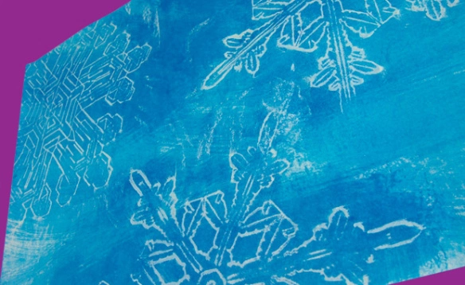
WATERCOLOR SNOWFLAKE RESIST PAINTING
November 12th, 1:00-3:00pm
Instructor: Lauren Tokar
Age Level: LATE ELEMENTARY & JR HIGH
$28
CHILDREN’S HOLIDAY BOOK ILLUSTRATION 101
November 19th, 2:00-4:00pm
Instructor: Jennifer Keller
Age Level: ELEMENTARY - HIGH SCHOOL
Learn about the art and process of children’s book illustration. Students will interpret text of a classic nursery rhyme and/or children’s poem to fulfill a design space within the perimeters professional illustrators have while creating work for publication. Process will include starting with concept/thumbnail drawings leading up to a full color spot illustration with dry media.
$28

