From: FEMA Private Sector <fema@service.govdelivery.com>
Sent: Friday, March 27, 2020 4:41 PM
Subject: FEMA Stakeholder Advisory: FEMA Offers Ways for Private Sector to Help Fight COVID-19

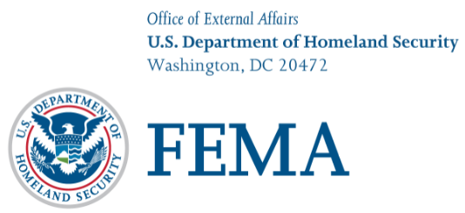

March 27, 2020
Contact: Congressional and Intergovernmental Affairs Division

Advisory

FEMA Offers Ways for Private Sector to Help Fight COVID-19

Under the White House Coronavirus Task Force’s direction, FEMA, HHS and our federal partners continue to work closely with state, local, tribal and territorial governments in executing a whole-of-government response to fight the COVID-19 pandemic and protect the public. The outpouring of support from the private sector to provide medical supplies and equipment has been tremendous. To help us match the many offers of assistance to the right place, at the right time, and in the right quantity, we ask for your help in ensuring partners know how to connect.

To sell medical supplies or equipment to the federal government, please submit a price quote under the COVID-19 PPE and Medical Supplies Request for Quotation. Full details can be found in the solicitation (Updated Notice ID 70FA2020R00000011). This solicitation requires registration with the System for Award Management (SAM) in order to be considered for award, pursuant to applicable regulations and guidelines. Registration information can be found at www.sam.gov. Registration must be “ACTIVE” at the time of award.

If you have medical supplies or equipment to donate, please provide us details on what you are offering through our online medical supplies and equipment form at https://www.fema.gov/covid19offers.

If you are interested in doing business with FEMA and supporting the response to COVID-19 with your company’s non-medical goods and/or services, please submit your inquiry to the Department of Homeland Security’s Procurement Action Innovative Response (PAIR) team at DHSIndustryLiaison@hq.dhs.gov.

In addition to these avenues to help, licensed healthcare professionals that want to volunteer can get information on eligibility, view credential levels by clinical competency and register with the Emergency System for Advance Registration of Volunteer Health Professionals in their state.

If you are a hospital or healthcare provider in need of medical supplies, please contact your state, local, tribal or territory department of public health and/or emergency management agency. Any needs that cannot be met by the state or tribe are then sent to the respective FEMA regional office who are coordinating requirements through the FEMA National Response Coordination Center. FEMA is working with the Department of Health and Human Services and other federal agencies to fulfill requests and ship supplies as quickly as possible.

Additional ways to help can be found at www.fema.gov/coronavirus/how-to-help.

If you have any questions, please contact the National Business Emergency Operations Center at NBEOC@max.gov.

###

FEMA’s mission is to help people before, during and after disasters.

Follow FEMA online, on Twitter @FEMA or @FEMAEspanol, on FEMA’s Facebook page or Espanol page and at FEMA’s YouTube account. Also, follow Administrator Pete Gaynor’s activities @FEMA_Pete.

