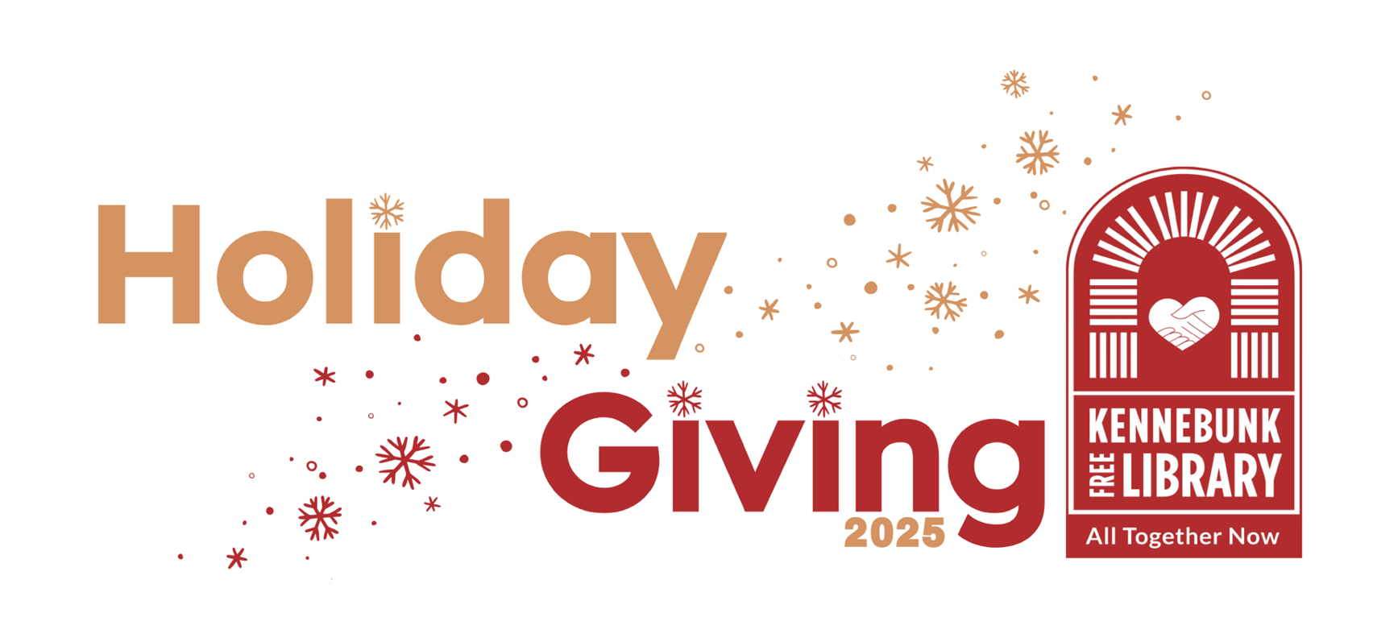

The holidays are a season of light, joy, and connection — and your generous support helps Kennebunk Free Library bring those moments to life for everyone who walks through our doors. You’ve been such an important part of our story, and we’re deeply grateful for the impact you’ve made.

🎁 A $20,000 Holiday Giving Challenge!
We are thrilled to share that George C. and Diantha C. Harrington, an anonymous donor, and KFL’s Board of Trustees have come together to create the $20,000 Holiday Giving Challenge Fund! When Holiday Giving donations reach $45,000, this Challenge Fund will be unlocked — bringing KFL an extraordinary $20,000 bonus gift! With your help, we can meet our goal and step into 2026 with gratitude and renewed purpose.

🌟 Your Gift Makes Magic Happen at KFL
Every donation has a story to tell — because at KFL, every gift creates a big impact:
- 📖 $20 – more than a picture book — it’s a bedtime story that sparks a lifelong love of reading.
- 💡 $50 – more than reference help — it’s a librarian guiding someone to their next big discovery.
- 🀄 $100 – more than a Mah Jongg game — it’s friends coming together to play and connect.
- 🗞️ $350 – more than digitizing the York County Coast Star — it’s preserving our local history.
- 🎵 $500 – more than a holiday concert — it’s live music filling our library with community and cheer.
- 🎮 $1,000 – more than teen programming — it’s anime clubs, game nights, and creative spaces where young people can connect, learn, and belong.
- 🌍 $6,000+ – more than Interlibrary Loan — it’s opening doors to millions of books and resources for curious minds of every age.

Every gift, in every amount, keeps KFL vibrant — connecting people, stories, and ideas that strengthen our whole community.
(over)

❤️ How You Can Help
Because of your ongoing partnership and generosity, KFL continues to grow and thrive. Your dedicated support helps make KFL what it is today — a place where dreams are nurtured, knowledge is shared, and community truly thrives.
Together, we can reach our $45,000 Holiday Giving goal and unlock the $20,000 Challenge Fund before December 31!
Here’s how you can make your gift today:
- 💌 Mail your check to Kennebunk Free Library.
- 💻 Give online — visit our website and click the Give Now tab.
- 📱 Scan the QR code below to make a secure online donation right from your phone.
- 💖 Become a Monthly Sustainer — your ongoing support counts toward our goal and provides steady, reliable funding all year long.
Every single gift matters. Your continued generosity will help KFL begin 2026 energized, inspired, and ready to serve our community in even bigger ways.
My warmest best wishes to you and your family for a holiday season filled with peace, joy, and connection.

With Great Thanks,
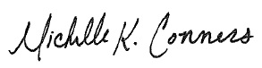
Michelle K. Conners, Executive Director

Scan to Donate!
P.S. Your gift brings joy to our community, from our young friends to those of us who are young at heart!
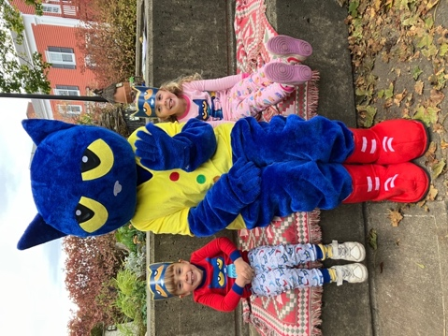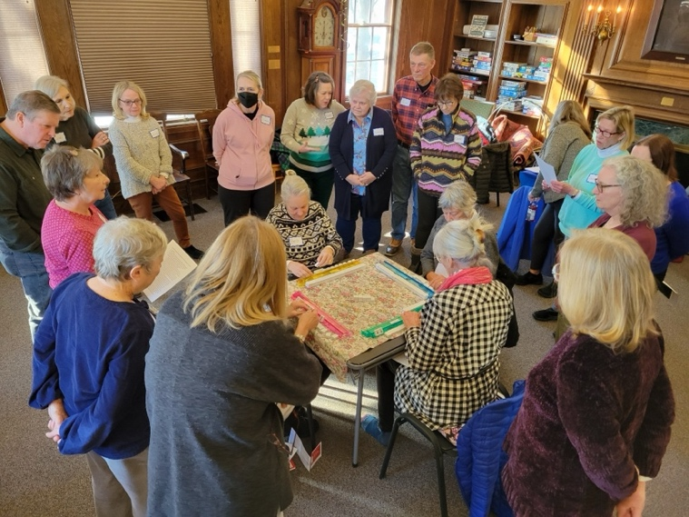
Pete the Cat & Friends Mah Jongg program

Kennebunk Free Library * 207-985-2173 * www.kennebunklibrary.org

