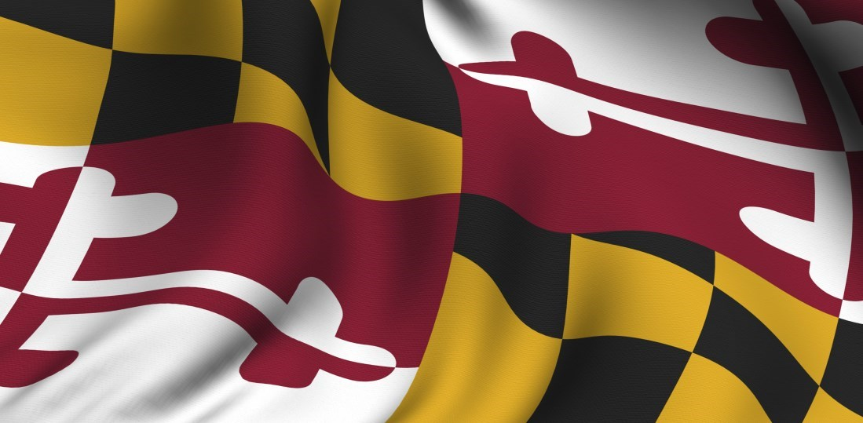
Maryland Department of Disabilities and the Developmental Disabilities Administration celebrate DSP Recognition Week!

Direct Support Professionals (DSPs) are vital to the life experiences of many people with disabilities in Maryland. The incredible dedication and contribution of DSPs has never been clearer than these past few years. These essential employees are the heart and soul of the system of supports that are vital to ensuring that people with disabilities can live the life of their choosing. As Direct Support Professionals on the front lines, these dedicated heroes are the key difference between community participation and isolation for those with disabilities.
The Maryland Department of Disabilities (MDOD) and the Maryland Department of Health Developmental Disabilities Administration (DDA) join others throughout the United States in marking September 10-16th, 2023 as DSP Recognition Week and plan to honor these outstanding Marylanders. Help us by nominating an outstanding DSP for recognition. If chosen, your nominee will be recognized during our DSP celebration.
Direct Support Professional
Recognition Week 2023
September 10-16, 2023
Nominate a Direct Support Professional in one of the following areas who provides an example of service that supports and encourages full community participation for those with disabilities in Maryland. Please provide specific examples of how the nominee encourages and supports community participation.

CATEGORIES:
- Employment Support Professional-A DSP who goes above and beyond to support integrated community employment for those with disabilities
- Community Living Professional– A DSP who goes above and beyond to support full community participation and membership for those with disabilities

Complete the attached form and return to Kim McKay at Kimberly.mckay1@maryland.gov or
217 East Redwood Street, Suite 1300, Baltimore MD 21202 by September 8, 2023.
This document is available in alternative accessible formats by request at 410.767.3654 or Kimberly.mckay1@maryland.gov

Nomination Form
Check one:
Employment DSP Community Living DSP
Name of Nominee:
Employer of Nominee (if applicable):
Email of Nominee:
Maryland County Where Services Provided/Organization Is Located:
Name of Person Completing Form:
Place of Business of Person Completing Form:
Provider-based Self-Direction
Email of Person Completing Form:
Direct Support Professional
Recognition Week 2023
September 10-16, 2023
Phone Number of Person Completing Form:
Relationship of Person Completing Form with Nominee:
Please indicate how your nominee provides an example of service that supports and encourages full community participation for those with disabilities in Maryland. Use a separate sheet if necessary.

Complete the attached form and return to Kim McKay at Kimberly.mckay1@maryland.gov or 217 East Redwood Street, Suite 1300, Baltimore MD 21202 by September 8, 2023.
This document is available in alternative accessible formats by request at 410.767.3654 or Kimberly.mckay1@maryland.gov

