PRESS RELEASE
FOR IMMEDIATE RELEASE
CONTACT:
Mickey Miller, Executive Director
Director@NewBernHistorical.org
Dec. 1, 2022

Historian Wade Sokolosky’s Duty Amidst the Chaos
Lecture Dec. 8, Book Signing Dec. 10

NEW BERN, NC, The New Bern Historical Society offers two opportunities to see local historian and award-winning author Wade Sokolosky. In a presentation titled “Duty Amidst the Chaos,” on December 8 at 6:30pm at the North Carolina History Center’s Cullman Performance Hall, Civil War author Wade Sokolosky takes a deeper dive into his most recent book, North Carolina’s Confederate Hospitals, Vol. I, 1861-1863, with a particular focus on New Bern’s hospitals. Whether you saw Sokolosky’s 2020 presentation or not, you’re in luck! With fresh information and insights drawn from extensive original research in his recently published book, this new program will explore the weeks leading up to the battle of New Bern, concluding with the chaotic Confederate retreat toward Kinston. In this oft-overlooked topic, Sokolosky shares the stories, as told by the participants - both men and women - of their care for the sick and wounded. Reservations are $10, available at www.NewBernHistorical.org/tickets. Or by calling 262-638-8558. Books will be available for sale.
Any history lovers on your holiday shopping list? The Historical Society will also host a book signing on December 10 at 10am at the Pavilion at New Bern Battlefield Park. Wade Sokolosky will sign his newest book, NC's Confederate Hospitals, 1861-1863, Vol I, and will have books for sale. There is no charge to attend.
Colonel Wade Sokolosky (Ret.), a native of Beaufort, North Carolina, is a graduate of East Carolina University and a 25-year veteran of the U.S. Army. He is one of North Carolina's leading experts on the 1865 Carolinas Campaign. In addition to North Carolina’s Confederate Hospitals, 1861-1863, Volume I, Wade is also co-author (with Mark A. Smith) of "To Prepare for Sherman's Coming": The Battle of Wise's Forks, March 1865, and "No Such Army Since the Days of Julius Caesar": Sherman's Carolinas Campaign from Fayetteville to Averasboro, and the compiler of “Final Roll Call” Confederate Losses during the Carolinas Campaign.
- more-

He is the recipient of the Raleigh Civil War Round Table’s 2017 T. Harry Gatton Award for his important efforts to study, preserve, and share the Civil War heritage of his native North Carolina. Additionally, Wade is a tour guide with the Friends of Bentonville Battlefield and is a member of the Brunswick County Civil War Round Table Advisory Council.
Wade lives in Beaufort, North Carolina, and works for the N.C. Department of Transportation Ferry System.
The mission of the New Bern Historical Society is to celebrate and promote New Bern and its heritage through events and education. Offices are located in the historic Attmore-Oliver House at 511 Broad Street in New Bern. For more information, call 252-638-8558 or go www.NewBernHistorical.org or www.facebook.com/NewBernHistoricalSociety.
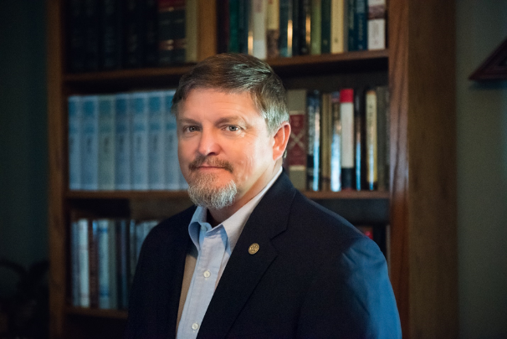 Wade Sokolosky

###

