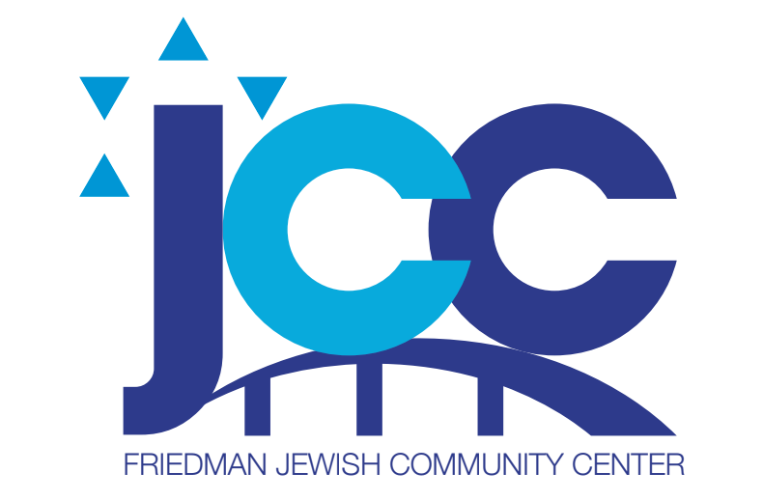

June 2024 Menu Friedman JCC
The menu is subject to change.
Monday, June 3 2 Pieces of Pizza, Salad, Chips, Fruit
Tuesday, June 4 Filet of Fish with Herbs, Sweet Potato, Mixed Vegetables, Fruit
Wednesday, June 5 BBQ Chicken, Roasted Potatoes, String Beans, Fruit
Thursday, June 6 Plain Bagel, Lox, Cream Cheese, Lettuce and Tomato, Chips, Fruit
Friday, June 7 TNT Baguette Tuna Fish Salad, Hard Boiled Egg, Pickles, Lettuce and Tomato, Potato Salad, Fruit
Monday, June 10 Spaghetti and Meatballs with Sauce, Broccoli and Cauliflower Medley, Fruit
Tuesday, June 11 Meatloaf, Gravy, Mashed Potatoes, Peas and Carrots, Fruit
Wednesday, June 12 NO LUNCH SHAVUOT
Thursday, June 13 NO LUNCH SHAVUOT
Friday, June 14 Oven Baked Fried Chicken, Roasted Potatoes, Zucchini, Cole Slaw, Fruit
Monday, June 17 Scoop of Tuna, on a Bed of Lettuce, Tomato, Cucumber, Cubes of Cheese, Crackers, Fruit
Tuesday June 18 Baked Ziti with Vegetables and Cheese, Lettuce and Tomato Salad, Fruit
Wednesday, June 19 Roasted Chicken, Baked Potato, Green Beans, Fruit
Thursday June 20 Chef Salad, Romaine Lettuce, Chicken, Tomatoes, Cucumber, Carrots, Hard Boiled Egg, Dressing, Crackers, Fruit
Friday, June 21 Hamburger on a Bun, Lettuce and Tomato, Cole Slaw, Fruit
Monday, June 24 Fettuccini Alfredo with Mushrooms, Tossed Salad…Lettuce, Tomato, Cucumber, Dressing, Fruit
Tuesday, June 25 Penne Rose, Tossed Salad, Dressing, Roll, Fruit
Wednesday, June 26 BBQ Chicken, Roasted Potato, Zucchini, Fruit
Thursday, June 27 Turkey Hoagie, Lettuce, Tomato, Potato Salad, Chips, Fruit
Friday, June 28 Pasta Primavera, Salad with Lettuce and Tomato, Dressing, Fruit.
Reservations must be made 1 week in advance. Reservations can be made for the month. Call the front Desk 570-824-4646. We appreciate your support with this matter. Courtesy counts.

