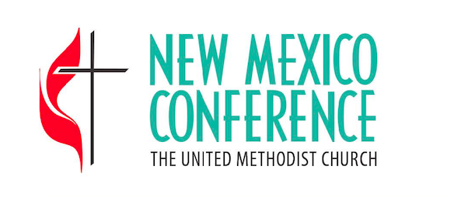
2020 General Conference
2020 South Central Jurisdictional Conference
Information Document

At our upcoming 2018 Annual Conference Session (June 13-15, 2018, in Albuquerque), we will elect clergy and laity delegates to the 2020 General and Jurisdictional Conferences. In the New Mexico Annual Conference, we elect one clergy and one laity delegate to General Conference (who also attend Jurisdictional Conference on our behalf), an additional clergy and laity voting delegate to Jurisdictional Conference (for a total of two voting members each), and two additional clergy and lay alternates.

The Conference Provost, the Conference Lay Leader, and the Chair of the Board of Ordained Ministry invite you to submit a completed “Delegation Interest Information Form” to serve as a delegate (or alternate delegate) to General and/or Jurisdictional Conference.

Here are some things to keep in mind when discerning whether or not to offer yourself or encourage someone else to put their name forward for potential service as a member of the delegation:

Eligibility: In order to be eligible to serve as a member of the delegation, clergy members must be either an elder or deacon in full connection, or an associate member of the Annual Conference, or a provisional member who has completed his/her educational requirements at the time of election, or a local pastor who has completed his/her Course of Study at the time of election (or have an MDiv degree), and have served under appointment since at least June of 2016. Lay members interested in serving must have been an active participant in The United Methodist Church since June of 2014 and a professing member of The United Methodist Church since June of 2016.

Time Commitment: Delegates and alternates are expected to fully participate in regular delegation meetings between their election and the dates of General and Jurisdictional Conference in 2020. In addition, the delegation is “in office” until the following General or Jurisdictional Conference (in 2024). Furthermore, it is customary for the delegation to meet with episcopal (bishop) candidates as part of the discernment process for the election of new bishops in our region. Most delegation meetings prior to General and Jurisdictional Conference will take place in Albuquerque. Episcopal interviews are held in conjunction with the delegation from Northwest Texas. Dates for the 2020 General Conference are May 1-15 (in Minneapolis, MN). Dates for the 2020 Jurisdictional Conference are July 15-18 (in The Woodlands, TX). During these Conferences, important matters for the life of our denomination and jurisdiction are decided but know that the days are long, demanding, and occasionally tedious.

Cost: While there is an Annual Conference budget line for delegation expenses it does not cover all related expenses. Delegation members are likely to incur out-of-pocket expenses related to meetings and to attendance and participation at General and Jurisdictional Conference – possibly substantial.

Nature of the Work: General Conference receives thousands of petitions that have to work through a number of conversations before coming to a vote. Delegation members have to be aware of and be able to track a (sometimes) meandering legislative process. Further, General and Jurisdictional Conferences are “political” in that they are designed to make corporate decisions on behalf of the whole Church. The sessions are marked by extremely long days of work filled with prayerful discernment, a wide range of emotion, and (occasionally) significant differences of opinion. This can be a rewarding but also challenging ministry.

Individuals interested in offering themselves to serve in this way are encouraged to submit a completed Delegation Interest Information Form with a color photo to the Conference Office no later than March 15, 2018.

Thank you for your prayerful discernment as we seek the guidance of God’s Spirit in this process.

Sid Strebeck Rev. Brad Bennett Rev. Randall W. Partin
Conference Lay Leader Chair of the Board of Ordained Ministry Conference Provost

