Asbury Pie Café has another successful year in 2018.

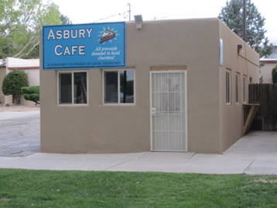

This year was the 59th year of the Asbury Pie Café. You may know that it started in the Goat Barn at the NM State Fair and has been in the present building on Main Street since the early 1970s. In 1987 St. Stephen’s United Methodist Church joined with Asbury UMC to expand the volunteer workers and supplement the outreach of the café. In 1993 St. John’s UMC joined. The 3 churches shared in all aspects of the café, such as picking fruit, processing fruit, making pies, and running the café. In 2001 three more churches joined. For 2018 there were 12 churches and one charity participating in the café:
Asbury United Methodist Heights Cumberland Presbyterian
Cornerstone United Methodist Mountainside United Methodist
Covenant Presbyterian Paradise Hills United Methodist
Covenant United Methodist St. John’s United Methodist
Faith Lutheran St. Stephen’s United Methodist
First United Methodist Rio Rancho First Baptist
Silver Horizons

This year there are 12 charity organizations that will be funded, these are:
The Storehouse Meals on Wheels First UMC Grace Meal The Rock @ Noon Day South ABQ Coop Ministry Good Shepherd Family Promise ABQ Street Outreach East Mountain Food Pantry Asbury UMC Breaking Bread Silver Horizons Rio Grande Food Project

The church members provide all the pies at no cost to the café. This makes the profit margin of the café very large. Every penny of the profit goes to helping charities that feed the needy. This year the total number of pies sold was 1843 and the total income was $70,000. This total amount was increased by a generous gift from Thomas Gammill in memory of Esther Gammill. Esther was the Pie Lady for several years. After paying expenses there will be $50,000 to fund the charities.

