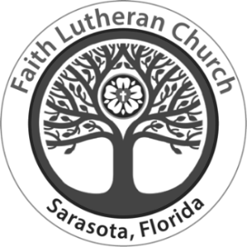
Faith Lutheran Church

We warmly greet members
and visitors in Jesus’ name

Eighth Sunday after Pentecost
10:15 a.m., July 14, 2024

When Amos reports his vision of God judging Israel for its mistreatment of the
poor, he becomes a threat to the power of the priests and the king.
John the Baptist also speaks truth to power, and Herod has him killed.
In Herod’s fear that Jesus is John returned from the dead, we may hear hope for
the oppressed: all the prophets killed through the ages are alive in Jesus.
We are called to witness to justice in company with them, and to proclaim
God’s saving love.

Welcome to Worship at Faith Lutheran Church
Gathered faithfully to love and serve God and all others
7750 Beneva Road, Sarasota, FL, 34238 | 941-924-4664 | www.faithlutheransrq.com
All the baptized are invited to the celebration of Holy Communion, trusting that Christ is present in this sacrament for the forgiveness of our sin and the strengthening of our faith.

The flowers on the altar today are given by
Alf & Denise Kirkeeng in celebration of their 47th anniversary,
and Amy & Brandon Parrish’s 16th anniversary.

Presiding Minister Rev. Eric Olaf Olsen
Rev. Marianne Powrie

Lector Tom Tryon

Director of Music/Organist David V. Patrick
Cantor and Vocals Hannah Boyd

Greeters & Ushers Jerry Cooper, Eloise Dettmer, Ashley Garlitz, Dottie Gustavson, Grace Kaarre,
Alf Kirkeeng, Gail Lidinsky, Judy Millard, Mark Nelson, Jan Phillips, Scott Rice,
Jane Sanks, Joan Searles, Dave Wardach

Media Team Kelly Ashlock, Greg Cooper, Kevin Fewell,
Andrea & Sergio Gamboa, Mark Greenwood

Altar Guild Linda Fewell, Dottie Gustavson,
Carole Inkrott, Judy Millard, Mark Nelson, Jan Phillips, Steve & Peggy Ragan

Congregation Council Scott Rice, president; Lauren Wardach, vice president; Mark Nelson, secretary; Anita Wooton, treasurer; Jane Sanks, assistant treasurer; Jerry Cooper; Quyen Dang;
Ann Greenwood; Peggy Ragan; Joan Searles

* * * * *

Pastor Rev. Eric Olaf Olsen
Assistant to the Pastor Rev. Larry Wright
Retired Pastors in Residence Rev. John Hilficker
Rev. Marianne Powrie
Rev. John Spittal

Lead Cantor/Music Librarian Tom Tryon

Interim Operations Administrator Kelly Ashlock

Communications Administrator Linda Fewell

- Noted throughout the service - P: Presiding Minister L: Lector C: Congregation
- Faith has a T-Coil-enabled hearing loop for those whose hearing aid(s) also are enabled.
- Smile! Faith worship services are live-streamed and recorded.
Prelude Holy Art Thou G.F. Handel

WELCOME AND Announcements

WE STAND

CONFESSION AND FORGIVENESS
P: Blessed be the holy Trinity, ☩ one God, the God of manna, the God of miracles,
the God of mercy.
C: Amen.

P: Drawn to Christ and seeking God’s abundance,
let us confess our sin. (brief silence)

Holy God,
C: we confess that we are captive to sin
and cannot free ourselves.
We have sinned against you
in thought, word and deed,
by what we have done
and by what we have left undone.
We have not loved you with our whole heart;
we have not loved our neighbors as ourselves.
For the sake of your Son, Jesus Christ,
have mercy on us.
Forgive us, renew us, and lead us,
so that we may delight in your will
and walk in your ways,
to the glory of your holy name.
Amen.

P: Beloved people of God:
in Jesus, the manna from heaven,
you are fed and nourished.
By Jesus, the worker of miracles,
there is always more than enough.
Through Jesus, ☩ the bread of life,
you are shown God’s mercy:
you are forgiven
and loved into abundant life.
C: Amen.

GATHERING HYMN Come Thou Fount of Every Blessing
ELW 807 We sing together

GREETING
P: The grace of our Lord Jesus Christ, the love of God,
and the communion of the Holy Spirit be with you all.
C: And also with you.

KYRIE
We sing responsively
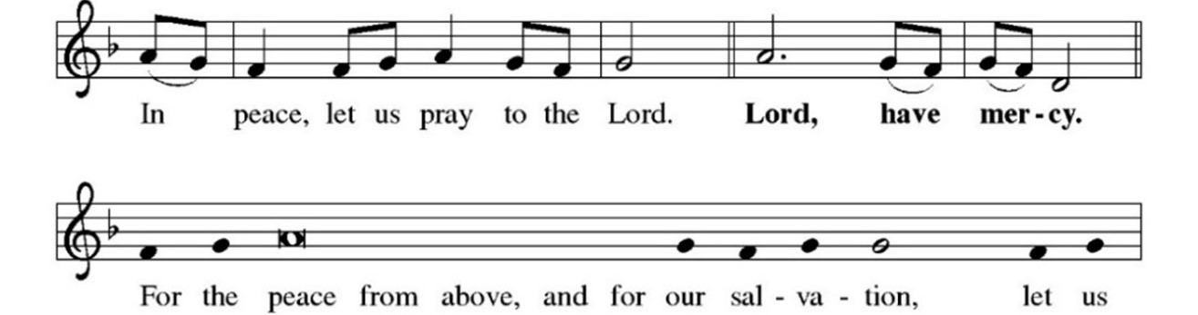

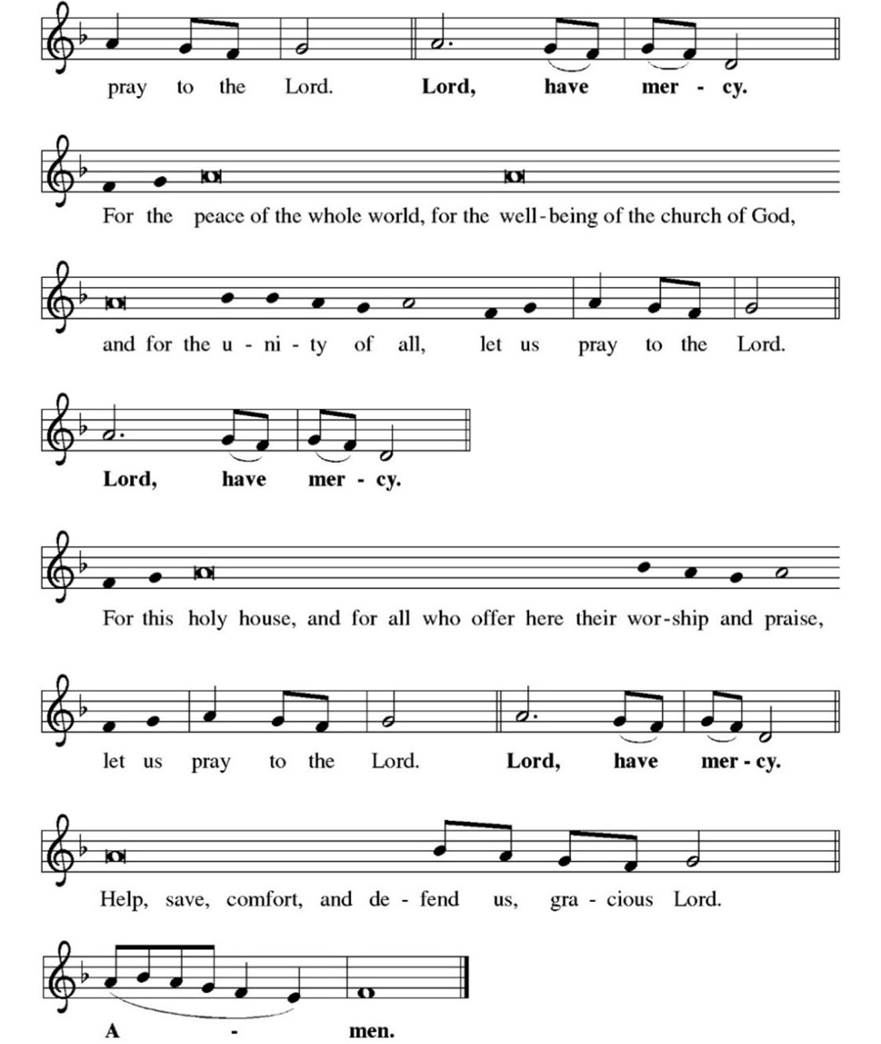

GLORIA
We sing together

PRAYER OF THE DAY
P: The Lord be with you.
C: And also with you.
P: Let us pray. O God, from you come all holy desires, good counsels and just
works. Give to us that peace which the world cannot give, that our hearts may obey your commandments; and that we, being defended from the fear of our enemies, may live in peace and quietness, through Jesus Christ, our Savior and Lord.
C: Amen.

WE SIT

FIRST READING: Amos 7:7-15
L: A Reading from Amos.

⁷This is what [the Lord God] showed me: the Lord was standing beside a wall built with a plumb line, with a plumb line in his hand. ⁸And the Lord said to me, “Amos, what do you see?” And I said, “A plumb line.” Then the Lord said,
“See, I am setting a plumb line in the midst of my people Israel; I will never again pass them by; ⁹the high places of Isaac shall be made desolate, and the sanctuaries of Israel shall be laid waste, and I will rise against the house of Jeroboam with the sword.” ¹⁰Then Amaziah, the priest of Bethel, sent to King Jeroboam of Israel, saying, “Amos has conspired against you in the very center of the house of Israel; the land is not able to bear all his words. ¹¹For thus Amos has said, ‘Jeroboam shall die by the sword, and Israel must go into exile away from his land.’ ” ¹²And Amaziah said to Amos, “O seer, go, flee away to the land of Judah, earn your bread there, and prophesy there; ¹³but never again prophesy at Bethel, for it is the king’s sanctuary, and it is a temple of the kingdom.” ¹⁴Then Amos answered Amaziah, “I am no prophet, nor a prophet’s son; but I am a herdsman, and a dresser of sycamore trees, ¹⁵and the Lord took me from following the flock, and the Lord said to me, ‘Go, prophesy to my people Israel.’ ”

Word of God, word of life.
C: Thanks be to God.

PSALM REFRAIN: Psalm 85:8
To begin, the organist plays the refrain once, the cantor sings it once, and then
we all sing it together.
PSALMODY: Psalm 85:8-13
L: ⁸I will listen to what the Lord God is saying; for you speak peace to your faithful
people and to those who turn their hearts to you.
⁹Truly, your salvation is very near to those who fear you,
that your glory may dwell in our land.
C: Refrain.

L: ¹⁰Steadfast love and faithfulness have met together;
righteousness and peace have kissed each other.
¹¹Faithfulness shall spring up from the earth,
and righteousness shall look down from heaven.
¹²The Lord will indeed grant prosperity, and our land will yield its increase.
¹³Righteousness shall go before the Lord and shall prepare for God a pathway.
C: Refrain.

SECOND READING: Ephesians 1:3-14
L: A Reading from Ephesians.

³Blessed be the God and Father of our Lord Jesus Christ, who has blessed us in Christ with every spiritual blessing in the heavenly places, ⁴just as he chose us in Christ before the foundation of the world to be holy and blameless before him in love. ⁵He destined us for adoption as his children through Jesus Christ, according to the good pleasure of his will, ⁶to the praise of his glorious grace that he freely bestowed on us in the Beloved. ⁷In him we have redemption through his blood, the forgiveness of our trespasses, according to the riches of his grace ⁸that he lavished on us. With all wisdom and insight ⁹he has made known to us the mystery of his will, according to his good pleasure that he set forth in Christ, ¹⁰as a plan for the fullness of time, to gather up all things in him, things in heaven and things on earth.
¹¹In Christ we have also obtained an inheritance, having been destined according to the purpose of him who accomplishes all things according to his counsel and will, ¹²so that we, who were the first to set our hope on Christ, might live for the praise of his glory. ¹³In him you also, when you had heard the word of truth, the gospel of your salvation, and had believed in him, were marked with the seal of the promised Holy Spirit; ¹⁴this is the pledge of our inheritance toward redemption as God’s own people, to the praise of his glory.

Word of God, word of life.
C: Thanks be to God.

CHILDREN’S SERMON

WE STAND

GOSPEL ACCLAMATION
We sing together
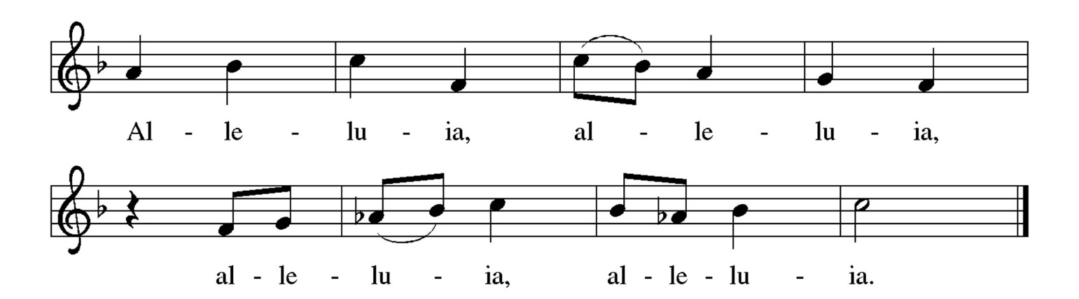

GOSPEL: Mark: 6:14-29
P: The Holy Gospel according to St. Mark.
C: Glory to you, O Lord.

P: ¹⁴King Herod heard of [the disciples’ preaching,] for Jesus’ name had become known. Some were saying, “John the baptizer has been raised from the dead; and for this reason these powers are at work in him.” ¹⁵But others said, “It is Elijah.” And others said, “It is a prophet, like one of the prophets of old.” ¹⁶But when Herod heard of it, he said, “John, whom I beheaded, has been raised.”
¹⁷For Herod himself had sent men who arrested John, bound him, and put him in prison on account of Herodias, his brother Philip’s wife, because Herod had married her. ¹⁸For John had been telling Herod, “It is not lawful for you to have your brother’s wife.” ¹⁹And Herodias had a grudge against him, and wanted to kill him. But she could not, ²⁰for Herod feared John, knowing that he was a righteous and holy man, and he protected him. When he heard him, he was greatly perplexed; and yet he liked to listen to him. ²¹But an opportunity came when Herod on his birthday gave a banquet for his courtiers and officers and for the leaders of Galilee. ²²When his daughter Herodias came in and danced, she pleased Herod and his guests; and the king said to the girl, “Ask me for whatever you wish, and I will give it.” ²³And he solemnly swore to her, “Whatever you ask me, I will give you, even half of my kingdom.” ²⁴She went out and said to her mother, “What should I ask for?” She replied, “The head of John the baptizer.” ²⁵Immediately she rushed back to the king and requested, “I want you to give me at once the head of John the Baptist on a platter.” ²⁶The king was deeply grieved; yet out of regard for his oaths and for the guests, he did not want to refuse her. ²⁷Immediately the king sent a soldier of the guard with orders to bring John’s head. He went and beheaded him in the prison, ²⁸brought his head on a platter, and gave it to the girl. Then the girl gave it to her mother. ²⁹When his disciples heard about it, they came and took his body, and laid it in a tomb.

The gospel of the Lord.
C: Praise to you, O Christ.
WE SIT

SERMON Rev. Eric Olaf Olsen

WE STAND

HYMN OF THE DAY Lead On, O King Eternal!
ELW 805 We sing together

APOSTLES’ CREED
P: Together, we confess our faith in the words of the Apostles’ Creed.
C: I believe in God, the Father almighty, creator of heaven and earth.
I believe in Jesus Christ, God’s only Son, our Lord, who was conceived
by the Holy Spirit, born of the virgin Mary, suffered under Pontius
Pilate, was crucified, died, and was buried; he descended to the
dead.*
On the third day he rose again; he ascended into heaven, he is seated
at the right hand of the Father, and he will come to judge the living
and the dead.
I believe in the Holy Spirit, the holy catholic church, the communion of
saints, the forgiveness of sins, the resurrection of the body, and the
life everlasting. Amen.
WE SIT

PRAYERS OF INTERCESSION
Following each prayer petition, we respond:
L: … In your mercy,
C: hear our prayer.

As the prayers conclude:
P: … trusting in the one who is the way, the truth and the life, Jesus Christ our Savior and Lord.
C: Amen.

WE STAND

PEACE
P: The peace of Christ be with you always.
C: And also with you.
Feel free to greet your neighbors with a word of peace.

WE SIT

OFFERTORY

The offering is collected at this time. Give online by scanning the QR Code printed here or at www.faithlutheransrq.com. We deeply appreciate your support of Faith Lutheran’s ministries.

OFFERTORY ANTHEM Come to Me Dan Forrest
Hannah Boyd, soloist

Come to Me, all you who labor, come to Me, and I will give you rest.
Come to Me, all who are weary and burdened, and you will find rest for your souls.
Come, My child, learn My Heart, for I am gentle and lowly.
See how great My love for you, that I have called you My child.
Copyright 2015, 2020 by Beckenhorst Press, Inc.

WE STAND
We sing together
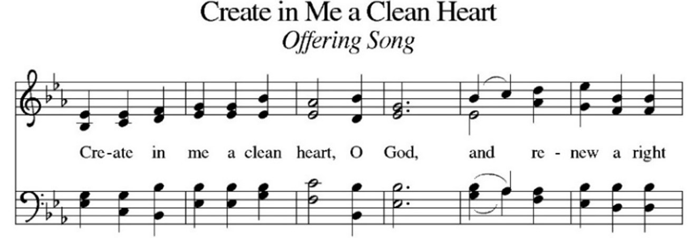

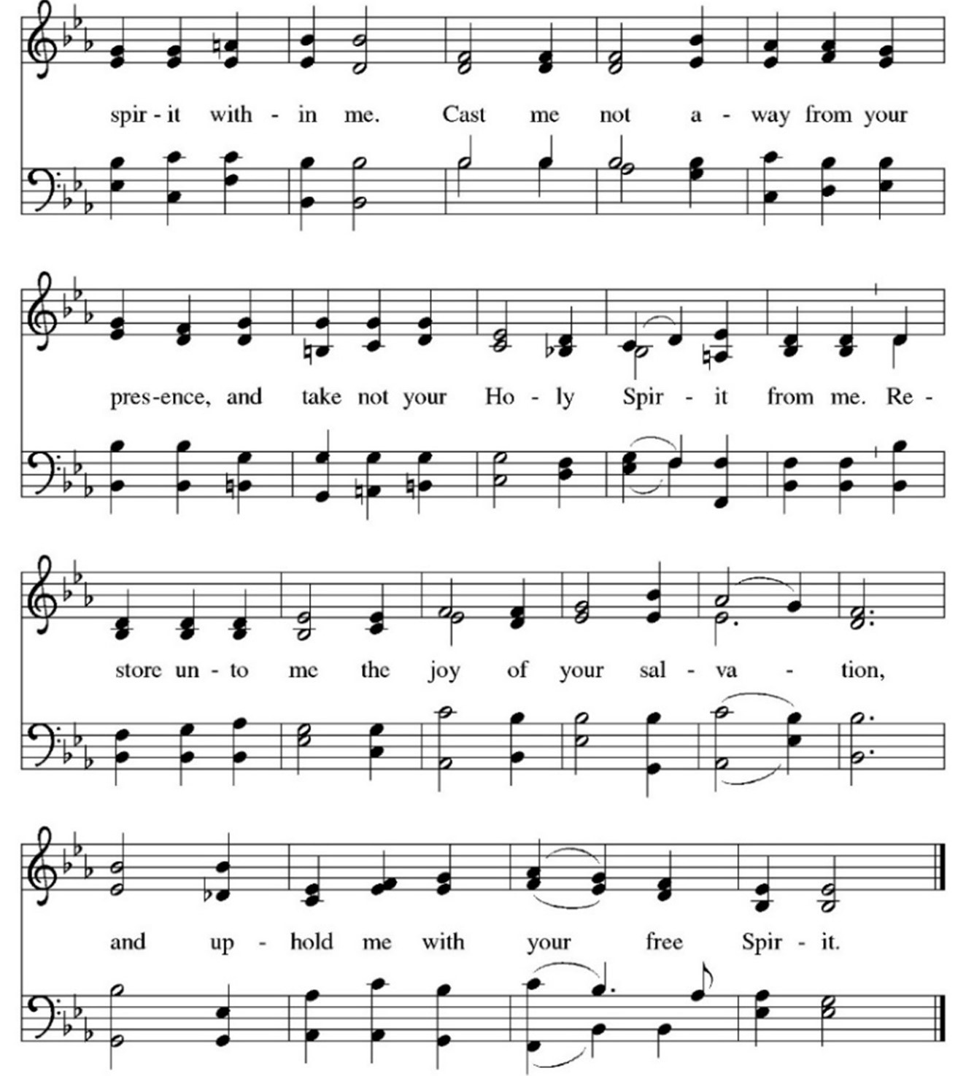

OFFERTORY PRAYER
P: Let us pray. Jesus, Bread of Life, you have set this table with your very self,
and called us to the feast of plenty. Gather what has been sown among us, and strengthen us in this meal. Make us to be what we receive here, your body for the life of the world.
C: Amen.

THE GREAT THANKSGIVING
We sing responsively
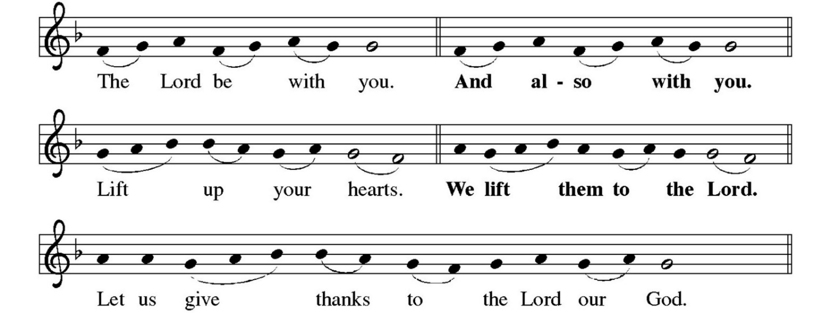
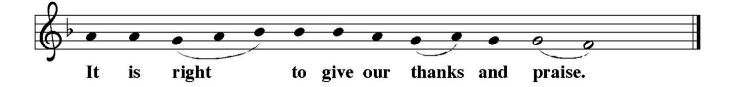

PREFACE
The presiding minister sings



The presiding minister continues, then concludes …
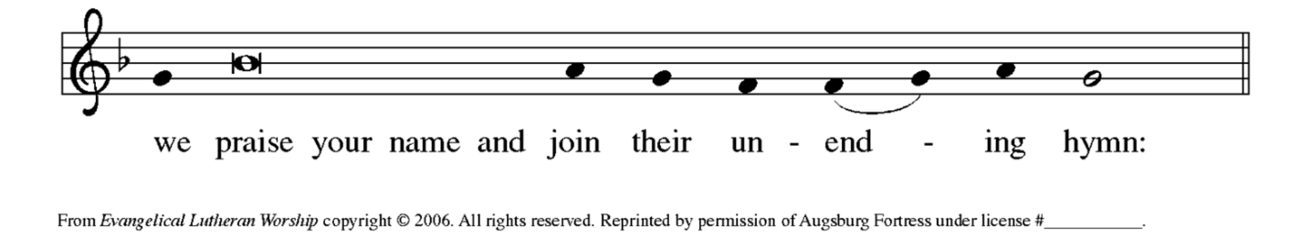

HOLY, HOLY, HOLY
We sing together
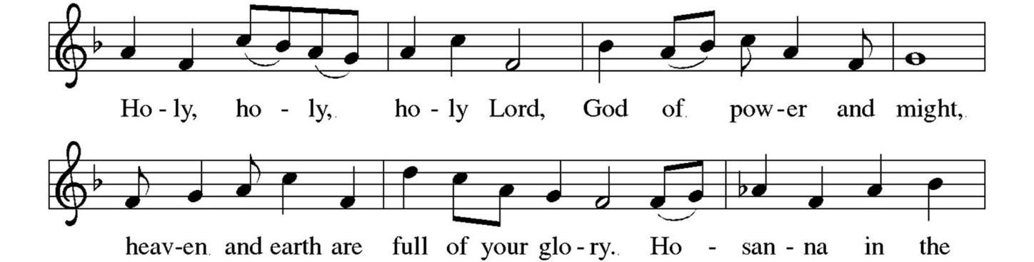

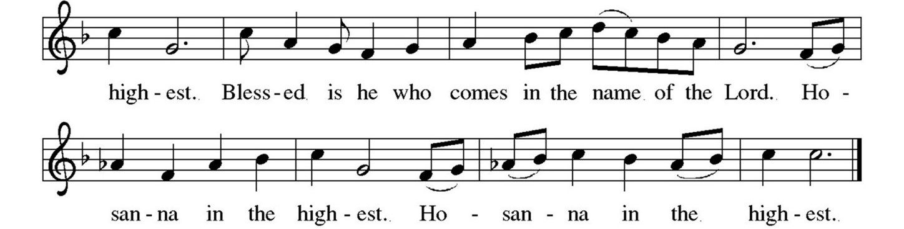

THANKSGIVING AT THE TABLE
P: You are indeed holy, almighty and merciful God ...

… For as often as we eat of this bread and drink from this cup,
we proclaim the Lord’s death until he comes.
C: Christ has died. Christ is risen. Christ will come again.

P: Remembering, therefore, his salutary command …

… To you, O God, Father, Son, and Holy Spirit,
be all honor and glory in your holy church, now and forever.
C: Amen.

LORD’S PRAYER
P: Gathered into one by the Holy Spirit, let us pray as Jesus taught us.
C: Our Father,
who art in heaven,
hallowed be thy name,
thy kingdom come,
thy will be done,
on earth as it is in heaven.
Give us this day our daily bread;
and forgive us our trespasses,
as we forgive those who trespass against us;
and lead us not into temptation,
but deliver us from evil.
For thine is the kingdom,
and the power,
and the glory, forever and ever.
Amen.

INVITATION TO COMMUNION
P: Christ has set the table with more than enough for all. Come!

COMMUNION SONG
We sing together
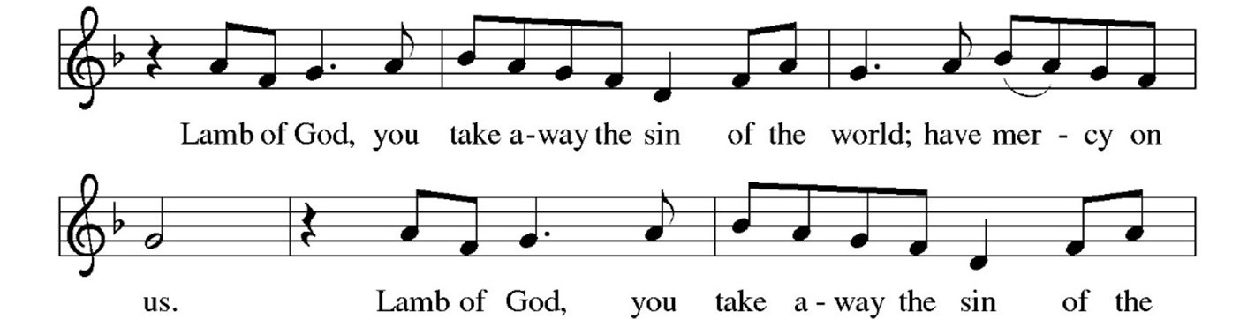

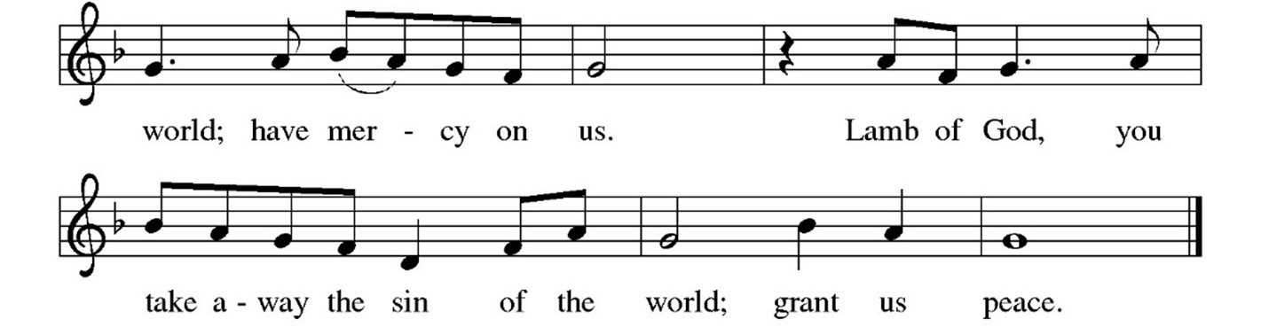

WE SIT

Everyone is welcome at the Lord’s table.

COMMUNION
The body of Christ, given for you ... The blood of Christ, shed for you.

COMMUNION ANTHEM Our Father Craig Courtney
Hannah Boyd, soloist
Copyright 2017, 2020 by Beckenhorst Press, Inc.

WE STAND

TABLE BLESSING
P: The body and blood of our Lord Jesus Christ strengthen you and keep you in
God’s grace.
C: Amen.

PRAYER AFTER COMMUNION
P: Let us pray. Jesus, Bread of Life, we have received from your table more than we could ever ask. As you have nourished us in this meal, now strengthen us to love the world with your own life. In your name we pray.
C: Amen.

NUNC DIMITTIS
We sing together

BLESSING
P: Now receive a blessing: The blessing of God, who provides for us, feeds us and journeys with us, ☩ be upon you now and forever.
C: Amen!

SENDING SONG Holy God, We Praise Your Name
ELW 414
We sing together
See next page

DISMISSAL
P: Go in peace. You are the body of Christ.
C: Thanks be to God.

POSTLUDE Trumpet Voluntary Henry Purcell

From sundaysandseasons.com. | Copyright © 2020 Augsburg Fortress. All rights reserved. Reprinted by permission under Augsburg Fortress Liturgies Annual License #SAS000587. New Revised
Standard Version Bible, Copyright © 1989, Division of Christian Education of the National Council of the Churches of Christ in the United States of America. Used by permission.
All rights reserved. Revised Common Lectionary, Copyright © 1992 Consultation on Common Texts, admin Augsburg Fortress.

_____________________________________________________________

Welcome, Visitors!

We are so glad you have joined us for worship. Please let us know that you visited by signing our guestbook and/or filling out a Visitor Card located on the table near the entrance. Kindly give the card to an usher or place it in the offering plate.
Join in Prayer

The Prayer Support Group meets at 10:30 a.m. Wednesdays in the chapel to pray for all in need, our community, nation and world, and to share Holy Communion. Can’t attend in person? Join via Zoom: Meeting ID 871 4720 3661. Passcode 041291.

Bereavement Group Meets Wednesdays

The Bereavement Group meets at 1 p.m. Wednesdays in the chapel. If you or a friend can use help bearing the burden of grief, this group is for you.
_____________________________________________________________

VBS Starts Soon!

Vacation Bible School (VBS) Day Camp, July 22-26, at Faith will run
9 a.m.-3 p.m. Monday-Thursday of that week, concluding at noon Friday with a special program for families and friends. There is no cost to attend, and lunch and snacks are included! Taught by trained teachers from Camp Luther Springs, VBS will include Bible study, worship, games, arts and crafts, nature studies and more. Registration is officially closed, but a few enrollments still could be accepted. Questions? Contact Pastor Eric, pastor@faithlutheransrq.com or

716-352-0055.
_____________________________________________________________

Help Feed the Hungry at St. Paul’s Lutheran

From 3 to 6:30 p.m. Tuesday, July 30, be part of the crew that will cook and serve for about 70 food-insecure and homeless siblings in Christ at St. Paul’s Lutheran in downtown Sarasota. To volunteer, sign up on the sheet in the narthex or contact the church office.
_____________________________________________________________

Readers Club Meets July 29

Readers Club will meet at 2 p.m., July 29, in the library to discuss Just for the Summer by Abby Jiminez. All are welcome!
_____________________________________________________________

You Can Help Faith Help the Needy through the
Pastor’s Discretionary Fund

Pastor Eric often speaks with people about aid they require. The Pastor's Discretionary Fund allows him to assist financially, when appropriate. The need currently is great so, if you can, please consider a donation to the fund so those in need can receive assistance. You can give online through the Online Giving page at faithlutheransrq.com, or by designating a check or cash contribution. Thank you!
_________________________________________________________
Donate Altar Flowers in Honor or in Memory

Please consider donating altar flowers in honor of a special occasion, in memory of a loved one or to glorify God. The cost is $30 for one vase or $60 for two. Make checks payable to Faith Lutheran Church with “altar flowers” in the memo line. Check the altar flowers donation board in fellowship hall to see if your desired date is available. If not, choose an alternate date. The next open date is Sunday,
September 4. When you purchase altar flowers, your name and dedication appear in the bulletin on your selected Sunday. To make a dedication:
- At church, complete an Altar Flowers envelope with payment, and place it in the offering plate. Indicate your wish to keep or donate the flowers on the donation board in fellowship hall.
- By mail, send payment with a note indicating your desired date and dedication, and if you want to keep the flowers or donate them.
- By email or phone, contact the church office with your desired date and dedication, and whether you want to keep or donate the flowers. Pay through the Altar Flowers option on the Online Giving page of the Faith website, faithlutheransrq.com.

_____________________________________________________________

Experiencing the Joy of Generosity! The Joy of Receiving God’s Blessings: What Belongs to God?
Scripture: “What do you have that you did not receive? If then you received it why do you boast as if you did not receive it?” (1 Corinthians 4:7) Prayer: Dear Father, you are the source of every good and perfect gift, for which I thank you. Amen.

_____________________________________________________________

Worship to Go Needs Your Help

Worship to Go needs additional helpers! You can participate at 1:30 p.m., Tuesday, July 16, at Angels Senior Living, 5750 Honore. Volunteers will meet at 12:45 p.m. in the chapel and will carpool to the facility. Participating is heartwarming and fun. To join in, contact Pastor Eric directly, 716-352-0055. No experience necessary! This will be the last one, with a break for August and will resume in September.

Worship and Service Calendar

Worship Services
Sundays at 8 a.m. & 10:15 a.m. in person.
Live streamed and recorded at
www.faithlutheransrq.com/live-service.

Sunday, July 7
Online views 167
8 a.m. in person 26
10:15 a.m. in person 73

Next Sunday, July 21
First Reading
Jeremiah 23:1-6
From David’s line, a righteous shepherd for Israel.

Psalmody
Psalm 23
The Lord is my shepherd; I shall not be in want (Ps. 23:1).

Second Reading
Ephesians 2:11-22
Reconciled to God through Christ, our peace.

Gospel
Mark 6:30-34, 53-56

This Week at Faith
Monday, July 15

Tuesday, July 16
10 a.m. Jazzercize, gym
12:45 p.m. Worship to Go Prep, chapel
1:30 p.m. Worship to Go at Angels Senior
Living 5750 Honore

Wednesday, July 17
10:30 a.m. Prayer Group, chapel
1 p.m. Bereavement Group, chapel

Thursday, July 18
9 a.m. Receive and Prep Food Delivery, food pantry
9:20 a.m. Finance Committee, conf. room
10 a.m. Jazzercise, gym
4:30 p.m. Food Pantry Prep
5 p.m. Food Pantry Open

Friday, July 19
8:30 a.m. Jazzercise, gym

Saturday, July 20
8:30 a.m. Jazzercise, gym
9 a.m. Diakonia, conference room

Sunday, July 21

Christ healing the multitudes.

- Contact officeadmin@faithlutheransrq.com if you or someone you know would appreciate
a communion, hospital or home visit, to be contacted or to receive a card in the mail.
- Contact communications@faithlutheransrq.com if you have an addition to the Prayer List. Please send updates when prayers are answered.

Prayer List

Alan
Pastor Steve Anderson, friend of Jan Phillips
Chuck & Tani Banta
Kathryn Bolon, mother of Barbara Bolon
Barbara Brannan, mother of Kim McDonald
Arthur Brucato,
friend of Karla Lewis & Michael Leonhardt
Michael Burgess, friend of Janice Lorenz’s son
Dee Burlingame
Evelyn Conlon
Jeanine Davis (nee Molella),
granddaughter of Karen and John White
Eloise Dettmer
Ryan Donahue, friend of Doris Anne Prieur-Lucia
Andrea Gamboa
Jeff Hansen, nephew of Joan Searles
Patricia Head, mother of Wayne Head
Sonja Hickling, mother of Kelly Ashlock
Becky Hilton Heeps, friend of Lisa Olsen
Al Hirsch, husband of Marilyn Hirsch
Kevin Hooks, son-in-law of
Anita and Jon Wooton
Cliff and Snookie Hornsby
Jesus & Rita Jimenez
Leonard Kotwitz, brother of Janet Falk
Lillian Lapenckas

Diane Lewis, sister-in-law of Karla Lewis &
Michael Leonhardt
Paul and Debbie Maresch,
brother and his wife of Patty McKee
Dennis McCaughey, friend of Lois Weaverling
Kim McDonald
Judi Melander
Alison Nommay, friend of Karla Lewis &
Michael Leonhardt
Terry O’Connell, friend of Marlene Radesk
Meghan Ortega, niece of Lisa and Pastor Eric Olsen
Judy Osborn, sister of Peggy Ragan
Family & Friends of Wally Pina
Cindy Press, friend of Kevin & Linda Fewell
Robin Ryder, daughter of Floyd Ryder and
sister of Gail Murphy
Lorna Sawyers-Sucra, friend of
Jeremy & Yvonne Mullins
Becky Sciranko, niece of Alice Rush
Joan Searles
Stephanie Sebastyn, friend of Carolyn Winemiller
Rev. John Spittal
Mark Stengel
David Turnbull, husband of Patricia White
Brittany Wanko and her premature newborn
infants, Olivia Mae and Emmet Walter
Jon Wooton

About Faith Lutheran Church

Our Mission
Gathered faithfully to love and serve God and all others.

Our Vision
To be an ELCA congregation that displays the true, unending love of Christ.
To promote peace, social justice and grace in all we do.

The ELCA
Faith Lutheran Church is part of the greater Evangelical Lutheran Church in America (ELCA). We are ecumenical, saved by grace and love Jesus.

Receive the Latest News and Updates
To receive the latest news and updates from Faith Lutheran, subscribe to our
weekly Friday Update at www.faithlutheransrq.com or email communications@faithlutheransrq.com.

