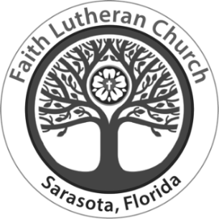
Faith Lutheran Church

We warmly greet members
and visitors in Jesus’ name

The Holy Trinity
10:15 a.m., May 26, 2024
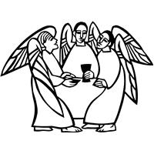

When we say God is the triune God, we are saying something about who
God is beyond, before and after the universe: that there is community within
God. When we pray to God as Jesus prayed to his Abba (an everyday, intimate parental address), the Spirit prays within us, creating between us and God the
same relationship Jesus has with the one who sent him.

Welcome to Worship at Faith Lutheran Church
Gathered faithfully to love and serve God and all others
7750 Beneva Road, Sarasota, FL, 34238 | 941-924-4664 | www.faithlutheransrq.com
All the baptized are invited to the celebration of Holy Communion, trusting that Christ is present in this sacrament for the forgiveness of our sin and the strengthening of our faith.

The flowers on the altar today are given by Marlene Radesk in honor and memory of her mother’s birthday.

Presiding Ministers Rev. Eric Olaf Olsen
Rev. Larry Wright

Lector Tom Tryon

Director of Music/Organist David V. Patrick
Cantor Hannah Boyd
Vocals Voices of Faith Choir

Greeters & Ushers Jerry Cooper, Eloise Dettmer, Ashley Garlitz, Dottie Gustavson, Grace Kaarre,
Alf Kirkeeng, Gail Lidinsky, Judy Millard, Mark Nelson, Jan Phillips, Scott Rice,
Joan Searles, Dave Wardach

Media Team Kelly Ashlock, Greg Cooper, Kevin Fewell,
Andrea & Sergio Gamboa, Mark Greenwood

Altar Guild Linda Fewell, Dottie Gustavson,
Carole Inkrott, Judy Millard, Mark Nelson, Jan Phillips, Steve & Peggy Ragan

Congregation Council Scott Rice, president; Lauren Wardach, vice president; Mark Nelson, secretary; Anita Wooton, treasurer; Jane Sanks, assistant treasurer; Jerry Cooper; Quyen Dang;
Ann Greenwood; Peggy Ragan; Joan Searles

* * * * *

Pastor Rev. Eric Olaf Olsen
Assistant to the Pastor Rev. Larry Wright
Retired Pastors in Residence Rev. John Hilficker
Rev. Marianne Powrie
Rev. John Spittal
Director of Family and Child Ministry Deborah Dornemann
Lead Cantor/Music Librarian Tom Tryon
Operations Administrator Jenniffer Shaffer
Communications Administrator Linda Fewell

- Noted throughout the service - P: Presiding Minister L: Lector C: Congregation
- Faith has a T-Coil-enabled hearing loop for those whose hearing aid(s) also are enabled.
- Smile! Faith worship services are live-streamed and recorded.

PRELUDE Nimrod Edward Elgar
arranged by Alan Ridout

WELCOME AND ANNOUNCEMENTS

WE STAND

CONFESSION AND FORGIVENESS
P: Blessed be the holy Trinity, ☩ one God, the God of manna, the God of miracles, the God of mercy.
C: Amen.

P: Drawn to Christ and seeking God’s abundance, let us confess our sin in the presence of God and of one another. (brief silence)

Holy God,
C: we confess that we are captive to sin
and cannot free ourselves.
We have sinned against you in thought, word and deed,
by what we have done
and by what we have left undone.
We have not loved you with our whole heart;
we have not loved our neighbors as ourselves.
For the sake of your Son, Jesus Christ, have mercy on us.
Forgive us, renew us, and lead us,
so that we may delight in your will
and walk in your ways,
to the glory of your holy name.
Amen.

P: Beloved people of God:
in Jesus, the manna from heaven,
you are fed and nourished.
By Jesus, the worker of miracles,
there is always more than enough.
Through Jesus, ☩ the bread of life,
you are shown God’s mercy:
you are forgiven and loved into abundant life.
C: Amen.

GATHERING HYMN Come, Thou Almighty King
ELW 408 We sing together

GREETING
P: The grace of our Lord Jesus Christ, the love of God,
and the communion of the Holy Spirit be with you all.
C: And also with you.

KYRIE
We sing responsively
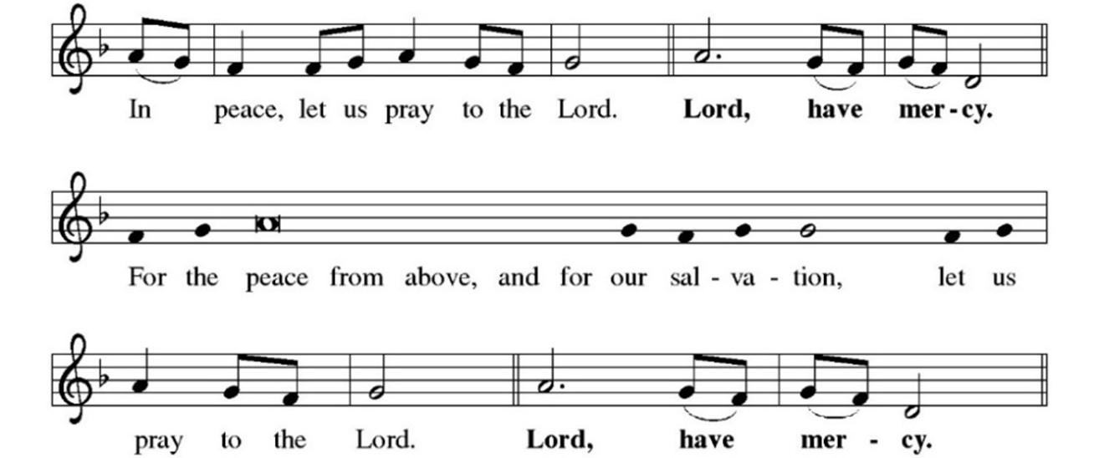
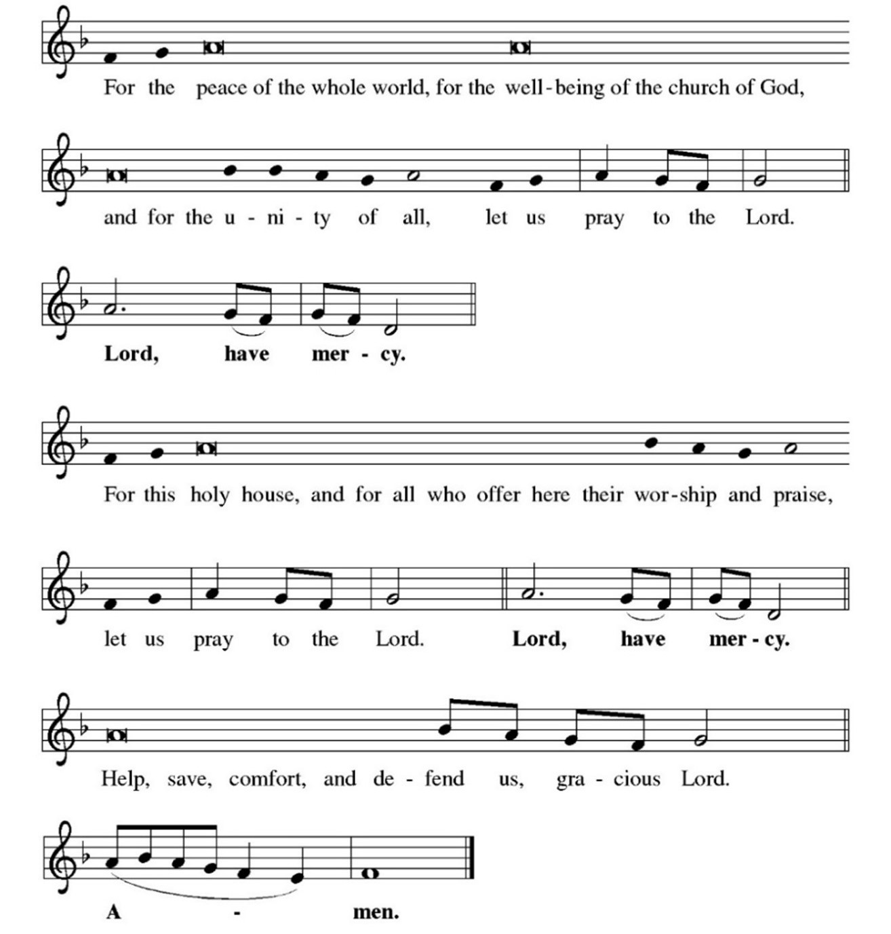

GLORIA
We sing together

PRAYER OF THE DAY
P: The Lord be with you.
C: And also with you.
P: Let us pray. Almighty Creator and ever-living God: we worship your glory, eternal Three-in-One, and we praise your power, majestic One-in-Three. Keep us steadfast in this faith, defend us in all adversity, and bring us at last into your presence, where you live in endless joy and love, Father, Son, and Holy Spirit, one God, now and forever.
C: Amen.

WE SIT

FIRST READING: Isaiah 6:1-8
L: A Reading from Isaiah.

¹In the year that King Uzziah died, I saw the Lord sitting on a throne, high and lofty; and the hem of his robe filled the temple. ²Seraphs were in attendance above him; each had six wings: with two they covered their faces, and with two they covered their feet, and with two they flew. ³And one called to another and said: “Holy, holy, holy is the Lord of hosts; the whole earth is full of his glory. ⁴The pivots on the thresholds shook at the voices of those who called, and the house filled with smoke. ⁵And I said: “Woe is me! I am lost, for I am a man of unclean lips, and I live among a people of unclean lips; yet my eyes have seen the King, the Lord of hosts!” ⁶Then one of the seraphs flew to me, holding a live coal that had been taken from the altar with a pair of tongs. ⁷The seraph touched my mouth with it and said: “Now that this has touched your lips, your guilt has departed and your sin is blotted out.” ⁸Then I heard the voice of the Lord saying, “Whom shall I send, and who will go for us?” And I said, “Here am I; send me!”

Word of God, word of life.
C: Thanks be to God.

PSALM REFRAIN: Psalm 29:2
To begin, the organist plays the refrain once, the cantor sings it once and then we all sing it together.
PSALMODY: Psalm 29
L: ¹Ascribe to the Lord, you gods, ascribe to the Lord glory and strength.
²Ascribe to the Lord the glory due God’s name;
worship the Lord in the beauty of holiness.
³The voice of the Lord is upon the waters; the God of glory thunders;
the Lord is upon the mighty waters.
⁴The voice of the Lord is a powerful voice;
the voice of the Lord is a voice of splendor.
C: Refrain.

L: ⁵The voice of the Lord breaks the cedar trees;
the Lord breaks the cedars of Lebanon;
⁶the Lord makes Lebanon skip like a calf,
and Mount Hermon like a young wild ox.
⁷The voice of the Lord bursts forth in lightning flashes.
⁸The voice of the Lord shakes the wilderness;
the Lord shakes the wilderness of Kadesh.
C: Refrain.

L: ⁹The voice of the Lord makes the oak trees writhe and strips the forests bare.
And in the temple of the Lord all are crying, “Glory!”
¹⁰The Lord sits enthroned above the flood;
the Lord sits enthroned as king forevermore.
¹¹O Lord, give strength to your people; give them, O Lord, the blessings of peace
C: Refrain.

SECOND READING: Romans 8:12-17
L: A Reading from Romans.

¹²Brothers and sisters, we are debtors, not to the flesh, to live according to the flesh—¹³for if you live according to the flesh, you will die; but if by the Spirit you put to death the deeds of the body, you will live. ¹⁴For all who are led by the Spirit of God are children of God. ¹⁵For you did not receive a spirit of slavery to fall back into fear, but you have received a spirit of adoption. When we cry, “Abba! Father!” ¹⁶it is that very Spirit bearing witness with our spirit that we are children of God, ¹⁷and if children, then heirs, heirs of God and joint heirs with Christ—if, in fact, we suffer with him so that we may also be glorified with him.

Word of God, word of life.
C: Thanks be to God.

CHILDREN’S SERMON

WE STAND

GOSPEL ACCLAMATION
We sing together
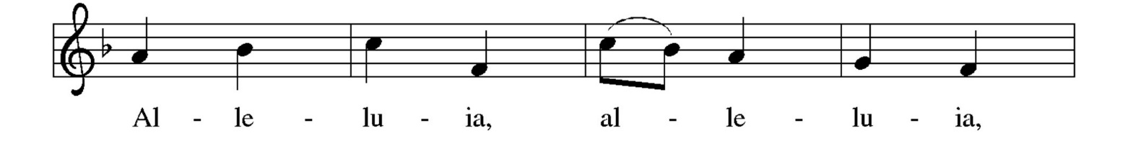
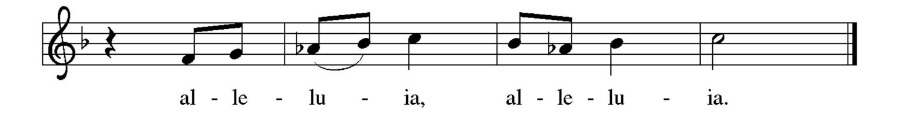

GOSPEL: John 3:1-17
P: The Holy Gospel according to St. John.
C: Glory to you, O Lord.

P: ¹Now there was a Pharisee named Nicodemus, a leader of the Jews. ²He came to Jesus by night and said to him, “Rabbi, we know that you are a teacher who has come from God; for no one can do these signs that you do apart from the presence of God.” ³Jesus answered him, “Very truly, I tell you, no one can see the kingdom of God without being born from above.” ⁴Nicodemus said to him, “How can anyone be born after having grown old? Can one enter a second time into the mother’s womb and be born?” ⁵Jesus answered, “Very truly, I tell you, no one can enter the kingdom of God without being born of water and Spirit. ⁶What is born of the flesh is flesh, and what is born of the Spirit is spirit. ⁷Do not be astonished that I said to you, ‘You must be born from above.’ ⁸The wind blows where it chooses, and you hear the sound of it, but you do not know where it comes from or where it goes. So it is with everyone who is born of the Spirit.”
⁹Nicodemus said to him, “How can these things be?” ¹⁰Jesus answered him, “Are you a teacher of Israel, and yet you do not understand these things? ¹¹“Very truly, I tell you, we speak of what we know and testify to what we have seen; yet you do not receive our testimony. ¹²If I have told you about earthly things and you do not believe, how can you believe if I tell you about heavenly things? ¹³No one has ascended into heaven except the one who descended from heaven, the Son of Man. ¹⁴And just as Moses lifted up the serpent in the wilderness, so must the Son of Man be lifted up, ¹⁵that whoever believes in him may have eternal life. ¹⁶“For God so loved the world that he gave his only Son, so that everyone who believes in him may not perish but may have eternal life. ¹⁷“Indeed, God did not send the Son into the world to condemn the world, but in order that the world might be saved through him.”

The gospel of the Lord.
C: Praise to you, O Christ.

WE SIT

SERMON Rev. Eric Olaf Olsen

WE STAND

HYMN OF THE DAY Come, Join the Dance of Trinity
ELW 412 We sing together

APOSTLES’ CREED
P: Together, we confess our faith in the words of the Apostles’ Creed.
C: I believe in God, the Father almighty, creator of heaven and earth.
I believe in Jesus Christ, God’s only Son, our Lord, who was conceived
by the Holy Spirit, born of the virgin Mary, suffered under Pontius
Pilate, was crucified, died, and was buried; he descended to the
dead.*
On the third day he rose again; he ascended into heaven, he is seated
at the right hand of the Father, and he will come to judge the living
and the dead.
I believe in the Holy Spirit, the holy catholic church, the communion of
saints, the forgiveness of sins, the resurrection of the body, and the
life everlasting. Amen.
WE SIT

PRAYERS OF INTERCESSION
Following each prayer petition, we respond:
P: … Merciful God,
C: receive our prayer.

As the prayers conclude:
P: … Receive our prayers, O God, and come quickly to our aid, through the power of the Spirit and the love of Jesus Christ.
C: Amen.

WE STAND

PEACE
P: The peace of Christ be with you always.
C: And also with you.
Feel free to greet your neighbors with a word of peace.

WE SIT

OFFERTORY

The offering is collected at this time. Give online by scanning the QR Code printed here or at www.faithlutheransrq.com. We deeply appreciate your support of Faith Lutheran’s ministries.

OFFERTORY ANTHEM Spirit of God, Descend Upon My Heart
Lloyd Larson
Voices of Faith Choir

Spirit of God, descend upon my heart; wean it from earth, through all its pulses move.
Stoop to my weakness, mighty as Thou art, and make me love Thee as I ought to love.
Teach me to feel that Thou art always nigh; teach me the struggle of the soul to bear.
To check the rising doubt, the rebel sigh; teach me the patience of unanswered prayer.
Teach me to love Thee as Thine angels love, one holy passion filling all my frame.
The baptism of the heaven descended Dove, my heart an altar, and Thy love the flame.
Copyright 1995 by Beckenhorst Press, Inc.

WE STAND

We sing together
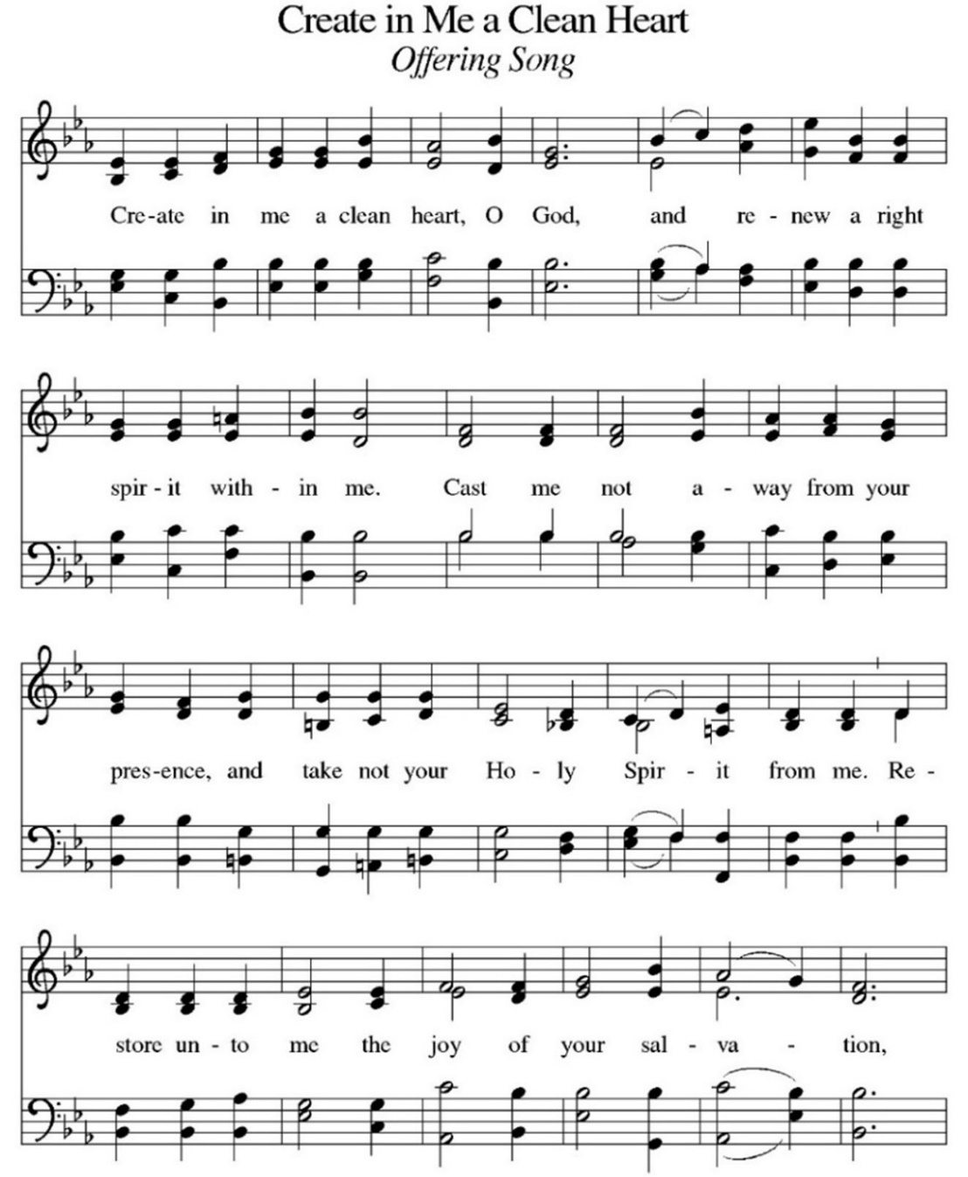
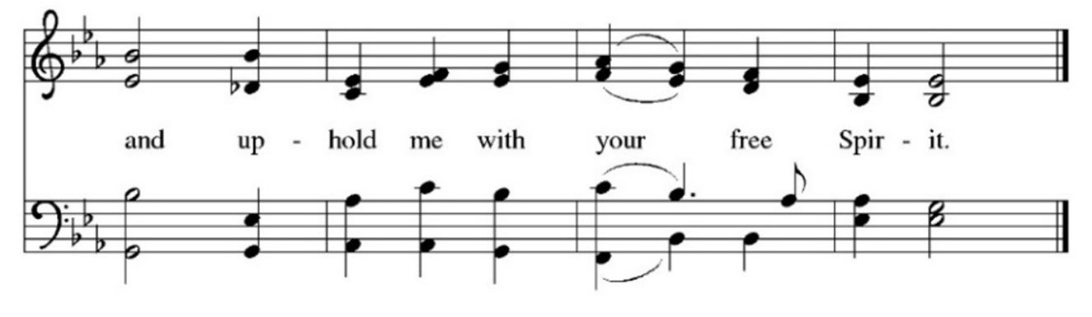

OFFERTORY PRAYER
P: Let us pray. Jesus, Bread of Life, you have set this table with your very self, and called us to the feast of plenty. Gather what has been sown among us, and strengthen us in this meal. Make us to be what we receive here, your body for the life of the world.
C: Amen.
THE GREAT THANKSGIVING
We sing responsively
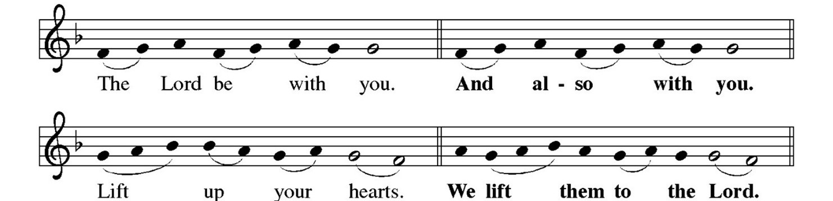

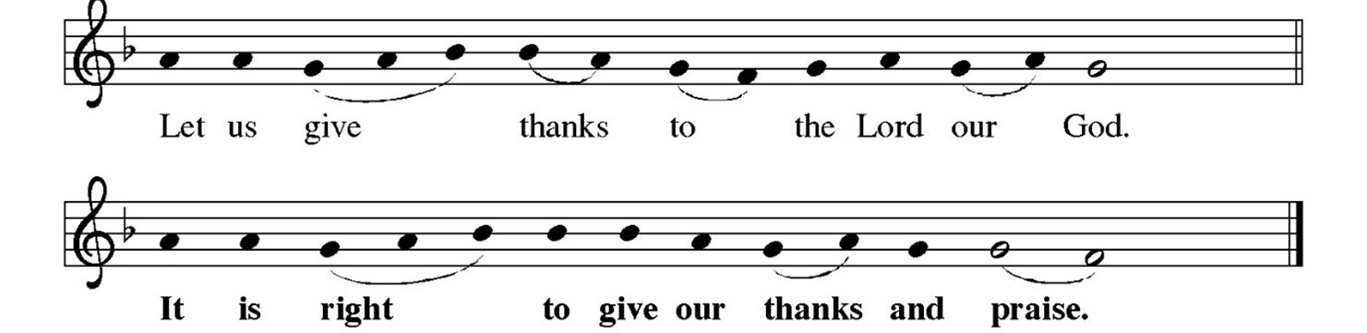

PREFACE
The presiding minister sings
The presiding minister continues, then concludes …

HOLY, HOLY, HOLY
We sing together
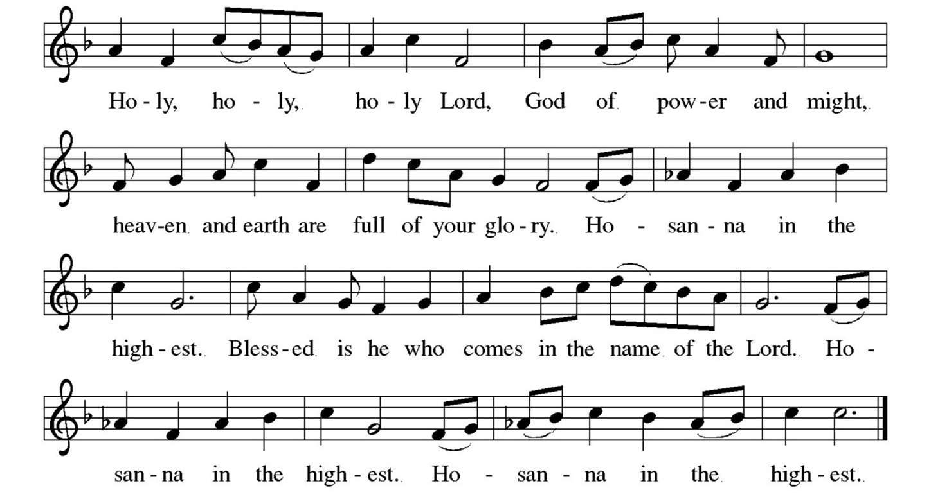
THANKSGIVING AT THE TABLE
P: Blessed are you, O God of the universe ...

… With this bread and cup we remember our Lord’s passover from death to life
as we proclaim the mystery of faith:
C: Christ has died. Christ is risen. Christ will come again.

P: O God of resurrection and new life: Pour out your Holy Spirit on us and on these gifts of bread and wine. Bless this feast. Grace our table with your presence. Reveal yourself to us in the breaking of the bread. Raise us up as the body of Christ for the world. Breathe new life into us. Send us forth, burning with justice, peace and love.
C: Come, Holy Spirit.

With your holy ones of all times and places, with the earth and all its creatures,
with sun and moon and stars, we praise you, O God, blessed and holy Trinity,
now and forever.
C: Amen.

LORD’S PRAYER
P: Gathered into one by the Holy Spirit, let us pray as Jesus taught us.
C: Our Father, who art in heaven, hallowed be thy name,
thy kingdom come, thy will be done,
on earth as it is in heaven.
Give us this day our daily bread; and forgive us our trespasses,
as we forgive those who trespass against us;
and lead us not into temptation,
but deliver us from evil.
For thine is the kingdom, and the power,
and the glory, forever and ever.
Amen.

INVITATION TO COMMUNION
P: Christ has set the table with more than enough for all. Come! All are welcome at the Lord’s table

COMMUNION SONG
We sing together
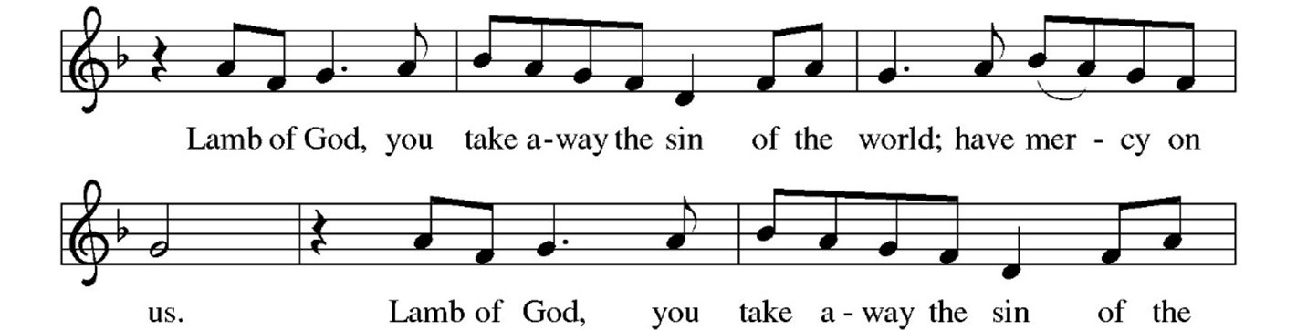
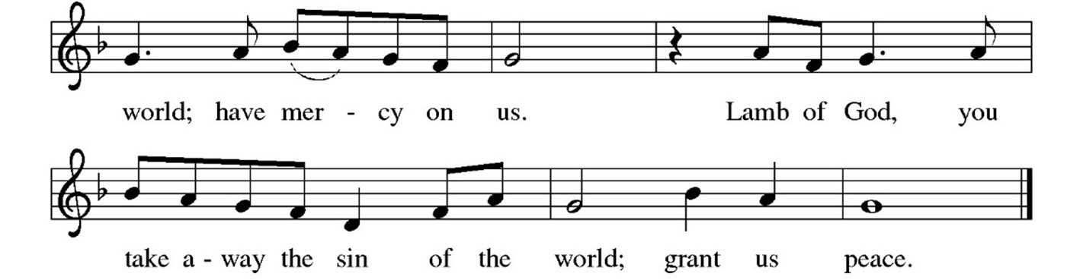

WE SIT

Everyone is welcome at the Lord’s table.

COMMUNION
The body of Christ, given for you ... The blood of Christ, shed for you.

COMMUNION ANTHEM Lord, Here I Am Jay Althouse
Voices of Faith Choir

Master, thou callest, I gladly obey. Only direct me, and I’ll find Thy way,
Teach me the mission appointed for me. What is my labor, and where shall it be?
Master, Thou callest, and this I reply, “Ready and willing, Lord, here am I.”
Lord, I will follow if Thou will but lead. Only support me with grace in my need.
Pardon whenever I turn from the right. Help me, and bring me again to the light.
Master, Thou callest, and this I reply, “Ready and willing, Lord, here am I.”
Copyright MCMXCIV by Alfred Publishing Co., Inc.

WE STAND

TABLE BLESSING
P: The body and blood of our Lord Jesus Christ strengthen you and keep you in
God’s grace.
C: Amen.

PRAYER AFTER COMMUNION
P: Let us pray. Jesus, Bread of Life, we have received from your table more than we could ever ask. As you have nourished us in this meal, now strengthen us to love the world with your own life. In your name we pray.
C: Amen.

NUNC DIMITTIS
We sing together

BLESSING
P: Now receive a blessing: The blessing of God, who provides for us, feeds us and journeys with us, ☩ be upon you now and forever.
C: Amen.

SENDING SONG Holy, Holy, Holy, Lord God Almighty!
ELW 413 We sing together

DISMISSAL
P: Go in peace. You are the body of Christ.
C: Thanks be to God.
POSTLUDE Allegro from Suite Gothique Leon Boellmann

From sundaysandseasons.com. | Copyright © 2020 Augsburg Fortress. All rights reserved. Reprinted by permission under Augsburg Fortress Liturgies Annual License #SAS000587. New Revised
Standard Version Bible, Copyright © 1989, Division of Christian Education of the National Council of the Churches of Christ in the United States of America. Used by permission.
All rights reserved. Revised Common Lectionary, Copyright © 1992 Consultation on Common Texts, admin Augsburg Fortress.
_____________________________________________________________

Welcome, Visitors!

We are so glad you have joined us for worship. Please let us know that you visited by signing our guestbook and/or filling out a Visitor Card located on the table near the entrance. Kindly give the card to an usher or place it in the offering plate.

_____________________________________________________________

Use Email or Prayer Request Cards to Add or Keep Someone on the Prayer List

It’s time to update the Faith Prayer List so, beginning Sunday, June 2, the list will begin anew. To add someone to the list or to ensure that someone who had previously been on the list remains there:
- Email communications@faithlutheransrq.com.
- Complete a Prayer Request Card, which are found in the pews, on the tables at the back of the sanctuary and in the narthex. Place it in the offering plate. You are welcome to use the back of the card for additional names.
It is a privilege and joy to pray for those in need, and all prayer requests are welcome. Names can remain on the list for as long as prayers are requested.

_____________________________________________________________

Considering Membership? Attend a Q&A and Coffee Today

Are you considering membership at Faith? Join Pastor Eric and congregational leaders for a Q&A and coffee after worship today. Faith will receive new members during both June 9 services.
_____________________________________________________________

The Faith Church Office Will Be Closed Tomorrow, May 27, in Observance of Memorial Day.
_____________________________________________________________

May Stewardship Message

If we are going to serve the Lord, we should do so wholeheartedly
and see what God will do in response.
“Whatever your hand finds to do, do it with all your might” (Ecclesiastes 9:10).
Join in Prayer and Bible Study

- Adult Forum now is on summer break. It will resume in the fall.
- Men of Faith meet for breakfast and prayer at 8:30 a.m. Tuesday, May 28, at Skillets, 8635 S. Tamiami Trail.
- G.I.F.T.S. (Growing in Faith Through Scripture) Women’s Bible study meets at 9:30 a.m. Tuesday, May 28, in the library to complete study of “Be Still and Know — A Study of Rest and Refuge.” May 28 is the final meeting before summer break. G.I.F.T.S. will resume in the fall with new study booklets provided. Plan to join in!
- The Prayer Support Group meets at 10:30 a.m. Wednesdays in the chapel to pray for all in need. You also can join via Zoom: Meeting ID 871 4720 3661. Passcode 041291.
_____________________________________________________________

Bereavement Group Meets Wednesdays

The Bereavement Group meets at 1 p.m. Wednesdays in the chapel. If you or a friend can use help bearing the burden of grief, this group is for you.

Kids and Families: Register for VBS

Register now for Vacation Bible School (VBS) Day Camp, July 22-26 at Faith. It will run 9 a.m.-3 p.m. Monday-Thursday of that week, concluding at noon Friday with a special program for families and friends. There is no cost to attend, and lunch and snacks are included! Taught by trained teachers from Camp Luther Springs, VBS will include Bible study, worship, games, arts and crafts, nature studies and more. Look for details, and the registration and health forms in the Faith Friday Update email. To ask questions or get hard copies of the forms, contact Deborah Dornemann, familyandchild@faithlutheransrq.com or 941-914-7553.

_____________________________________________________________

Readers Club Meets May 28

Readers Club meets at 2 p.m., Tuesday, May 28, in the library to discuss The Women by Kristin Hannah. All are welcome!

Donate Altar Flowers in Honor or in Memory

Please consider donating altar flowers in honor of a special occasion, in memory of a loved one or to glorify God. The cost is $30 for one vase or $60 for two. Make checks payable to Faith Lutheran Church with “altar flowers” in the memo line. Check the altar flowers donation board in fellowship hall to see if your desired date is available. If not, choose an alternate date. The next open date is Sunday,
June 2. When you purchase altar flowers, your name and dedication appear in the bulletin on your selected Sunday. To make a dedication:
- At church, complete an Altar Flowers envelope with payment, and place it in the offering plate. Indicate your wish to keep or donate the flowers on the donation board in fellowship hall.
- By mail, send payment with a note indicating your desired date and dedication, and if you want to keep the flowers or donate them.
- By email or phone, contact the church office with your desired date and dedication, and whether you want to keep or donate the flowers. Pay through the Altar Flowers option on the Online Giving page of the Faith website, faithlutheransrq.com.
_____________________________________________________________

Mary Circle Enjoys a Busy Spring

On April 6, Mary Circle members attended the annual Women of the ELCA (WELCA) Spring Gathering at Living Waters Lutheran Church in North Port. They enjoyed meeting women from other churches in our conference, hearing speakers on a variety of topics and sharing Bible Study. As a speaker pointed out, all women members of the church are members of WELCA. Faith is blessed to have many women’s groups, including Mary Circle, Women’s Bible Study and Stitch ‘n’ Chatter. Circle members are excited to begin planning for the 2025 Spring Gathering, which will be hosted by Faith.
Thanks to generous contributions and assistance from the congregation, 110 personal-care kits for Lutheran World Relief were packaged May 5. Mary Circle members will box and weigh the kits in preparation for fall shipping.
Tuesday, June 11, Mary Circle will meet at noon for lunch in fellowship hall. The agenda will include growth strategies and plans. The group will take a July break before starting afresh with new activities. All women are invited to join as Mary Circle provides service to the church and fellowship for all.
____________________________________________

Coffee Hour: Volunteer to Set Up, Clean Up

Coffee hour is an important fellowship ministry at Faith that needs additional volunteers. All you have to do is put out snacks and clean up afterward. Please sign up on the sheet beside the coffee pot in fellowship hall. Questions? Contact Karen Naulty, knaulty@yahoo.com or 406-334-1063; or Denise Kirkeeng, kirkeengd@verizon.net or 941-468-6668.
_____________________________________________________________
You Can Help Faith Help the Needy

Pastor Eric often speaks with people about aid they might require. The Pastor’s Discretionary Fund allows him to assist financially, when appropriate. If you can, please consider a donation to the fund so those in need can receive assistance. And if someone at Faith approaches you for assistance, please direct that person to Pastor Eric.
_____________________________________________________________

Need a Ride to Church? Contact Pastor Eric

Faith will pay for Uber or Lyft to bring you or others to worship or other events at Faith. Contact Pastor Eric to make arrangements: 716-352-0055 or pastor@faithlutheransrq.com.

A Beautiful Poem by former member, Paula Harris,
"What If"
What if today we offered our hand, said Hello and gave a smile.
What if today we stopped, listened, and talked awhile.

What if we listened and found we are all much the same.
What if it does not matter the color of our skin or our name.

What if we stopped, looked about, and could see all the gifts we are given.
What if these gifts opened our hearts and by kindness and service we are driven

What if we no longer accept injustice, greed, and power.
What if we begin spreading love everywhere, every hour.

What if we gave up hard feelings and judging and caused hatred to cease.
What if Faith, Hope, and Love abide would cause Peace.
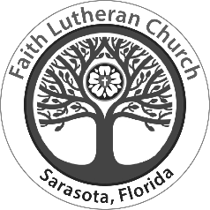

W0rship and Service Calendar

Worship Services
Sundays at 8 a.m. and 10:15 a.m.
Live-streamed and recorded at:
www.faithlutheransrq.com/live-service

Sunday, May 19
Online views 226
8 a.m. in person 25
10:15 a.m. in person 124

Next Sunday, June 2
First Reading
Deuteronomy 5:12-15
The commandments regarding the sabbath.

Psalmody
Psalm 81:1-10
Raise a loud shout to the God of Jacob.
(Ps. 81:1)

Second Reading
2 Corinthians 4:5-12
Treasure in clay jars.

Gospel
Mark 2:23 – 3:6
Doing the work of God on the sabbath.

This Week at Faith
Monday, May 27
Memorial Day: Church Office Closed

Tuesday, May 28
8:30 a.m. Men of Faith Prayer Breakfast, Skillets, 8635 S. Tamiami
9:30 a.m. Women’s Bible Study, library
10 a.m. Jazzercise, gym
2 p.m. Readers Club, library
5 p.m. Congregation Council, conf. room
7 p.m. Diversity Voices of Sarasota, sanctuary

Wednesday, May 29
10:30 a.m. Prayer Support Group, chapel
1 p.m. Bereavement Group, chapel
6:30 p.m. Voices of Faith Choir Rehearsal,
choir room

Thursday, May 30
9 a.m. Receive and Prep Food Delivery
10 a.m. Jazzercize, gym
1 p.m. Stitch ‘n’ Chatter, room 212
4:30 p.m. Food Pantry Prep
5 p.m. Food Pantry Open

Friday, May 31
8:30 a.m. Jazzercise, gym

Saturday, June 1
8:30 a.m. Jazzercise, gym
9 a.m. Diakonia, conf. room

Sunday, June 2
9:30 a.m. Voices of Faith, choir

___________________________________________________________________
Contact officeadmin@faithlutheransrq.com if you or someone you know would appreciate
a communion, hospital or home visit, to be contacted or to receive a card in the mail. Contact communications@faithlutheransrq.com to add someone to or remove someone from the Prayer List.
Prayer List

Marsha Anderson, sister of Gail Murphy
Rev. Steve Anderson, pastor at
Good Shepherd Lutheran Church
Tim Anderson, son-in-law of Dick and Jetty Zarfos
George and James Ball, brothers of Alix Giannini
Anna Bancroft, young friend of Alyene Weaver
Chuck Banta
Chloe Bennenthum, friend of Gail Murphy
Allan Boardman, friend of Kevin & Linda Fewell
Sean & Rebekah Brett, son and daughter-in-law
of Alyene Weaver
Charles Budreau
Dee Burlingame
Byrne, friend of Anita Wooton
Elise Carmona
Michelle Cave, friend of George Young
Evelyn Conlon
Family & Friends of John Conlon
Family & Friends of Jordan Demers,
cousin of Hannah Boyd
Eloise Dettmer
Philomena Dimichelle, friend of Conrad Zabor
Ken Dixon
Ryan and Valerie Donahue
Elizabeth Farmer
Judy & Robert Ferguson
Carolyn & Marty Friedman,
friends of Marlene Radesk
John Gallo, friend of April Shettler
Andrea Gamboa
Laurie Good, friend of Ann Greenwood
Paula Haas, friend of Eloise Dettmer
Jon Hale
Alyssa Hansen, cousin of Lisa Olsen
Jeff Hansen, nephew of Joan Searles
Patricia Head, mother of Wayne Head
Becky Heeps, friend of Lisa Olsen
Family & Friends of Michael Helpin
Christiana Holmes
Kevin Hooks, son-in-law of
Anita and Jon Wooton
Rod Holter and Family, friend of
Mark and Ann Greenwood
Tesa Inkrott,
granddaughter of Pete & Carole Inkrott

Jesus & Rita Jimenez
Alf Kirkeeng
Lillian Lapenckas
Family & Friends of Kathy Lasko
Jacqueline Laurent,
friend of Margaret Borrows
Diane Lewis, sister-in-law of Karla Lewis &
Michael Leonhardt
Lois Light
Shirley Manning, friend of Margaret Borrows
Paul & Debby Maresch
Vincenzo Mariani, friend of Conrad Zabor
Annabelle Martone
Kathleen McBride
Judi Melander
Jeremy & Yvonne Mullins
Beverly Novak, cousin of Patty McKee
Olaf Olsen, father of Pastor Eric Olsen
Judy Osborn, sister of Peggy Ragan
James & Virginia Pease
Fran Perkins
Wally Pina
Kristen Pizan
Cindy Press, friend of Kevin & Linda Fewell
Marlene Radesk
Fritz Rappold
Gabriel Rockwell
Ted and Carol Rodi
Floyd Ryder
Mike Schell
Phillip Schlueter
Family & Friends of Donna Souders, mother of
Lois Weaverling's friend
Adam Spartaro
Rev. John Spittal
Ron and Leigh Tarrantino
Werner Thomsen, brother of John Thomsen
Colette Thornbloom
David Turnbull
Family & Friends of Pastor David Wagner
Brittany Wanko and her premature newborn
infants, Olivia Mae and Emmet Walter
Alyene Weaver
Jon Wooton

About Faith Lutheran Church

Our Mission
Gathered faithfully to love and serve God and all others.

Our Vision
To be an ELCA congregation that displays the true, unending love of Christ.
To promote peace, social justice and grace in all we do.

The ELCA
Faith Lutheran Church is part of the greater Evangelical Lutheran Church in America (ELCA). We are ecumenical, saved by grace and love Jesus.

Receive the Latest News and Updates
To receive the latest news and updates from Faith Lutheran, subscribe to our
weekly Friday Update at www.faithlutheransrq.com or email communications@faithlutheransrq.com.

