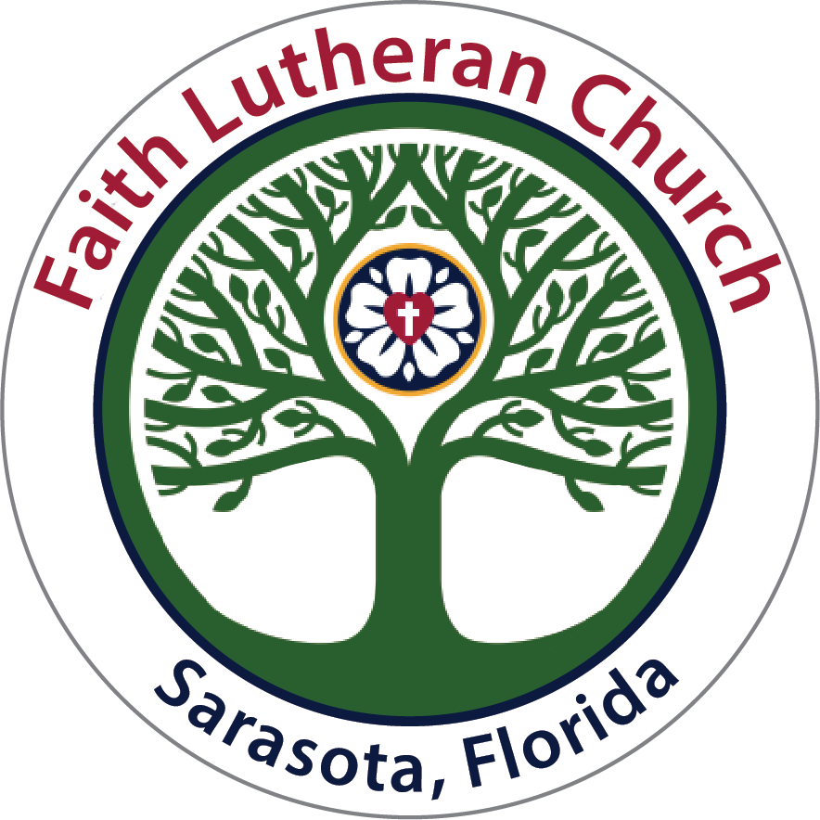 Faith Lutheran Church Council Meeting Minutes

Tuesday, May 27, 2025; 5:00PM in Person/Zoom

*Mission – "Gathered faithfully to love and serve God and all others."*

*Values – Mutual Respect, Honesty, Kindness, Service, Forgiveness, Commitment, Perseverance, Faithfulness, Compassion, Flexibility*

In Attendance: Pastor Eric Olsen, Ann Greenwood-President, Joan Searles-Vice President, Lauren Wardach-Secretary, Jane Sanks-Asst. Treasurer, Peggy Ragan, Jerry Cooper, Scott Rice and Julianne Geyser. Excused: Anita Wooton - Treasurer, Mark Nelson and Quyen Dang

* **Call to Order:** Ann Greenwood opened the meeting at 5:02 PM.
* A Quorum of members was established.
* **Opening Prayer and Prayer Concerns:**  Pastor Eric opened the meeting with a meditation reading highlighting various Psalms.
* **March 22, 2025, Council Minutes: Action:** A motion was made by Jane Sanks to accept the minutes from the Council Meeting in April. Joan seconded the motion. There was no discussion. All were in favor of approving the minutes.
* A consent agenda was motioned by Ann and seconded by Peggy to accept the minutes as written by the following committees.
* **Committee Reports**:
  + Mission Endowment Committee – Distributed
  + Evangelism & Outreach Committee – No Report
  + Hospitality Committee - No Report
  + Stewardship Committee - No Report
  + Worship & Music Committee – Distributed
  + Property Committee – Distributed

Discussion: No Discussion. The vote showed all in favor.

* **Finance Report:** Jane Sanks presented the Finance report. April was steady and much as expected. Jane highlighted a meeting between Anita W., Julianne G., and herself about Quick Books and what the software can do for us. Jen will incorporate the suggestions from Julianne G.
  + - Action: A motion was made by Pastor Eric to introduce a savings plan for employees as was presented by our Finance Committee to our Executive Council. It would be offered to our Music Director and Office Administrator/Executive Assistant. The plan would be an IRA and be held by Edward Jones Investments. Should employees opt for the maximum match of 3%, the cost potential to the church at this time would be $4050.00. The minimum percentage of 3% is an IRS mandate. Ann G. seconded the motion.
      * Discussion: The discussion raised a concern that this was a non-budgeted program; however, in keeping with today’s expenses for employees we want to offer a competitive compensation to our much-appreciated staff. This led to an amended motion.
      * An amended motion was made by Scott R. As a show of faith and appreciation the new motion is to not only offer this IRA option, but also to include a nominal monetary incentive as an initial deposit into the IRA if the employee opted to open and continue contributions into such account. Pastor Eric seconded the motion. A vote was called and all were in favor.
    - Action: A presentation was made by Jane S. that our on-line donation company, Vanco, requires us to have an “owner.” Owner is merely a term used by this company. In the past this was an employee who is no longer with us. Our Finance committee suggests our Assistant Treasurer, Jane Sanks take on this role. This was brought to our Executive Council who gave unanimous approval. It is now being brought to our Church Council for approval. Peggy R. made a motion to name Jane Sanks, Assistant Treasurer, as our “owner” representative for the Vanco Company. Ann G. seconded the motion. Discussion was had. A vote was called and all were in favor.
* **Church Directory:** Paper copies of our directory have been requested. Lauren will offer help with Directory choices on Sunday, June 1 at a table set up in the Narthex. All members must make their personal preferences clear on the website by checking various boxes which many people haven’t done yet. Soon we will attempt to print color copies on the printer in the conference room.

**Pastor’s Report:**

* + **Executive Assistant**: Carrie Christenson began Monday, April 28th. We welcome Carrie.
  + **Vision Group:** The group continues to meet and discern God’s will for our congregation. There is strong support for this ministry.
  + **♪ Music News**: Pastor Eric is working together with Andi on a Summer Music Academy for Youth. Andi is in conversation with the Sarasota Conservatory.
  + **Honor our Neighbor’s Faith**: A new study offered on Wednesdays at 9:30 AM by Pastor Eric is going well.
  + **Website**: Carrie may be able to update our website going forward.
  + **Lighting**: The lighting in the Sanctuary is poor. Spotlights are needed. The property committee is working on this.
  + **Live Streaming**: This has presented some issues. Andi is working on the technicalities.
  + **Worship Service at 5 PM**: This service appears to be growing and well received. Attendance has increased.
  + **Chaplin of the Fire Department**: Pastor Eric has been called upon for ministry. He will be attending a training class next week.
* **Bread for the World:** Pastor Eric will be attending a conference in Washington DC. Pastor Larry will fill in for Pastor Eric while he’s away. Pastor Eric will be in Washinton from June 8 – 11th.
  + **Synod Assembly in Orlando:** Pastor Eric will attend and participate. Pastor will be there from June 12 – 14th, 2025.

Pastor Eric requested to go into Executive Session. Ann motioned to do so. Peggy R. seconded the motion. Pastor Eric then motioned to leave Executive Session and Ann seconded.

* + **Humor Ministry:** Al Ernst will be restarting the comedy ministry. By August he hopes to have the second-floor studio up and running. The comedy ministry would like to offer a fund raiser for the Food Pantry. The plan is to have a “Breakfast for Dinner” at the Toasted Yolk restaurant. Tickets would cost $65 pp. They are looking for a donation to match the funds raised by selling tickets. They will offer new material and would like to sell 50 tickets. The event is planned for Saturday, September 6th.
  + **Sunday, September 7th, God’s Work, Our Hands** This day is an opportunity to celebrate who we are as the Evangelical Lutheran Church in America — one church, freed in Christ to serve and love our neighbor.

We closed with The Lord’s Prayer.

The meeting ended at 6:40 PM.

Respectfully submitted,

Lauren Wardach Church Council Secretary