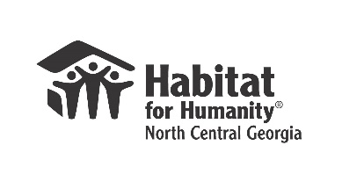
TO PARTICIPATE IN OUR PROGRAM, YOU MUST ATTEND AN INFORMATIONAL MEETING where we explain our program, answer your questions & distribute applications. An Informational Meeting is scheduled for Saturday, January 20, 2018 at 10:30 AM at Central Park Recreation Center – Meeting Room (2300 Keith Bridge Road – Cumming, GA) THIS MEETING IS ONLY FOR THOSE WHO WISH TO LIVE IN FORSYTH COUNTY.

The doors to the meeting room will close at 10:30 a.m. sharp, so arrive early to ensure you get a seat. Those arriving late will not be admitted. You must attend the entire meeting, which will last approximately 1-1/2 hour. A photo i.d. must be presented in order to receive an application.
WE WILL BUILD HOMES IN FORSYTH COUNTY (Gainesville/Cumming) AND IN CHEROKEE COUNTY (Acworth/Canton/Woodstock) in 2018 and 2019. NO HOMES WILL BE CONSTRUCTED IN NORTH FULTON COUNTY IN 2018 OR 2019. You may visit www.habitat-ncg.org for details about future meeting dates/locations for Cherokee County.
Questions? Send an email to mlamond@habitat-ncg.org

To be eligible to PURCHASE an Affordable Home, you:
- Must be a permanent legal resident of the United States.
- Must demonstrate a need for housing (rent is high, housing is not safe or unhealthy, overcrowded, etc.)
- Must have the ability to pay affordable monthly mortgage payments (typical payments are approximately $650 per month), show good credit history, and provide proof of income at the level required in the table below for the last 2 years.
- Must have lived or worked in the Atlanta metro area for at least one year.
- Must be willing to work (if you are physically able) on your and other Habitat homes, make a minimal down payment of $1,250 paid over several months and attend education classes about owning a home
- Must meet the following income guidelines: Effective March 28, 2017

Income Guidelines
Family Members | Lower Income Limit | Upper Income Limit
1 | $14,650 | $29,280
2 | $16,750 | $33,480
3 | $20,420 | $37,680
4 | $24,600 | $41,820
5 | $28,780 | $45,180
6 | $32,960 | $48,540
7 | $37,140 | $51,900
8 | $41,320 | $55,260
Source U. S. Department of Housing and Urban Development [HUD] www.huduser.gov
*Income of all persons living in the household

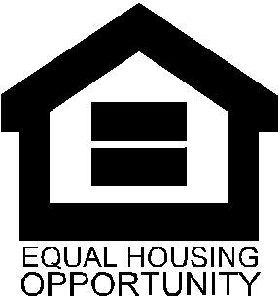 | Habitat for Humanity-North Central Georgia is pledged to the letter and spirit of U.S. policy for the achievement of equal housing opportunity. We encourage and support an affirmative advertising and marketing program in which there are no barriers to obtaining housing because of race, color, religion, sex, handicap, familial status, or national origin. The federal Equal Credit Opportunity Act prohibits creditors from discriminating against credit applicants on the basis of race, color, religion, national origin, sex, marital status, age, or because all or part of the applicant’s income derives from any public assistance program or the applicant has in good faith exercised any right under the Consumer Credit Protection Act. The federal agency that administers compliance with this law is the Federal Trade Commission, Washington, DC 20580.

