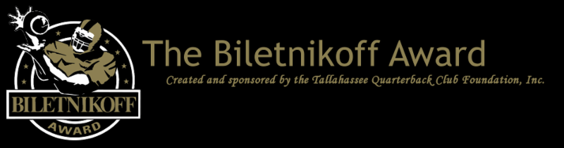

The Biletnikoff Award's 2020 Finalists Are Announced Today While the Biletnikoff Award National Selection Committee's Voting Commences December 22 and Ends December 31 to Determine the Winner of the Biletnikoff Award, Which Recognizes the College Football Season's Outstanding FBS Receiver Regardless of Position.

  For Immediate Release: December 22, 2020
  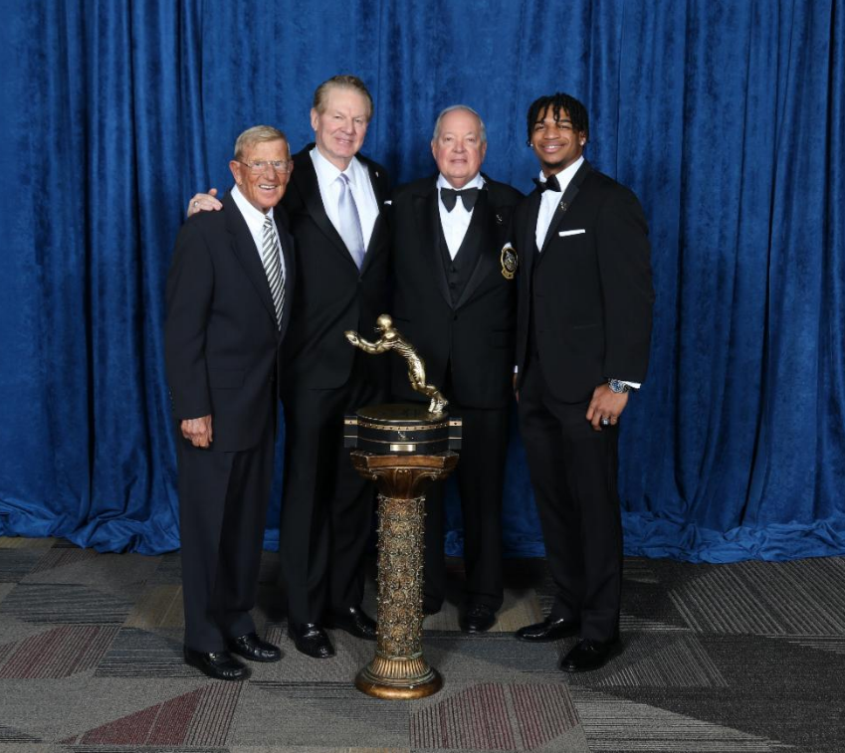
  Hall of Famer and 2020 Biletnikoff Award Banquet keynote speaker Lou Holtz, Founding Trustee & Past Chairman of the Biletnikoff Award Walter Manley II, 2019-20 Chairman of the Biletnikoff Award Steve Dobson III, and 2019 Biletnikoff Award Winner Ja'Marr Chase
  Tallahassee, FL - The Tallahassee Quarterback Club (TQC) Foundation, Inc., the Florida-based creator and sponsor of the prestigious Biletnikoff Award, announces the finalists for the 2020 Biletnikoff Award. The secure and confidential electronic voting by the distinguished members of the Biletnikoff Award National Selection Committee was conducted from December 8th through December 20th, and certified by a prominent CPA firm.
  The Biletnikoff Award annually recognizes the college football season's outstanding FBS receiver. Any player, regardless of position (wide receiver, tight end, slot back, and running back) who catches a pass is eligible for the award. As such, the Biletnikoff Award recognizes college football's outstanding receiver, not merely college football's outstanding wide receiver.
  The semifinalists, finalists, and award recipient are selected by the highly distinguished Biletnikoff Award National Selection Committee, a group of prominent college football journalists, commentators, announcers, Biletnikoff Award winners, and other former receivers. Foundation trustees do not vote and have never voted. For a list of voters, please see BiletnikoffAward.com/voters.
  The Biletnikoff Award candidate eligibility and voting criteria, transparently explicit and detailed, are available for review at BiletnikoffAward.com/criteria.
  Recently, the Tallahassee Quarterback Club Foundation opened the 2020 FanVote. Every fan may vote once daily on the Biletnikoff Award FanVote page. The aggregate fan tally will be counted as one official vote to determine semifinalists, finalists (three receivers), and the winner. In the closest contest in years, the FanVote tally provided the one-vote margin of victory for 2013 winner Brandin Cooks of Oregon State.
  The 2020 Biletnikoff Award finalists are as follows (in alphabetical order):
  Player | Position | School
  Elijah Moore | WR | Ole Miss
  Kyle Pitts | TE | Florida
  DeVonta Smith | WR | Alabama
  Ole Miss wide receiver Elijah Moore had 86 receptions in eight games for 8 touchdowns and averaged 149 yards in receptions per game, which led all FBS players. His 1,193 yards receiving rank second among FBS players.
  Florida tight end Kyle Pitts had 43 receptions in eight games for 770 yards, averaging 17.9 yards per catch and 96 yards receiving per game. His 12 receiving touchdowns rank fourth among FBS players.
  Alabama wide receiver DeVonta Smith caught 98 passes for an FBS-leading 1,511 yards and averaged 15.4 yards per reception. His 17 touchdown passes caught and 137 yards per game in receptions both rank second among FBS players.
  Twelve times in the Biletnikoff Award's history of 27 years, two of the 3 finalists have played in the same conference. This year, as in 2008, when finalists and AP first team All-America receivers Michael Crabtree and Dez Bryant, and All-America Jeremy Maclin played in the same conference --the Big 12-- the three finalists also played in the same conference, the SEC.
  Noteworthy is the strength of schedule of the 2020 finalists' teams as ranked by Sagarin: Alabama at 6, Ole Miss at 12, and Florida at 15. ESPN's ranking of strength of schedule has Florida at 7, Alabama at 15, and Ole Miss at 20. Moreover, according to ESPN, SEC teams played the ten most difficult schedules in college football this year, while Sagarin ranks 13 SEC teams' schedules among the 15 most difficult in 2020.
  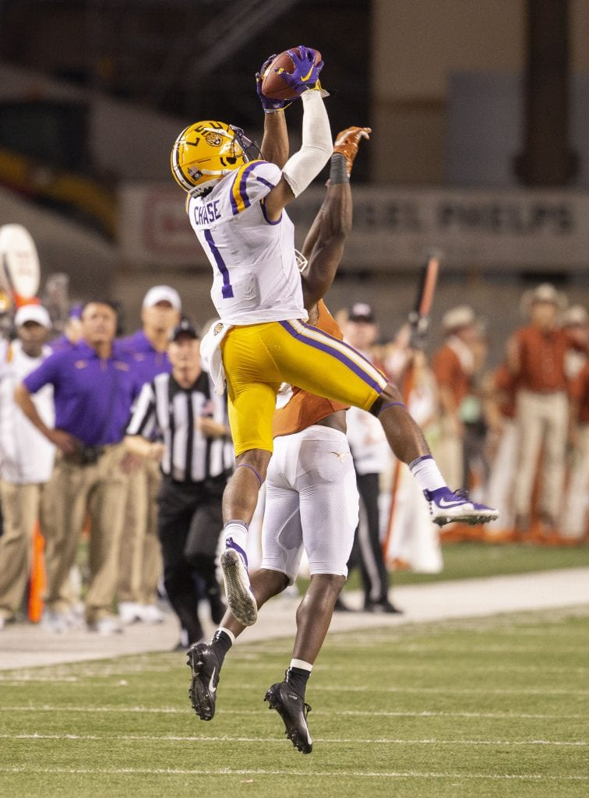
  2019 Biletnikoff Award winner Ja'Marr Chase
  The correlation between Biletnikoff Award winners and stardom in the National Football League is nearly uniformly consistent. Past Biletnikoff Award winners include Calvin Johnson, Randy Moss, Michael Crabtree, Amari Cooper, the late Terry Glenn, and Larry Fitzgerald.
  The 2020 Biletnikoff Award winner will be presented the Biletnikoff Award trophy by TQC Foundation Chairman George Avant, Jr., keynoter and college hall of famer Chad Hennings, and college and pro football hall of famer Fred Biletnikoff the Biletnikoff Award celebration/presentation at the University Center Club at Doak Campbell Stadium in Tallahassee on Saturday, March 6, 2021. The banquet was hailed by 2014 keynote speaker Dick Vermeil, as well as by 2013 keynoter Larry Csonka, as "the best banquet in college sports."
  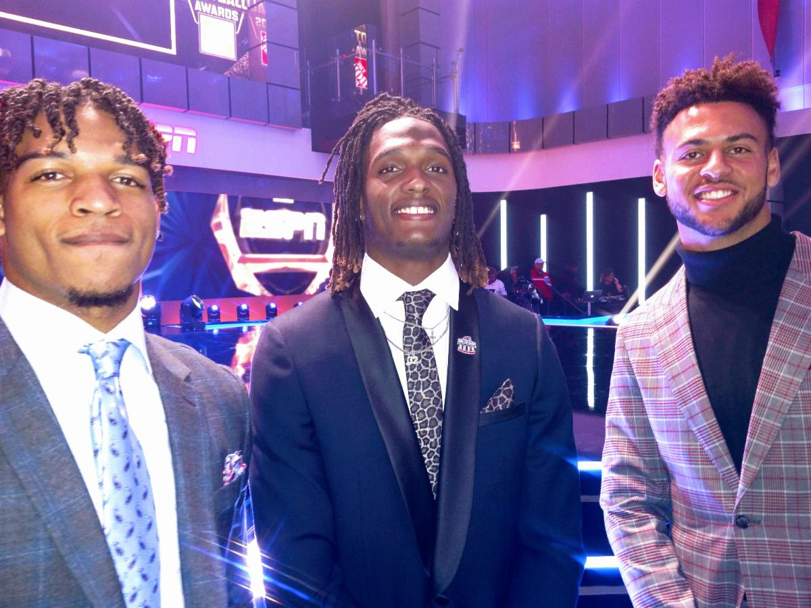
  2019 Biletnikoff Award finalists: Ja'Marr Chase, CeeDee Lamb, and Michael Pittman, Jr.
  The banquet has featured distinguished keynoters of profound character and accomplishments including the late Bart Starr, Dick Vermeil, Floyd Little, Larry Csonka, Steve Largent, Mike Ditka, the late Don Shula, Dan Reeves, Archie Manning, Ron Jaworski, Gene Stallings, Bob Griese, Bill Curry, Bobby Bowden, Jim Kelly, Jerry Kramer, Joe Theismann, Dan Fouts, Lou Holtz, and Aaron Taylor.
  The TQC Foundation's charitable mission is the provision of college and vocational scholarships to North Florida high school seniors who have overcome significant barriers to achieve at the highest academic and extracurricular levels. Participation in sports is not a requirement. The Foundation has provided many millions of dollars for several hundreds of scholarships and related benefits through 2020.
  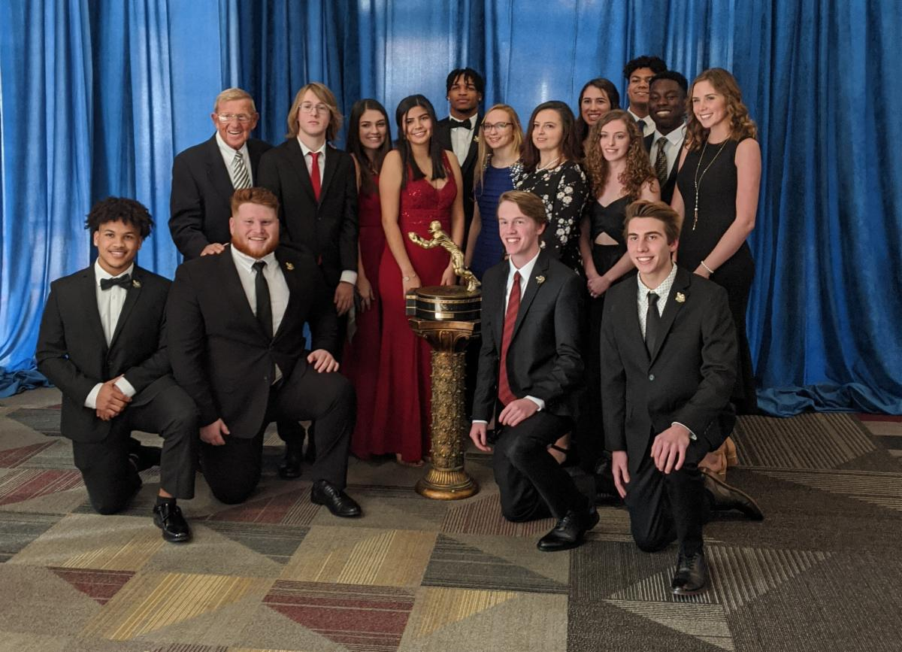
  2020 Scholarship Recipients
  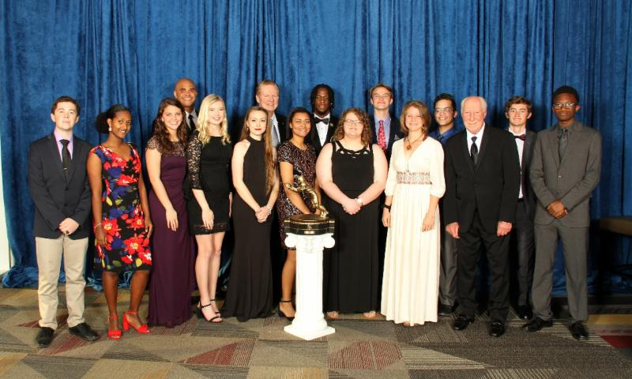
  2019 Scholarship Recipients
  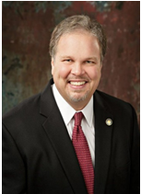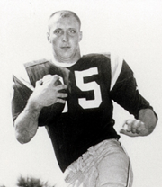
  Florida State's Fred Biletnikoff | Foundation Chairman George Avant, Jr.
  The name Biletnikoff is synonymous with the term
  receiver. Fred Biletnikoff, a member of the pro and college football halls of fame, was a consensus All-America receiver at Florida State University, and an All-Pro receiver for the Oakland Raiders. He caught 589 passes for 8,974 yards and 76 touchdowns in his 14-year Raiders career from 1965 through 1978. Fred was the Most Valuable Player of Super Bowl XI.
  The Biletnikoff Award
  
  The Biletnikoff Award is presented annually to the season's outstanding college football receiver regardless of position (the award defines receiver as any player who catches a pass; hence, tight ends, slot receivers and backs, inside receivers, wide receivers, split ends, and running backs are eligible)
  (BiletnikoffAward.com/about_award)
  The TQC Foundation, Inc., is an independent, charitable organization that was founded in 1994. Past Chairman & Founding Trustee Professor Walter W. Manley II, Founding Trustee L. Thomas Cox, Jr., Founding Trustee Rocky Bevis, and Founding Trustee Bob Teel established the award and the TQC Foundation, Inc., that sponsors it. Many more trustees have contributed to its development as one of the most prominent awards in college football. The TQC Foundation, Inc., joined the idea of a college receiver's award to the organization's vision and created the outstanding award and dynamic organization.
  The trophy, presented to each winner, is the most beautiful in college football - it has won several national, juried competitions for design excellence and aesthetic appeal.
  Likewise, the website and printed banquet program have been cited nationally for excellence in design.
  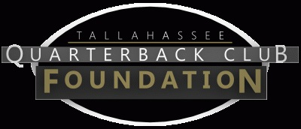
  The Tallahassee Quarterback Club Foundation, Inc., a 501(c)(3) organization, is the creator and sponsor of the Biletnikoff Award. The Foundation administers the Biletnikoff Award, its charitable activities, and the distinguished Biletnikoff Award National Selection Committee. Foundation Trustees are prohibited from serving on the National Selection Committee. For a full recounting of the Foundation's activities, please consult BiletnikoffAward.com.
  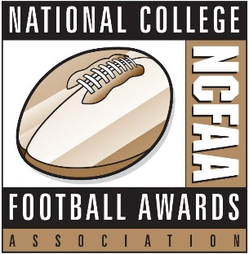
  National College Football Awards Association
  The Biletnikoff Award is a member of the National College Football Awards Association (NCFAA), which encompasses the most prestigious awards in college football. Founded in 1997, the NCFAA and its 25 awards now boast over 800 recipients, dating to 1935. Visit ncfaa.org and @NCFAA on Twitter to learn more about the association.
  Important Dates
  July 16, 2020:
  Preseason Watch List announcement
  September 30, 2020:
  FanVote opens
  November 30 - December 6, 2020:
  Vote by the Biletnikoff Award National Selection Committee to determine Semifinalists
  December 7, 2020:
  Semifinalists announcement
  December 8 - 20, 2020:
  Vote to determine 3 Finalists
  December 22, 2020:
  3 Finalists announcement
  December 22 - January 1, 2020:
  Final vote to determine Biletnikoff Award Winner
  January 7, 2021:
  Biletnikoff Award Winner announced on The Home Depot College Football Awards presented by Gildan
  The Home Depot College Football Awards airs live on ESPN January 7, 2021, 7 - 8:30 PM (EST)
  The Biletnikoff Award Celebration & Presentation
  honors the 2020 Biletnikoff Award Winner on Saturday, March 6, 2021
  University Center Club at
  Doak Cambell Stadium, Tallahassee, Florida
  Inquiries:
  Chairman of Selection:
  Professor Walter W. Manley II
  Founding Trustee & Past Chairman of the Tallahassee Quarterback Club Foundation, Inc.
  Creator and Sponsor of the Biletnikoff Award
  BiletnikoffAward.com/Manley
  Cell 850-766-0800
  prof.wwmii@comcast.net
  TQCF Chairman:
  George Avant, Jr.
  Cell 850-566-7135
  gavantjr@gmail.com
  Website and Publicity Contact:
  Will Stewart
  biletnikoffaward@biletnikoffaward.com
  Website
  www.biletnikoffaward.com
  FanVote
  www.biletnikoffaward.com/fan-vote
  Important Links
  About Scholarships
  Scholarship Application
  Candidate Eligibility, Watch List Inclusion & Voting Criteria
  National Selection Committee
  Past Winners in Action
  Banquet Keynote Speakers
  For more useful links see
  BiletnikoffAward.com


  Biletnikoff Award, PO Box 10762, Tallahassee, FL 32302
  SafeUnsubscribe™ {recipient's email}
  Forward email | Update Profile | About our service provider
  Sent by biletnikoffaward@biletnikoffaward.com powered by
  
  Try email marketing for free today!

