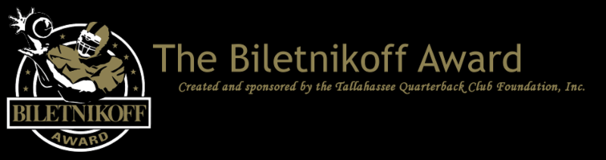
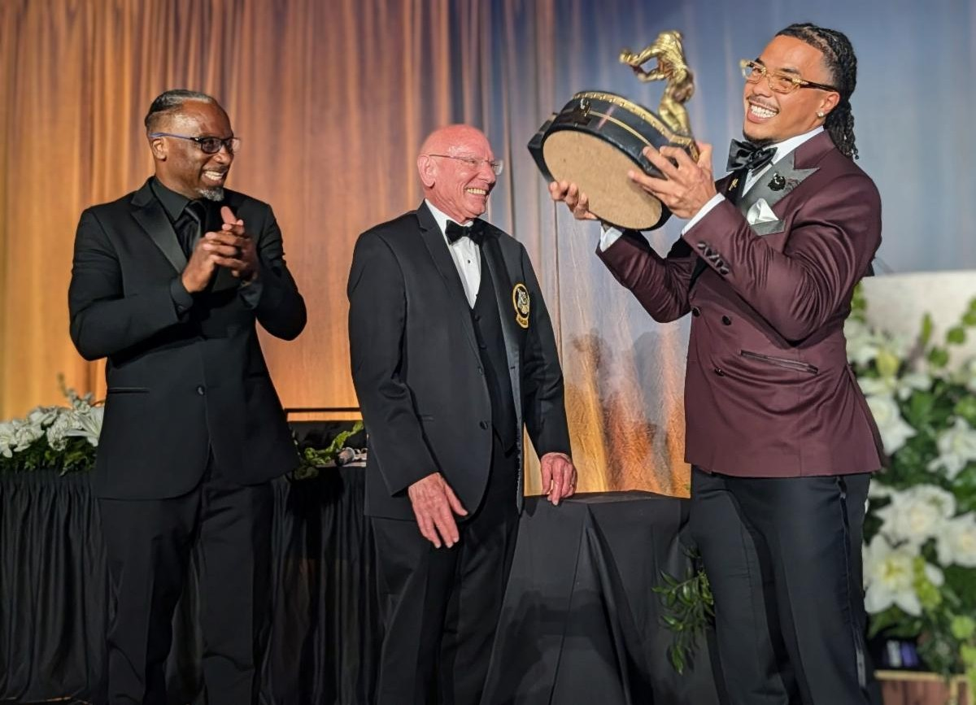

The Tallahassee Quarterback Club Foundation Adds a Tight End and Three Wide Receivers to the Watch List of the Biletnikoff Award, Presented to the College Football Season's Outstanding FBS Receiver at any Position.
For Immediate Release: October 14, 2026

Foundation Chairman John Harris Jr., assisted by Rocket Ismail, keynote speaker, presented the beautiful Biletnikoff Award trophy to All-America Makai Lemon at the 32nd Biletnikoff Award Banquet with 700 patrons in attendance on
Saturday March 28, 2026.

Tallahassee, FL - The Tallahassee Quarterback Club (TQC) Foundation, Inc., the Florida- based creator and sponsor of the prestigious Biletnikoff Award, released the 2026 Biletnikoff Award Preseason Watch List on August 19. Today, October 14, the Foundation announces the second in-season addition of receivers, 4 at this time, to the Biletnikoff Award Watch List. See 2026 Biletnikoff Award Watch List.

The Biletnikoff Award annually recognizes the college football season's outstanding FBS receiver. Any player, regardless of position (wide receiver, tight end, slot back, and running back) who catches a pass is eligible for the award. As such, the Biletnikoff Award recognizes college football's outstanding receiver, not merely college football's outstanding wide receiver. Tight end Kyle Pitts was a finalist in 2020 and other tight ends were semifinalists in prior and subsequent years. Moreover, the Biletnikoff Award is a single season, not career, award.

The Biletnikoff Award's semifinalists, three finalists, and award recipient are selected by the highly distinguished Biletnikoff Award National Selection Committee, a group of 625 prominent college football journalists, commentators, announcers, Biletnikoff Award winners, and other former receivers. Foundation trustees do not vote and have never voted. For a list of voters, please see BiletnikoffAward.com/voters.

Receivers are frequently added to the watch list as their season performances dictate. Actual, not potential, performance is the basis for inclusion on the Biletnikoff Award Watch List.

The Biletnikoff Award candidate eligibility and voting criteria, transparently explicit and detailed, are available for review at BiletnikoffAward.com/criteria.

The Tallahassee Quarterback Club Foundation announces the second in- season addition to the 2026 season watch list.
(Other receivers will be added as their season performances dictate) (See below)
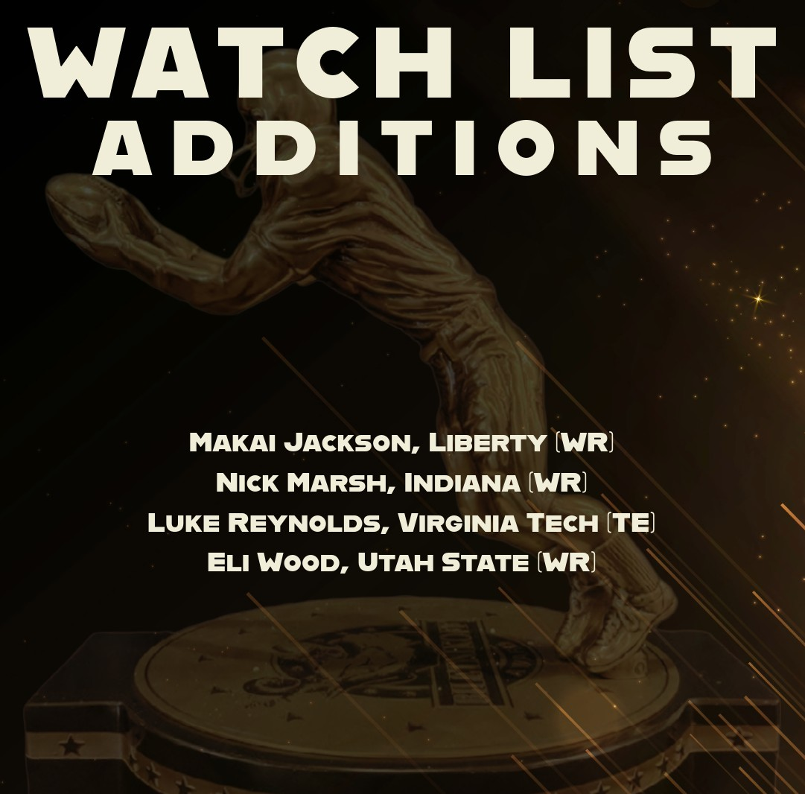




2025 Biletnikoff Award winner Makai Lemon of USC

Makai Lemon was formerly introduced by Coach Lincoln Riley and presented the Biletnikoff Award trophy by TQC Foundation Chairman John Harris Jr., assisted by College Football Hall of Famer Raghib "Rocket" Ismail, keynote speaker, at the sold-out black-tie Biletnikoff Award Banquet & Celebration at the Donald L. Tucker Civic Center in Tallahassee on Saturday, March 28, 2026. Internationally acclaimed concert pianist Marvin Goldstein composed and played a tribute to the greatness of Makai Lemon and America. The banquet, always sold-out and attended by 700 patrons, was hailed by 2014 keynote speaker Dick Vermeil, as well as by 2013 keynoter Larry Csonka, as "the best banquet in college sports."

The banquet has featured distinguished keynoters of profound character and accomplishments including the late Bart Starr, Dick Vermeil, the late Floyd Little, Larry Csonka, Steve Largent, Mike Ditka, the late Don Shula, the late Dan Reeves, Archie Manning, Ron Jaworski, Gene Stallings, Bob Griese, Bill Curry, the late Bobby Bowden, Jim Kelly, Jerry Kramer, Joe Theismann, Dan Fouts, Chad Hennings, the late Lou Holtz, Aaron Taylor, Archie Griffin, Danny Wuerffel, Rocket Ismail, Drew Pearson, and Gino Torretta.

The correlation between Biletnikoff Award winners and stardom in the National Football League is nearly uniformly consistent. Past Biletnikoff Award winners include Calvin Johnson, Randy Moss, Michael Crabtree, Amari Cooper, Golden Tate, Brandin Cooks, the late Terry Glenn, Ja'Marr Chase, DeVonta Smith, and Larry Fitzgerald.

The 501(c)(3) TQC Foundation's charitable mission is the provision of college and vocational scholarships to North Florida high school seniors who have overcome significant challenges to achieve at the highest academic and extracurricular levels. Participation in sports is not a requirement, but does count as an extracurricular activity. The all-volunteer Foundation has provided over 360 scholarships with benefits of over 7 million dollars through 2026. TQC Founding Trustee & many-times chairman Walter Manley II, serving his 30th year as fundraising chairman, recently announced a goal of 10 million dollars in the aggregate to be awarded in scholarships by 2030.
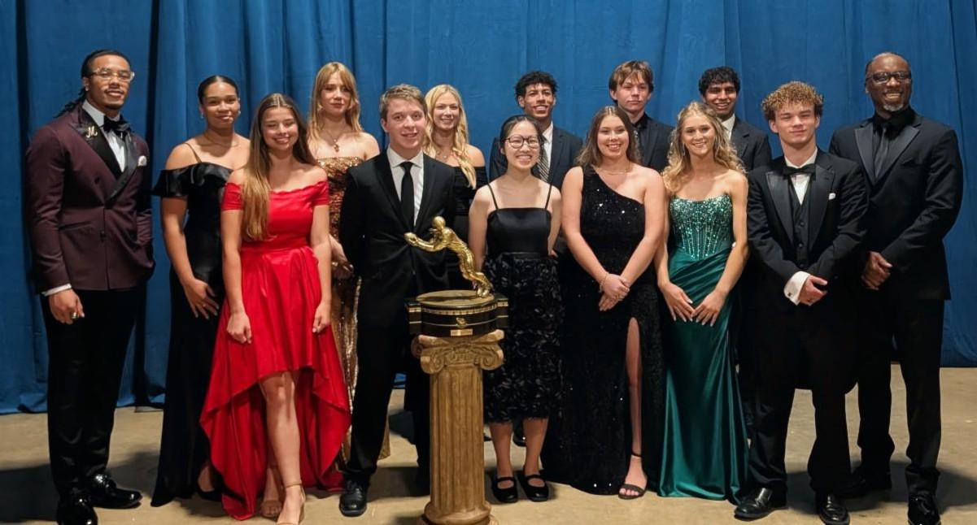

2026 Scholarship Recipients
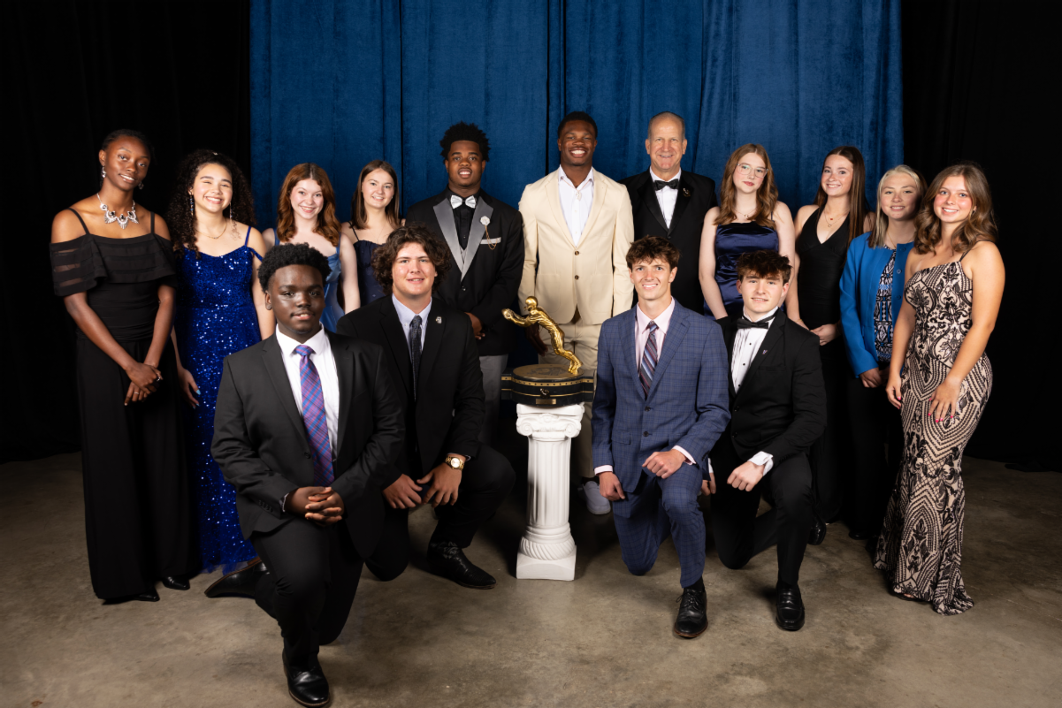

2025 Scholarship Recipients

The name Biletnikoff is synonymous with the term receiver. Fred Biletnikoff, a member of the pro and college football halls of fame, was a consensus 1st-team All-America receiver at Florida State University and an All-Pro receiver for the Oakland Raiders. He caught 589 passes for 8,974 yards and 76 touchdowns in his 14-year Raiders career from 1965 through 1978.

Fred was the Most Valuable Player of Super Bowl XI.
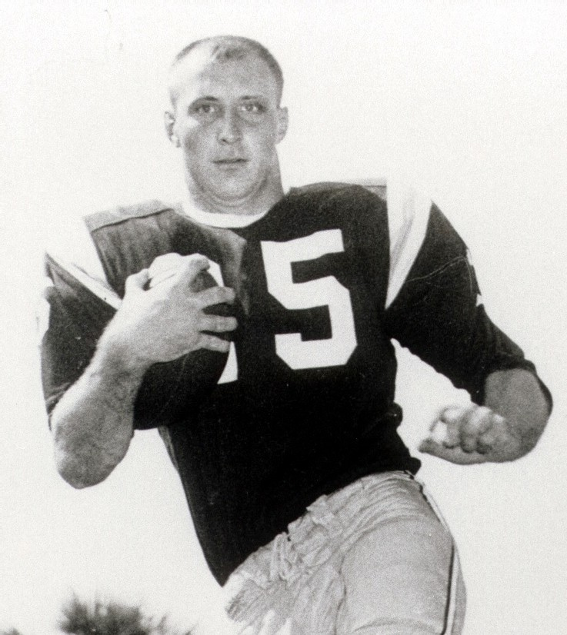

Fred Biletnikoff was Florida State's first consensus 1st-Team All-America
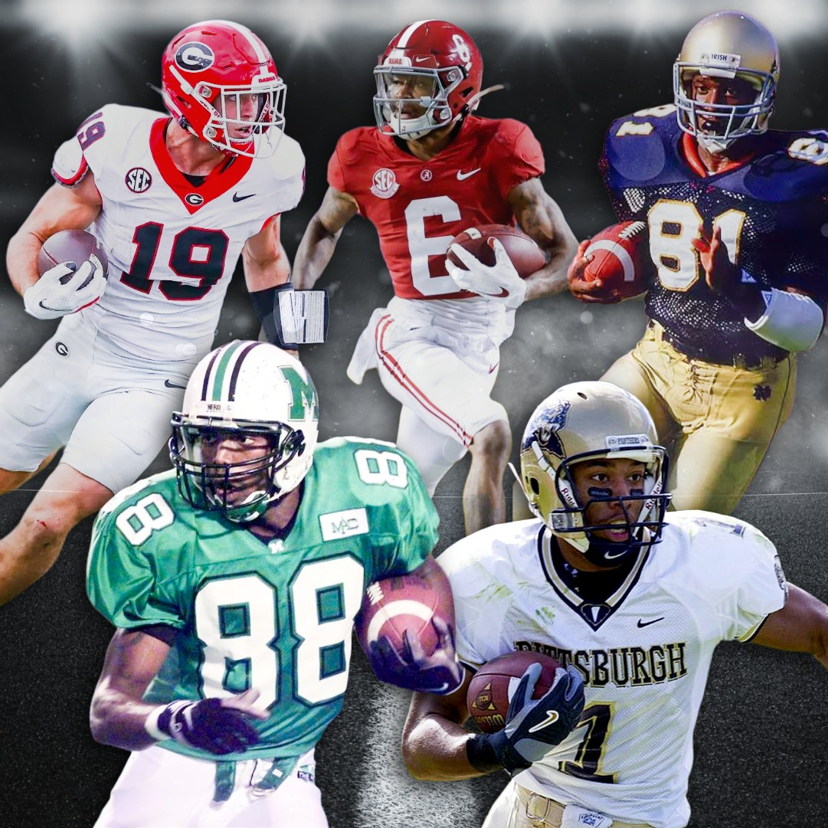

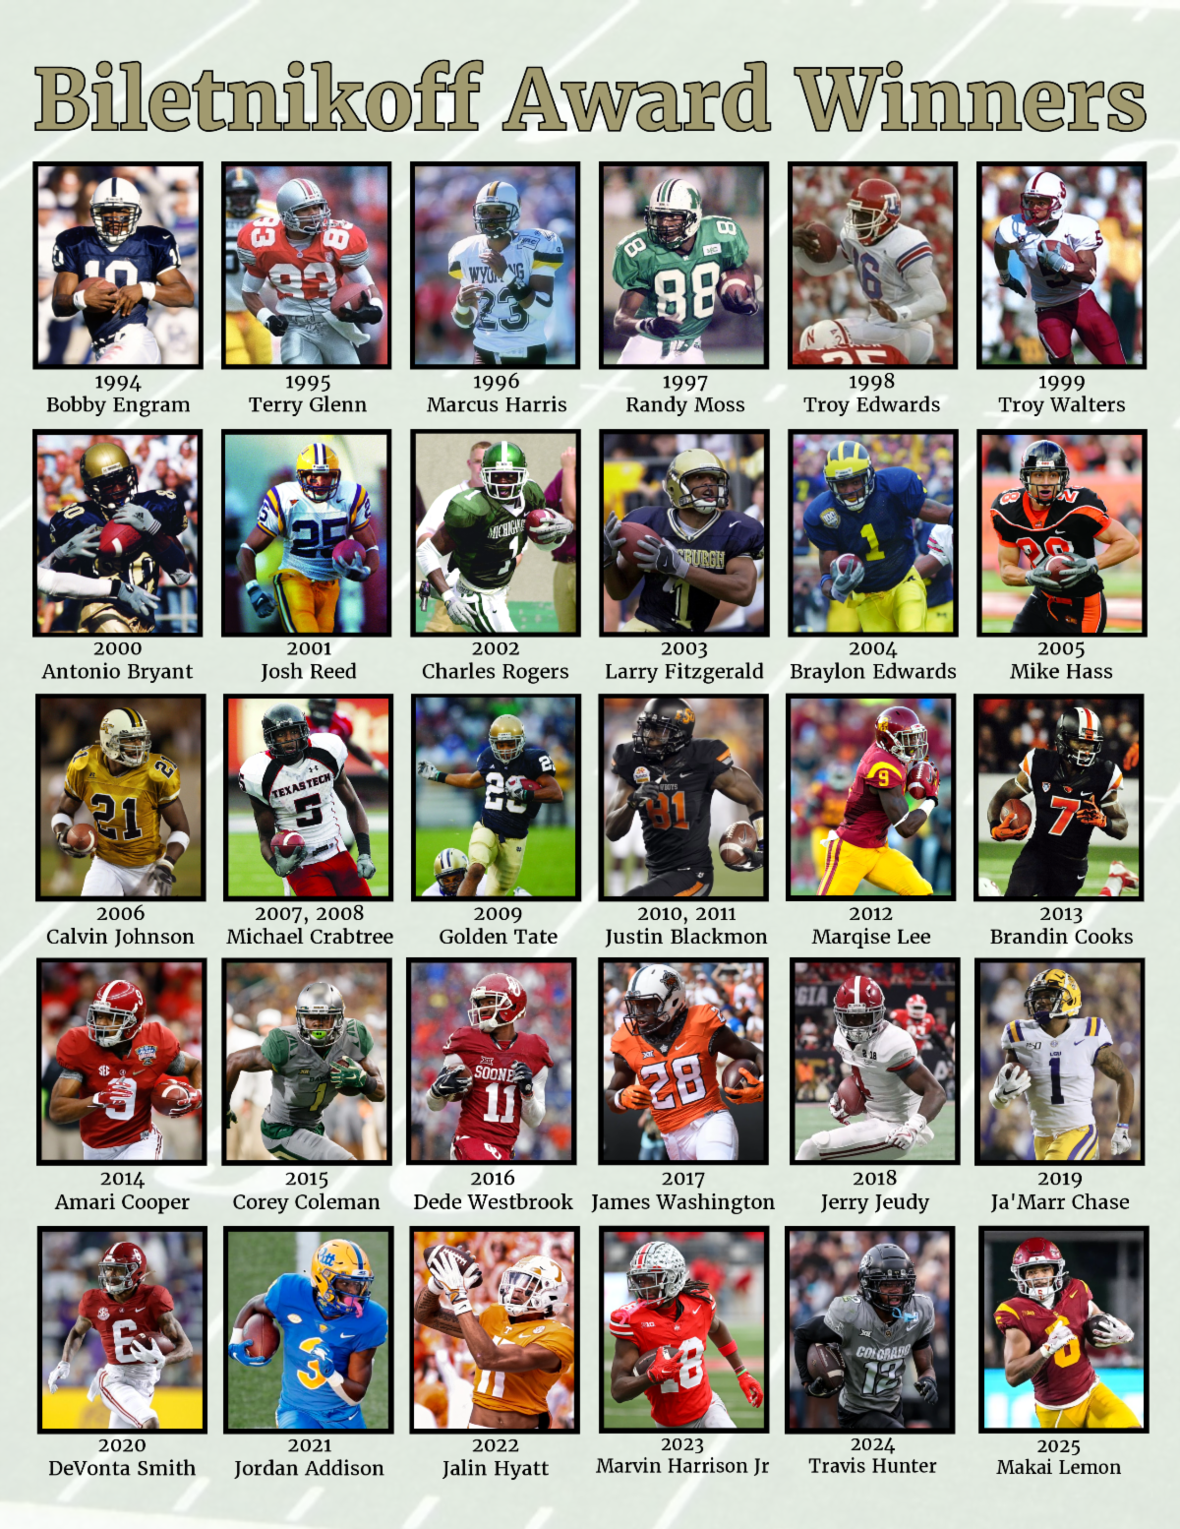
The AP All-Time All-America college football team features some of the most dominant Biletnikoff Award legends to ever play the game: First Team - Randy Moss (1997 winner), Larry Fitzgerald (2003 winner), and Brock Bowers (2022-23 semifinalist). Second Team - DeVonta Smith (2020 winner) and Tim Brown (BA voter). Congrats to these outstanding receivers!

The Biletnikoff Award



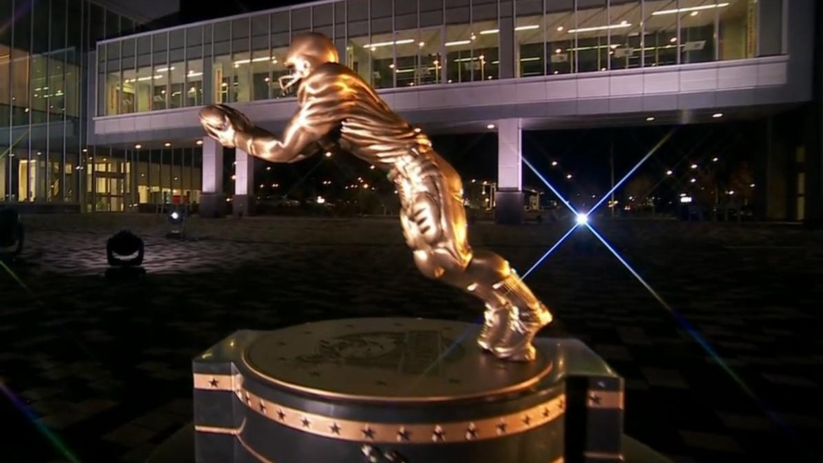
The Biletnikoff Award annually recognizes the college football season's outstanding FBS receiver. Any player, regardless of position (wide receiver, tight end, slot back, and running back) who catches a pass is eligible for the award. (BiletnikoffAward.com/about_award)

The TQC Foundation, Inc., is an independent, charitable organization designated with 501(c)(3) status that was founded in 1994. Many trustees have contributed to its development as one of the most prominent awards in college football. The TQC Foundation, Inc., joined the idea of a college receiver's award to the organization's vision and created the outstanding award and dynamic organization.

The trophy, presented to each winner, is the most beautiful in college football - it has won several national, juried competitions for design excellence and aesthetic brilliance.

Likewise, the website and printed banquet program have been cited nationally for excellence in design and content.

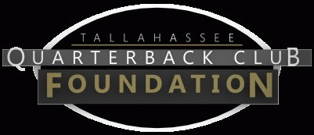

The Tallahassee Quarterback Club Foundation, Inc., a 501(c)(3) organization, is the creator and sponsor of the Biletnikoff Award. The Foundation administers the Biletnikoff Award, its charitable activities, and the distinguished Biletnikoff Award National Selection Committee. Foundation Trustees do not serve on the National Selection Committee. For a full recounting of the Foundation's activities, please consult BiletnikoffAward.com.
Important Dates

Aug. 19, 2026:
Preseason Watch List announcement

Sept. 23, 2026:
FanVote opens

Nov. 9 - 15, 2026:
Vote by the Biletnikoff Award National Selection Committee to determine Semifinalists

Nov. 16, 2026:
Semifinalists announcement

Nov. 16 - 22, 2026:
Vote to determine 3 Finalists

Nov. 24, 2026:
3 Finalists announcement

Nov. 24 - Dec. 5, 2026 :
Final vote to determine Biletnikoff Award Winner

Dec. 11, 2026:
Biletnikoff Award Winner announced on The Home Depot College Football Awards

The Biletnikoff Award Banquet & Celebration honors the 2026 Biletnikoff Award Winner on Saturday, March 20, 2027, at the basketball arena at Donald L. Tucker Civic Center in Tallahassee, Florida 32301

Inquiries:

Chairman of Selection: Professor Walter W. Manley II Foundation Founding Trustee & Past Chairman of the Tallahassee Quarterback Club Foundation, Inc.
Creator and Sponsor of the Biletnikoff Award BiletnikoffAward.com/Manley Cell 850-766-0800


prof.wwmii@comcast.net

Website and Publicity Contact: Will Stewart biletnikoffaward@biletnikoffaw ard.com

Trustees to contact regarding questions about scholarships and applications:
John Harris 850-524-6627
jjharrisjr@outlook.com Melissa Hancock
850-340-0194
melissalynn527@gmail.com

Important Links:

Biletnikoff Award Website
National College Football Awards Association
Scholarship Information

Scholarship Application
The Biletnikoff Award is a member of the National College
Football Awards Association (NCFAA), which encompasses Scholarship Donations
college football’s most prestigious awards. The NCFAA’s 25 awards have honored nearly 1,000 recipients since 1935. This season, 12 NCFAA awards will honor national players of the week each Tuesday.

For more information about the NCFAA and its award programs, visit NCFAA.org or follow on X at @NCFAA and Instagram @TheNCFAA.

Biletnikoff Award | PO Box 10762 | Tallahassee, FL 32302 US

Unsubscribe | Update Profile | Constant Contact Data Notice


