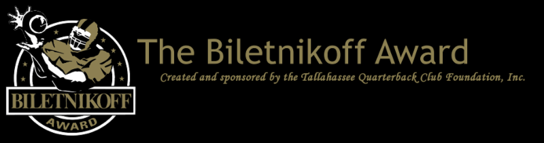

Announcement of 11 Semifinalists of the Biletnikoff Award, Which Recognizes the College Football Season's Outstanding FBS Receiver Regardless of Position.

﻿For Immediate Release: November 19, 2024

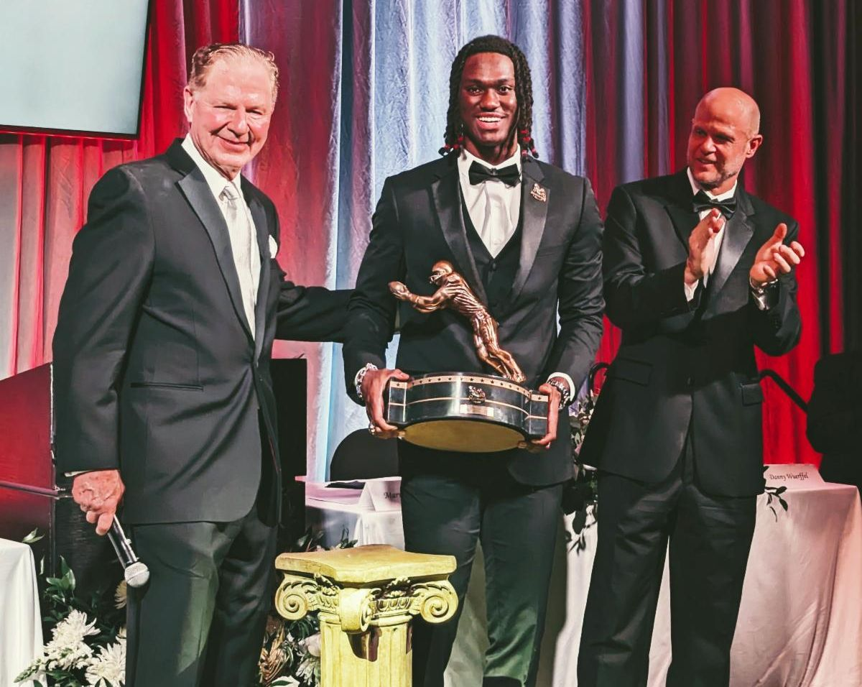

Foundation Chairman and Founding Trustee Walter Manley II presented the beautiful Biletnikoff Award trophy to unanimous 1st-team All America Marvin Harrison Jr. with the 1996 Heisman Trophy winner and national champion Danny Wuerffel, keynote speaker, at the 30th Biletnikoff Award Banquet on Saturday March 9, 2024.

Tallahassee, FL - The Tallahassee Quarterback Club (TQC) Foundation, Inc., the Florida-based creator and sponsor of the prestigious Biletnikoff Award, announces the semifinalists for the 2024 Biletnikoff Award. The secure and confidential electronic voting by the distinguished members of the Biletnikoff Award National Selection Committee was conducted from November 11th through November 17th, and certified by a prominent CPA firm.
﻿
The Biletnikoff Award annually recognizes the college football season's outstanding FBS receiver. Any player, regardless of position (wide receiver, tight end, slot back, and running back) who catches a pass is eligible for the award. As such, the Biletnikoff Award recognizes college football's outstanding receiver, not merely college football's outstanding wide receiver. Tight end Kyle Pitts was a finalist in 2020 and other tight ends were semifinalists in prior years. Moreover, the Biletnikoff Award is a single season, not career, award.

The semifinalists, finalists, and award recipient are selected by the highly distinguished Biletnikoff Award National Selection Committee, a group of 600 prominent college football journalists, commentators, announcers, Biletnikoff Award winners, and other former receivers. Foundation trustees do not vote and have never voted. For a list of voters, please see BiletnikoffAward.com/voters.

Receivers are frequently added to the watch list as their season performances dictate. Actual, not potential, performance is the basis for inclusion on the Biletnikoff Award Watch List.

The Biletnikoff Award candidate eligibility and voting criteria, transparently explicit and detailed, are available for review at BiletnikoffAward.com/criteria.

Recently, the Tallahassee Quarterback Club Foundation opened the 2024 FanVote. Every fan may vote once daily on the Biletnikoff Award FanVote page. The aggregate fan tally will be counted as one official vote to determine semi-finalists, finalists (three receivers), and the winner. In the closest contest in years, the FanVote tally provided the one-vote margin of victory for 2013 winner Brandin Cooks of Oregon State.

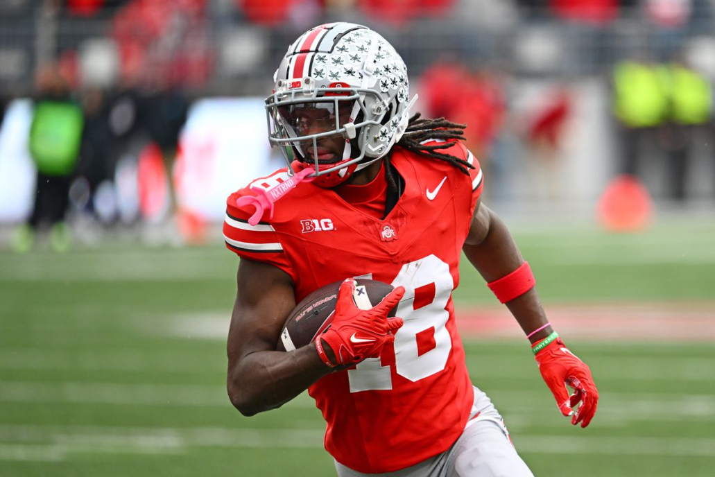

2023 Biletnikoff Award winner and unanimous 1st-team All-America
﻿Marvin Harrison Jr.

Marvin Harrison Jr. was formally introduced and presented the Biletnikoff Award trophy by TQC Foundation Founding Trustee and Chairman Walter Manley II, assisted by the 1996 Heisman Trophy winner and national champion Danny Wuerffel, keynote speaker, at the black-tie Biletnikoff Award Banquet & Celebration, at the Dunlap Champions Club, at Doak Campbell Stadium in Tallahassee on Saturday, March 9, 2024. The banquet, always sold-out and attended by 600 patrons, was hailed by 2014 keynote speaker Dick Vermeil, as well as by 2013 keynoter Larry Csonka, as "the best banquet in college sports."

The banquet has featured distinguished keynoters of profound character and accomplishments including the late Bart Starr, Dick Vermeil, the late Floyd Little, Larry Csonka, Steve Largent, Mike Ditka, the late Don Shula, the late Dan Reeves, Archie Manning, Ron Jaworski, Gene Stallings, Bob Griese, Bill Curry, the late Bobby Bowden, Jim Kelly, Jerry Kramer, Joe Theismann, Dan Fouts, Chad Hennings, Lou Holtz, Aaron Taylor, Archie Griffin, Danny Wuerffel, and Drew Pearson.

The correlation between Biletnikoff Award winners and stardom in the National Football League is nearly uniformly consistent. Past Biletnikoff Award winners include Calvin Johnson, Randy Moss, Michael Crabtree, Amari Cooper, Golden Tate, Brandin Cooks, the late Terry Glenn, Ja'Marr Chase, DeVonta Smith, and Larry Fitzgerald.

The 501(c)(3) TQC Foundation's charitable mission is the provision of college and vocational scholarships to North Florida high school seniors who have overcome significant challenges to achieve at the highest academic and extracurricular levels. Participation in sports is not a requirement, but does count as an extracurricular activity. The all-volunteer Foundation has provided over 300 scholarships with benefits of nearly six million dollars through 2024. TQC Foundation Chairman Manley, serving his 26th year as fundraising chairman, recently announced a goal of 10 million dollars to be awarded in scholarships by 2030.

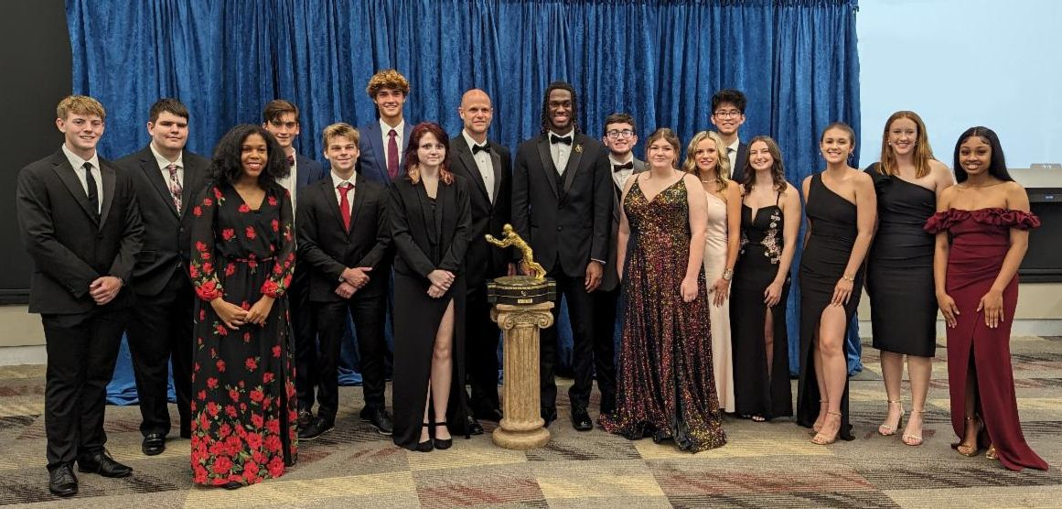

2024 Scholarship Recipients

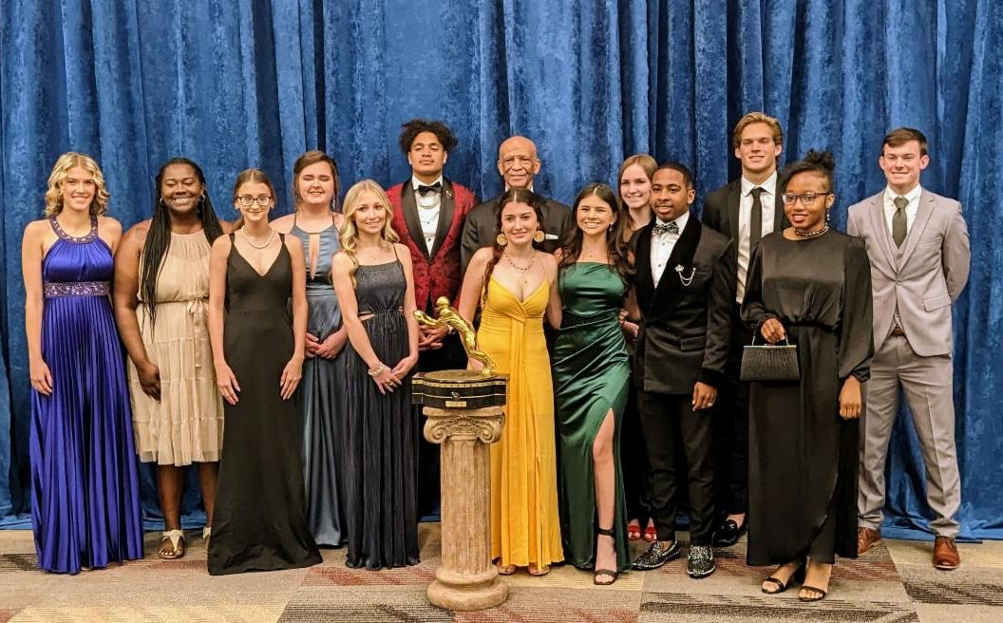

2023 Scholarship Recipients

The 2024 Biletnikoff Award semifinalists are as follows (in alphabetical order):
(See below)

Jack Bech (WR), TCU
Ja'Corey Brooks (WR), Louisville
Harold Fannin Jr. (TE), Bowling Green
Tai Felton (WR), Maryland
Tre Harris (WR), Ole Miss
Travis Hunter (WR), Colorado
Tetairoa McMillan (WR), Arizona
Nick Nash (WR), San Jose State
Xavier Restrepo (WR), Miami
Jeremiah Smith (WR), Ohio State
Ryan Williams (WR), Alabama
﻿

The name Biletnikoff is synonymous with the term receiver. Fred Biletnikoff, a member of the pro and college football halls of fame, was a consensus All-America receiver at Florida State University and an All-Pro receiver for the Oakland Raiders. He caught 589 passes for 8,974 yards and 76 touchdowns in his 14-year Raiders career from 1965 through 1978. Fred was the Most Valuable Player of Super Bowl XI.



Fred Biletnikoff was Florida State's first consensus 1st-Team All-America



  The Biletnikoff Award
  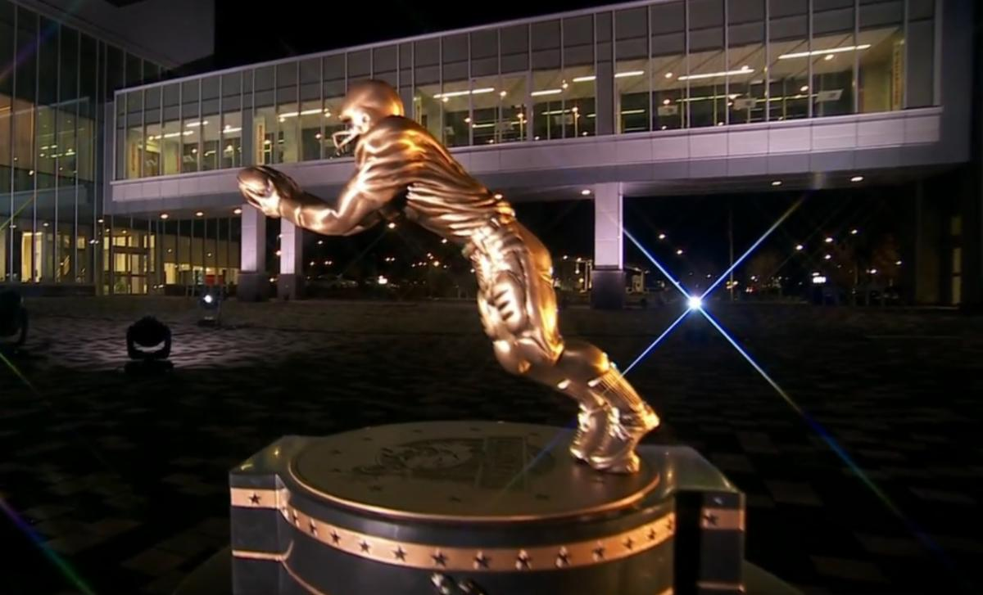
  The Biletnikoff Award annually recognizes the college football season's outstanding FBS receiver. Any player, regardless of position (wide receiver, tight end, slot or inside receiver, wingback, and running back) who catches a pass is eligible for the award.
  (BiletnikoffAward.com/about_award)
  The TQC Foundation, Inc., is an independent, charitable organization designated with 501(c)(3) status that was founded in 1994. Many trustees have contributed to its development as one of the most prominent awards in college football. The TQC Foundation, Inc., joined the idea of a college receiver's award to the organization's vision and created the outstanding award and dynamic organization.
  The trophy, presented to each winner, is the most beautiful in college football - it has won several national, juried competitions for design excellence and aesthetic brilliance.
  Likewise, the website and printed banquet program have been cited nationally for excellence in design.
  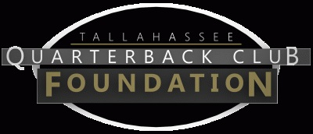
  The Tallahassee Quarterback Club Foundation, Inc., a 501(c)(3) organization, is the creator and sponsor of the Biletnikoff Award. The Foundation administers the Biletnikoff Award, its charitable activities, and the distinguished Biletnikoff Award National Selection Committee. Foundation Trustees are prohibited from serving on the National Selection Committee. For a full recounting of the Foundation's activities, please consult BiletnikoffAward.com.
  
  National College Football Awards Association
  The Biletnikoff Award is a member of the National College Football Awards Association. Founded in 1997, the NCFAA includes college football’s most prestigious awards and its 24 awards have honored more than 900 recipients dating back to 1935. For more information about the NCFAA and its award programs, visit the NCFAA.org or follow on X at @NCFAA.
  
  Important Dates
  August 7, 2024:
  Preseason Watch List announcement
  Sept. 25, 2024:
  FanVote opens
  Nov 11 - 17, 2024:
  Vote by the Biletnikoff Award National Selection Committee to determine Semifinalists
  Nov 19, 2024:
  Semifinalists announcement
  Nov 19 - 24, 2024:
  Vote to determine 3 Finalists
  Nov 26, 2024:
  3 Finalists announcement
  Nov 26 - Dec. 7, 2024:
  Final vote to determine Biletnikoff Award Winner
  Dec. 12, 2024:
  Biletnikoff Award Winner announced on The Home Depot College Football Awards
  The Home Depot College Football Awards airs live on ESPN Dec. 12, 2024, 7 - 8:30 PM (EST)
  The Biletnikoff Award Banquet & Celebration
  honors the 2024 Biletnikoff Award Winner on Saturday, March 29, 2025, at the basketball arena at Donald L. Tucker Civic Center in Tallahassee, Florida 32301
  Inquiries:
  Chairman of Selection:
  Professor Walter W. Manley II
  Foundation Founding Trustee & Past Chairman of the Tallahassee Quarterback Club Foundation, Inc.
  Creator and Sponsor of the Biletnikoff Award
  BiletnikoffAward.com/Manley
  Cell 850-766-0800
  prof.wwmii@comcast.net
  Website and Publicity Contact:
  Will Stewart
  biletnikoffaward@biletnikoffaward.com
  Trustees to contact regarding questions about scholarships and applications:
  John Harris
  850-524-6627
  John.Harris@gray-robinson.com
  Melissa Hancock
  850-340-0194 melissalynn527@gmail.com
  Important Links:
  Biletnikoff Award Website
  Scholarship Information
  Scholarship Application
  Scholarship Donations

Biletnikoff Award | PO Box 10672 | Tallahassee, FL 32302 US

Unsubscribe | Update Profile | Constant Contact Data Notice



