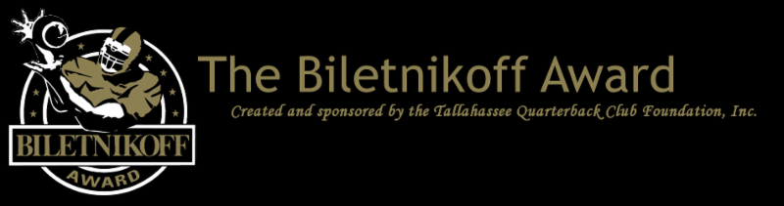

Makai Lemon of the University of Southern California Wins the Prestigious 2025 Biletnikoff Award Which Recognizes the College Football Season’s Outstanding FBS Receiver at Any Position

﻿For Immediate Release: December 12, 2025

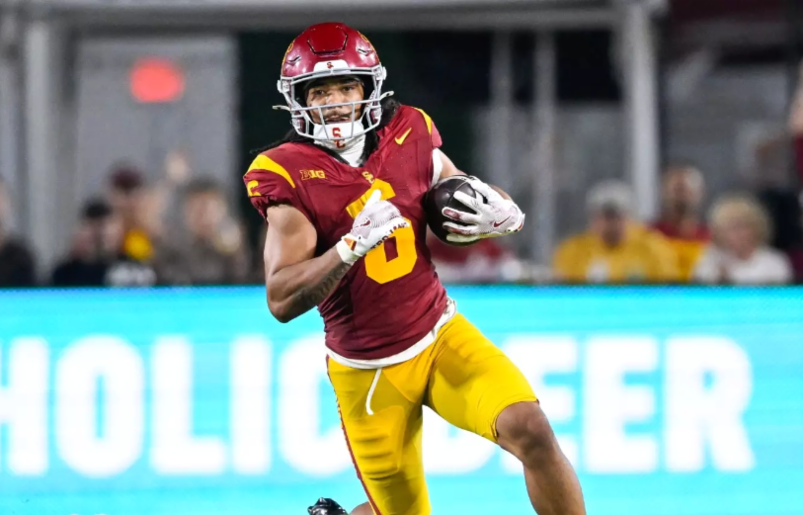

The 2025 Biletnikoff Award winner:
Makai Lemon of the University of Southern California

Tallahassee, FL - The Tallahassee Quarterback Club (TQC) Foundation, Inc., the Florida-based creator and sponsor of the prestigious Biletnikoff Award, announces that receiver Makai Lemon of the University of Southern California is the 2025 winner of the Biletnikoff Award. Tonight, Makai was introduced as the winner on The Home Depot College Football Awards. The other outstanding finalists are Skyler Bell of Connecticut and Jeremiah Smith of Ohio State.
The secure and confidential electronic voting by the 625 distinguished members of the Biletnikoff Award National Selection Committee was conducted from November 25 through December 6, and certified by a prominent CPA firm.
The Biletnikoff Award annually recognizes the college football season's outstanding FBS receiver. Any player, regardless of position (wide receiver, tight end, slot or inside receiver, wing back, or running back) who catches a pass is eligible for the award. As such, the Biletnikoff Award recognizes college football's outstanding receiver, not merely college football's outstanding wide receiver. Tight end Kyle Pitts was a finalist in 2020 and other tight ends were semifinalists in other years. Moreover, the Biletnikoff Award is a single season, not career, award. The Biletnikoff Award is one of the most highly followed college football awards. In 2024, the announcement of the Biletnikoff Award winner on X garnered a remarkable 2.6 million views, second only to the Heisman winner's announcement with 3.2 million views.

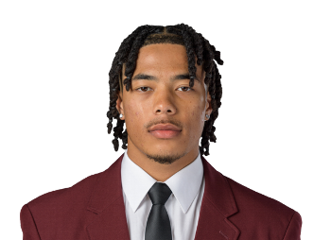

Makai Lemon caught 79 passes for 1,156 yards and 11 touchdowns this season.

The Biletnikoff Award's semifinalists, three finalists, and award recipient are selected by the highly distinguished Biletnikoff Award National Selection Committee, a group of 625 prominent college football journalists, commentators, announcers, Biletnikoff Award winners, and other former receivers. Foundation trustees do not vote and have never voted. For a list of voters, please see BiletnikoffAward.com/voters.
The Biletnikoff Award candidate eligibility and voting criteria, transparently explicit and detailed, are available for review at BiletnikoffAward.com/criteria.
The correlation between Biletnikoff Award winners and stardom in the National Football League is nearly uniformly consistent. Past Biletnikoff Award winners include Calvin Johnson, Randy Moss, Michael Crabtree, Amari Cooper, Golden Tate, Brandin Cooks, the late Terry Glenn, Ja'Marr Chase, DeVonta Smith, and Larry Fitzgerald.
Makai Lemon will be presented the Biletnikoff Award trophy by TQC Foundation Chairman John Harris Jr., assisted by Coach Lincoln Riley and College Football Hall of Famer Raghib "Rocket" Ismail, keynote speaker, at the black-tie Biletnikoff Award Banquet & Celebration at the Donald L. Tucker Civic Center in Tallahassee on Saturday, March 28, 2026. The banquet, always sold-out and attended by 700 patrons, was hailed by 2014 keynote speaker Dick Vermeil, as well as by 2013 keynoter Larry Csonka, as "the best banquet in college sports."
The banquet has featured distinguished keynoters of profound character and accomplishments including the late Bart Starr, Dick Vermeil, the late Floyd Little, Larry Csonka, Steve Largent, Mike Ditka, the late Don Shula, the late Dan Reeves, Archie Manning, Ron Jaworski, Gene Stallings, Bob Griese, Bill Curry, the late Bobby Bowden, Jim Kelly, Jerry Kramer, Joe Theismann, Dan Fouts, Chad Hennings, Lou Holtz, Aaron Taylor, Archie Griffin, Danny Wuerffel, Drew Pearson, and Gino Torretta.

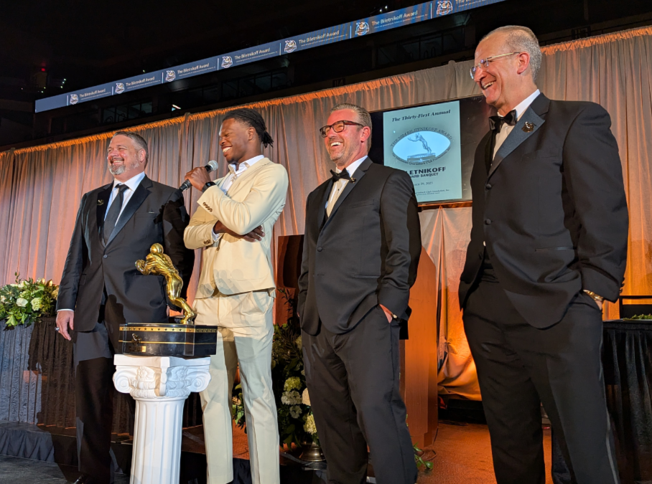

Foundation Chairman Charles Hopkins presented the beautiful Biletnikoff Award trophy to All-America and Heisman Memorial Trophy Winner Travis Hunter with Coach Michael Pollock and the 1992 Heisman Memorial Trophy winner and national champion Gino Torretta, keynote speaker, at the 31st Biletnikoff Award Banquet with 700 patrons in attendance on Saturday March 29, 2025.

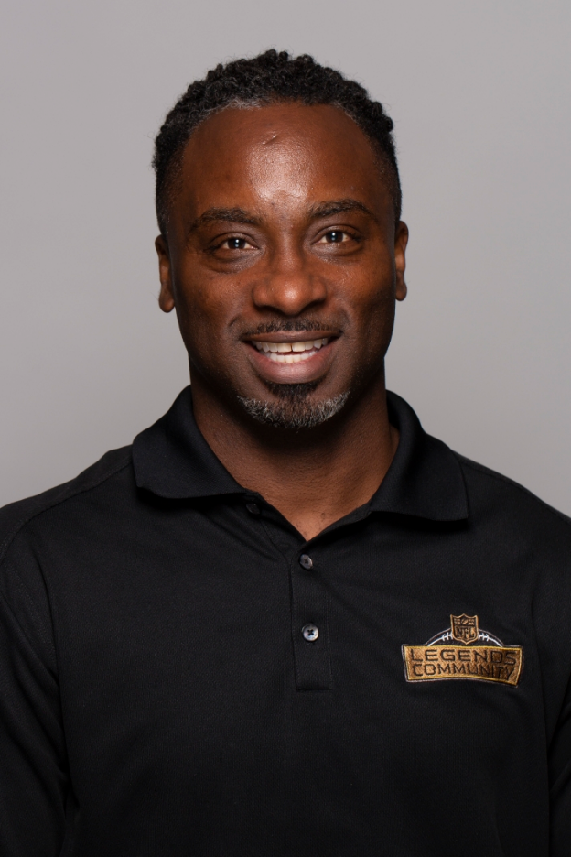

2025 Biletnikoff Award keynote speaker and College Football Hall of Famer Raghib "Rocket" Ismail

The 501(c)(3) TQC Foundation's charitable mission is the provision of college and vocational scholarships to North Florida high school seniors who have overcome significant challenges to achieve at the highest academic and extracurricular levels. Participation in sports is not a requirement, but does count as an extracurricular activity. The all-volunteer Foundation has provided over 375 scholarships with benefits of nearly 7 million dollars through 2025. TQC Founding Trustee & many-times chairman Walter Manley II, serving his 29th year as fundraising chairman, recently announced a goal of 10 million dollars in the aggregate to be awarded in scholarships by 2030.

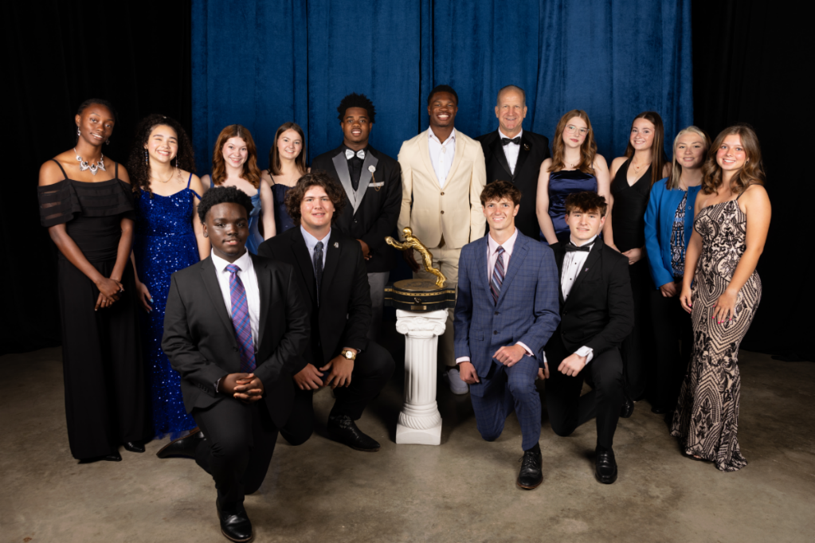

2025 Scholarship Recipients

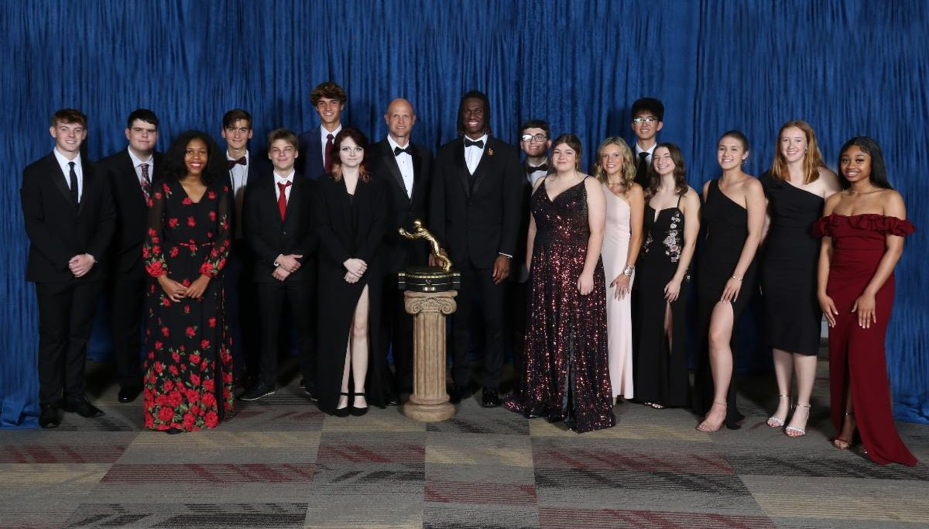

2024 Scholarship Recipients

The name Biletnikoff is synonymous with the term receiver. Fred Biletnikoff, a member of the pro and college football halls of fame, was a consensus 1st-team All-America receiver at Florida State University and an All-Pro receiver for the Oakland Raiders. He caught 589 passes for 8,974 yards and 76 touchdowns in his 14-year Raiders career from 1965 through 1978. Fred was the Most Valuable Player of Super Bowl XI.

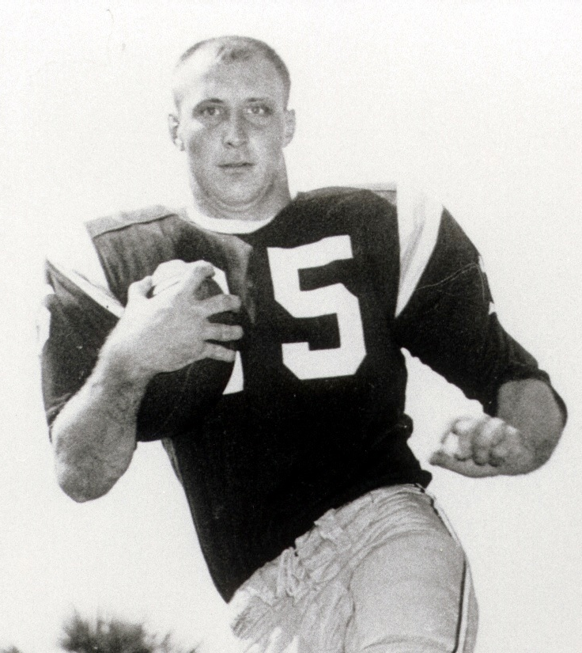

Fred Biletnikoff was Florida State's first consensus 1st-Team All-America



  The Biletnikoff Award
  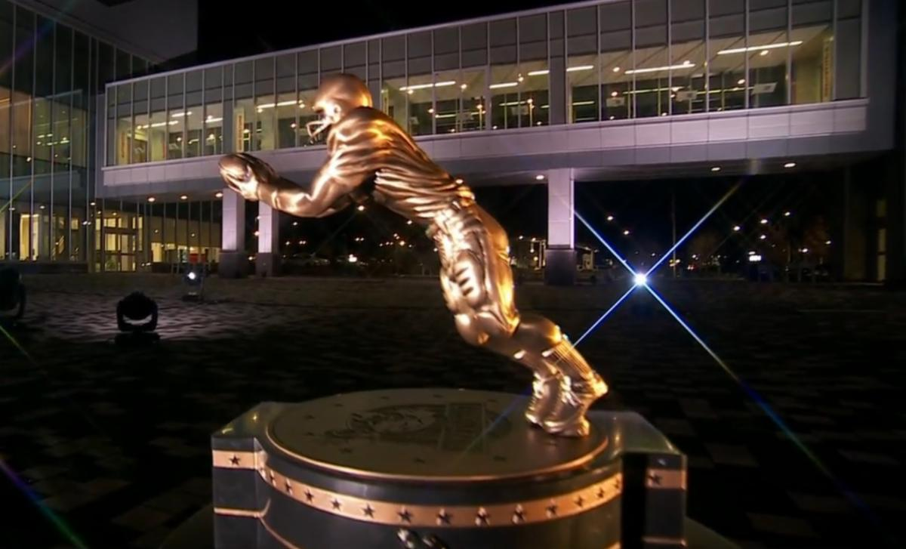
  The Biletnikoff Award annually recognizes the college football season's outstanding FBS receiver. Any player, regardless of position (wide receiver, tight end, slot or inside receiver, wing back, or running back) who catches a pass is eligible for the award.
  (BiletnikoffAward.com/about_award)
  The TQC Foundation, Inc., is an independent, charitable organization designated with 501(c)(3) status that was founded in 1994. Many trustees have contributed to its development as one of the most prominent awards in college football. The TQC Foundation, Inc., joined the idea of a college receiver's award to the organization's vision and created the outstanding award and dynamic organization.
  The trophy, presented to each winner, is the most beautiful in college football - it has won several national, juried competitions for design excellence and aesthetic brilliance.
  Likewise, the website and printed banquet program have been cited nationally for excellence in design and content.
  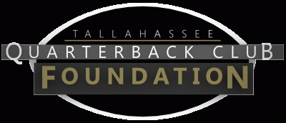
  The Tallahassee Quarterback Club Foundation, Inc., a 501(c)(3) organization, is the creator and sponsor of the Biletnikoff Award. The Foundation administers the Biletnikoff Award, its charitable activities, and the distinguished Biletnikoff Award National Selection Committee. Foundation Trustees are prohibited from serving on the National Selection Committee. For a full recounting of the Foundation's activities, please consult BiletnikoffAward.com.
  
  National College Football Awards Association
  The Biletnikoff Award is a member of the National College Football Awards Association. Founded in 1997, the NCFAA includes college football’s most prestigious awards and its 24 awards have honored more than 900 recipients dating back to 1935. For more information about the NCFAA and its award programs, visit the NCFAA.org or follow on X at @NCFAA.
  
  Important Dates
  Aug. 6, 2025:
  Preseason Watch List announcement
  Sept. 24, 2025:
  FanVote opens
  Nov. 10 - 16, 2025:
  Vote by the Biletnikoff Award National Selection Committee to determine Semifinalists
  Nov. 17, 2025:
  Semifinalists announcement
  Nov. 17 - 23, 2025:
  Vote to determine 3 Finalists
  Nov. 25, 2025:
  3 Finalists announcement
  Nov. 25 - Dec. 6, 2025 :
  Final vote to determine Biletnikoff Award Winner
  Dec. 12, 2025:
  Biletnikoff Award Winner announced on The Home Depot College Football Awards
  The Biletnikoff Award Banquet & Celebration
  honors the 2025 Biletnikoff Award Winner on Saturday, March 28, 2026, at the basketball arena at Donald L. Tucker Civic Center in Tallahassee, Florida 32301
  Inquiries:
  Chairman of Selection:
  Professor Walter W. Manley II
  Foundation Founding Trustee & Past Chairman of the Tallahassee Quarterback Club Foundation, Inc.
  Creator and Sponsor of the Biletnikoff Award
  BiletnikoffAward.com/Manley
  Cell 850-766-0800
  prof.wwmii@comcast.net
  Website and Publicity Contact:
  Will Stewart
  biletnikoffaward@biletnikoffaward.com
  Trustees to contact regarding questions about scholarships and applications:
  John Harris
  850-524-6627
  jjharrisjr@outlook.com
  Melissa Hancock
  850-340-0194 melissalynn527@gmail.com
  Important Links:
  Biletnikoff Award Website
  Scholarship Information
  Scholarship Application
  Scholarship Donations

Biletnikoff Award | PO Box 10762 | Tallahassee, FL 32302 US

Unsubscribe | Update Profile | Constant Contact Data Notice



