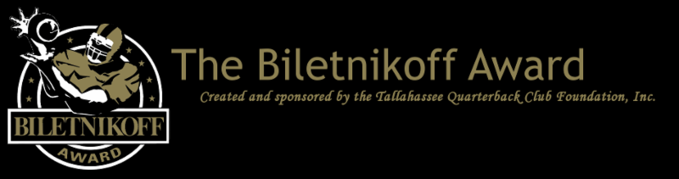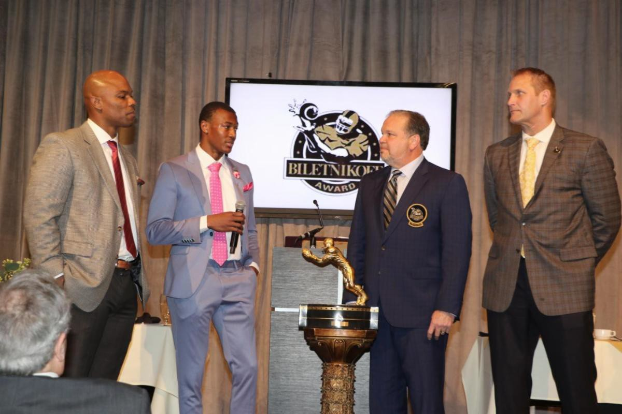

The Tallahassee Quarterback Club Foundation, the Creator and Sponsor of the Biletnikoff Award, Recognizing the College Football Season's Outstanding FBS Receiver Regardless of Position, Announces the 2021 Preseason Biletnikoff Award Watch List

## For Immediate Release: July 22, 2021

**2020-21 Foundation Chairman George Avant, Jr., presents the beautiful Biletnikoff Award trophy to DeVonta Smith, 2020 winner, with Coach Holmon Wiggins and keynoter and College Football Hall of Famer Chad Hennings watching at the 27th Biletnikoff Award Banquet & Celebration on Saturday, March 6, 2021. The banquet will return to a black tie, evening event on Saturday, March 5, 2022.**

**Tallahassee, FL** - The Tallahassee Quarterback Club (TQC) Foundation, Inc., the Florida-based creator and sponsor of the prestigious Biletnikoff Award, has released the 2020 Biletnikoff Award Preseason Watch List.

The Biletnikoff Award annually recognizes the college football season's outstanding FBS receiver. **Any player, regardless of position (wide receiver, tight end, slot back, and running back) who catches a pass is eligible for the award.** As such, the Biletnikoff

Award recognizes college football's outstanding receiver, not merely college football's outstanding *wide* receiver.

The semifinalists, finalists, and award recipient are selected by the highly distinguished Biletnikoff Award National Selection Committee, a group of prominent college football journalists, commentators, announcers, Biletnikoff Award winners, and other former receivers.

Foundation trustees do not vote and have never voted. For a list of voters, please see [BiletnikoffAward.com/voters](https://www.biletnikoffaward.com/voters).

Receivers are frequently added to the watch list as their season performances dictate. Actual, not potential, performance is the basis for inclusion on the Biletnikoff Award Watch List.

The Biletnikoff Award candidate eligibility and voting criteria, transparently explicit and detailed, are available for review at [BiletnikoffAward.com/criteria](https://www.biletnikoffaward.com/criteria).

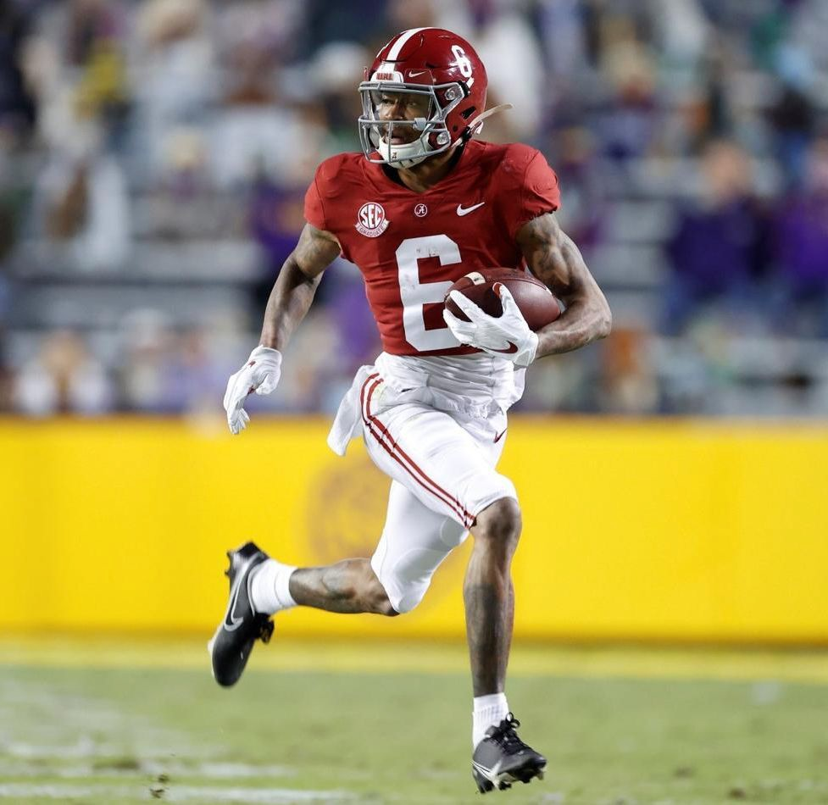

## 2021 Biletnikoff Award winner DeVonta Smith

The correlation between Biletnikoff Award winners and stardom in the National Football League is nearly uniformly consistent. Past Biletnikoff Award winners include Calvin Johnson, Randy Moss, Michael Crabtree, Amari Cooper, the late Terry Glenn, and Larry Fitzgerald.

The 2021 Biletnikoff Award winner will be presented the Biletnikoff Award trophy by TQC Foundation Chairman Roger Champion, keynoter and college hall of famer and two-time Heisman Trophy winner Archie Griffin, and college and pro football hall of famer Fred Biletnikoff at the Biletnikoff Award Banquet & Celebration at the University Center Club at Doak Campbell Stadium in Tallahassee on Saturday, March 5, 2022. The banquet was hailed by 2014 keynote speaker Dick Vermeil, as well as by 2013 keynoter Larry Csonka, as "the best banquet in college sports."

The banquet has featured distinguished keynoters of profound character and accomplishments including the late Bart Starr, Dick Vermeil, the late Floyd Little, Larry Csonka, Steve Largent, Mike Ditka, the late Don Shula, Dan Reeves, Archie Manning, Ron Jaworski, Gene Stallings, Bob Griese, Bill Curry, Bobby Bowden, Jim Kelly, Jerry Kramer, Joe Theismann, Dan Fouts, Chad Hennings, and Aaron Taylor.

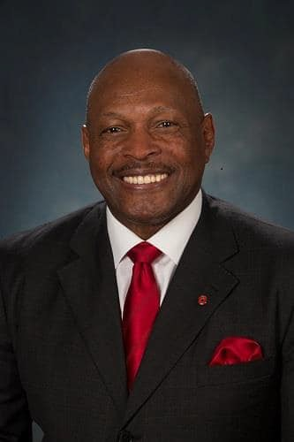

## 2022 Biletnikoff Award keynote speaker and college hall of famer Archie Griffin

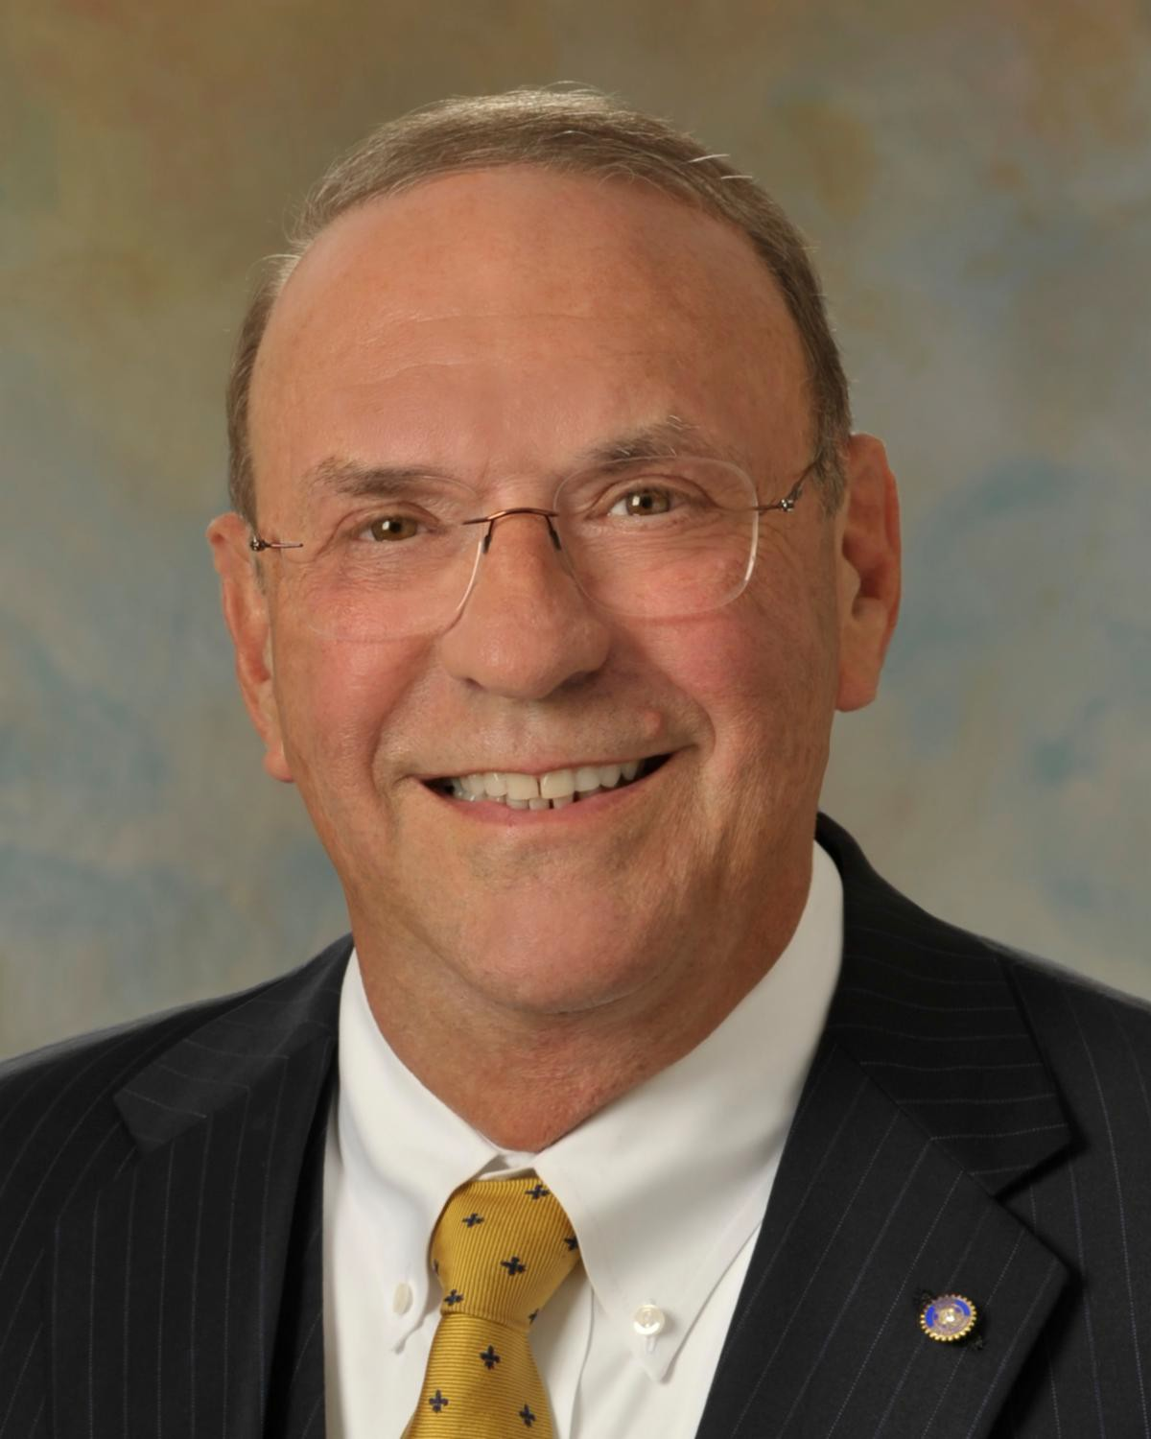

**2021-22 Foundation Chairman Roger Champion**

The TQC Foundation's charitable mission is the provision of college and vocational scholarships to North Florida high school seniors who have overcome significant barriers to achieve at the highest academic and extracurricular levels. Participation in sports is not a requirement. The Foundation has provided many millions of dollars for several hundreds of scholarships and related benefits through 2020.

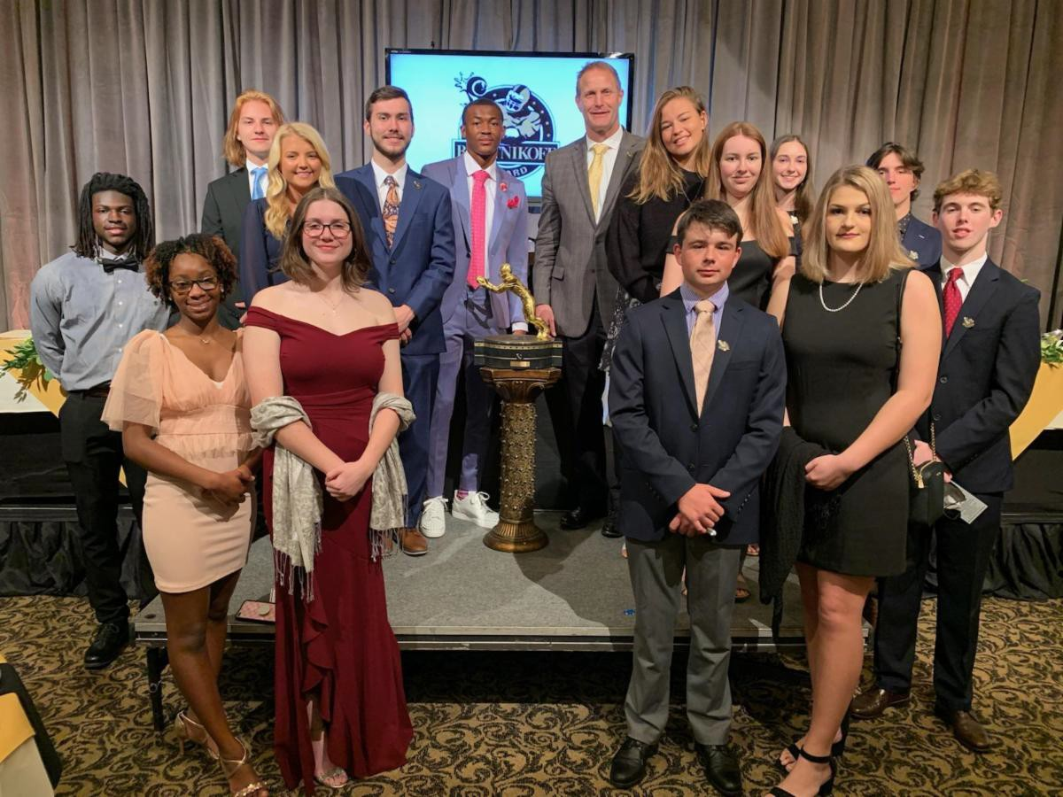

**2021 Scholarship Recipients**

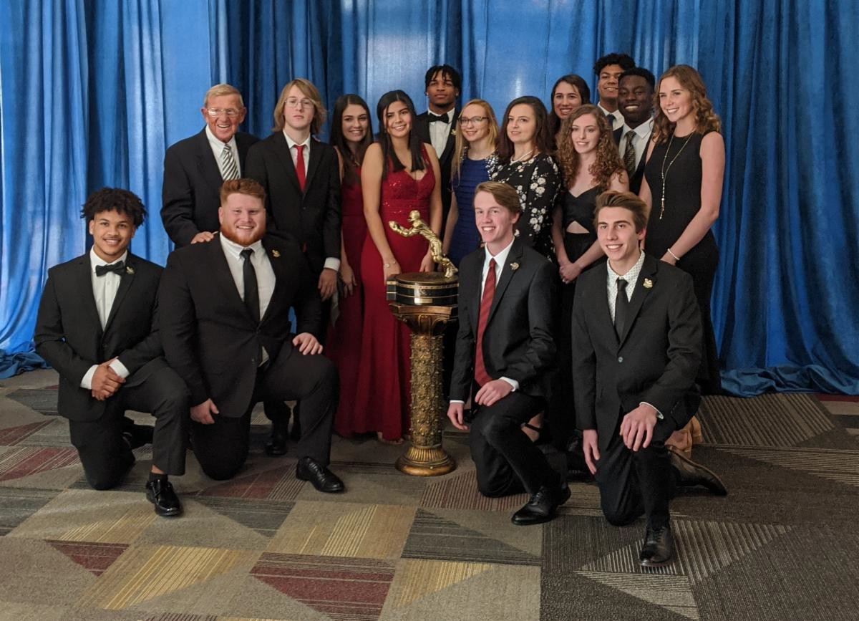

**2020 Scholarship Recipients**

The name Biletnikoff is synonymous with the term receiver. Fred Biletnikoff, a member of the pro and college football halls of fame, was a consensus All-America receiver at Florida State University, and an All-Pro receiver for the Oakland Raiders. He caught 589 passes for 8,974 yards and 76 touchdowns in his 14-year Raiders career from 1965 through 1978. Fred was the Most Valuable Player of Super Bowl XI.

## The 2021 Biletnikoff Award Preseason Watch List

(Other receivers will be added as their season performances dictate)

Jordan Addison, Pitt Calvin Austin III, Memphis David Bell, Purdue

Ronnie Bell, Michigan Max Borghi, Washington State

Kayshon Boutte, LSU Treylon Burks, Arkansas Elijah Cooks, Nevada Jacob Cowing, UTEP

Dontay Demus Jr., Maryland Jahan Dotson, Penn State Romeo Doubs, Nevada Emeka Emezie, NC State Erik Ezukanma, Texas Tech Zay Flowers, Boston College Zakhari Franklin, UTSA

Ty Fryfogle, Indiana Kaylon Geiger, Texas Tech Justin Hall, Ball State Mike Harley, Miami

Taj Harris, Syracuse Jaivon Heiligh, Coastal Carolina Xavier Hutchinson, Iowa State

Johnny Johnson III, Oregon Billy Kemp IV, Virginia Charlie Kolar, Iowa State

Isaiah Likely, Coastal Carolina Drake London, USC

Michael Mayer, Notre Dame Bo Melton, Rutgers

John Metchie III, Alabama Marvin Mims, Oklahoma Chris Olave, Ohio State

Sam Pinckney, Georgia State Rashee Rice, SMU

Jaquarii Roberson, Wake Forest Reggie Roberson Jr., SMU Jaylon Robinson, UCF

Gunner Romney, BYU Justyn Ross, Clemson Bradley Rozner, Rice Khalil Shakir, Boise State Keylon Stokes, Tulsa



**Important Dates**

**July 22, 2021:**

Preseason Watch List announcement

**Sept. 30, 2021:**

FanVote opens

**Nov. 15 - 21, 2021:**

Vote by the Biletnikoff Award National Selection Committee to determine Semifinalists

**Nov. 22, 2021:**

Semifinalists announcement

**Nov. 22 - 28, 2021:**

Vote to determine 3 Finalists

**Nov. 29, 2021:**

3 Finalists announcement

**Nov. 29 - Dec. 5, 2021:**

Final vote to determine Biletnikoff Award Winner

**Dec. 9, 2021:**

Biletnikoff Award Winner announced on The Home Depot College Football Awards

**The Home Depot College Football Awards** airs live on

Jalen Tolbert, South Alabama Cole Turner, Nevada

Jaden Walley, Mississippi State Tahj Washington, USC

Garrett Wilson, Ohio State Michael Wilson, Stanford Mike Woods, Oklahoma

Jalen Wydermyer, Texas A&M

# The Biletnikoff Award

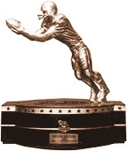

The Biletnikoff Award annually recognizes the college football season's outstanding FBS receiver. **Any player, regardless of position (wide receiver, tight end, slot or inside receiver, wingback, and running back) who catches a pass is eligible for the award.** ([BiletnikoffAward.com/about_award](https://biletnikoffaward.com/about_award))

The TQC Foundation, Inc., is an independent, charitable organization that was founded in 1994. Past Chairman & Founding Trustee Professor Walter W. Manley II, Founding Trustee L. Thomas Cox, Jr., Founding Trustee Rocky Bevis, and Founding Trustee Bob Teel established the award and the TQC Foundation, Inc., that sponsors it. Many more trustees have contributed to its development as one of the most prominent awards in college football. The TQC Foundation, Inc., joined the idea of a college receiver's award to the organization's vision and created the outstanding award and dynamic organization.

The trophy, presented to each winner, is the most beautiful in college football - it has won several national, juried competitions for design excellence and aesthetic appeal.

ESPN Dec. 9, 2021, 7 - 8:30 PM (EST)

**The Biletnikoff Award Banquet & Celebration** honors the 2021 Biletnikoff Award Winner on Saturday, March 5, 2022

University Center Club at Doak Cambell Stadium, Tallahassee, Florida

**Inquiries:**

Chairman of Selection: Professor Walter W. Manley II Founding Trustee & Past Chairman of the Tallahassee Quarterback Club Foundation, Inc.

Creator and Sponsor of the Biletnikoff Award [BiletnikoffAward.com/Manley](https://biletnikoffaward.com/Manley) Cell 850-766-0800

[prof](mailto:prof.wwmii@comcast.net)[.wwmii@comcast.net](mailto:.wwmii@comcast.net)

TQCF Chairman:

Roger Champion Cell 850-508-1647

champion.management.compa [n](mailto:ny@gmail.com)[y@gmail.com](mailto:y@gmail.com)

Website and Publicity Contact: Will Stewart biletnikoffaward@biletnikoffa ward.com

Trustees to contact regarding questions about scholarships and applications:

John Harris (John.Harris@gray- robinson.com

850-524-6627)

Charles Hopkins [(charles.hopkins@suntrust.com](mailto:(charles.hopkins@suntrust.com) 850-445-2300)

**Important Links:**

[Biletnikoff Award Website](https://www.biletnikoffaward.com/) [2021 Watch List](https://biletnikoffaward.com/2021-biletnikoff-award-watch-list/)

[FanVote](https://biletnikoffaward.com/fan-vote/)

[Scholarship Information](https://biletnikoffaward.com/about-scholarships/) [Scholarship Application](https://biletnikoffaward.com/wp-content/uploads/2021/04/2022Scholarship-Application.pdf)

Likewise, the website and printed banquet program have been cited nationally for excellence in design.

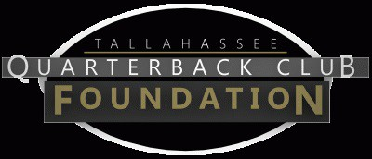

The Tallahassee Quarterback Club Foundation, Inc., a 501(c)(3) organization, is the creator and sponsor of the Biletnikoff Award. The Foundation administers the Biletnikoff Award, its charitable activities, and the distinguished Biletnikoff Award National Selection Committee. Foundation Trustees are prohibited from serving on the National Selection Committee. For a full recounting of the Foundation's activities, please consult [BiletnikoffAward.com](https://www.biletnikoffaward.com/).

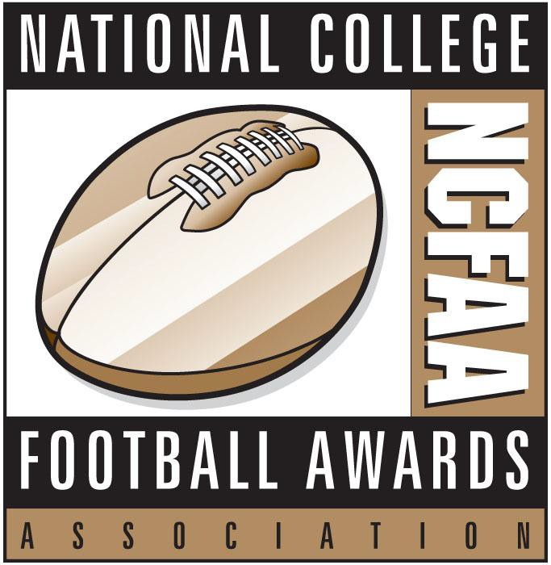

# National College Football Awards Association

The Biletnikoff Award is a member of the National College Football Awards Association (NCFAA), which encompasses the most prestigious awards in college football. Founded in 1997, the NCFAA and its 25 awards now boast over 800 recipients, dating to 1935. Visit [ncfaa.org](http://ncfaa.org/) and [@NCFAA](https://twitter.com/ncfaa?lang=en) on Twitter to learn more about the association.