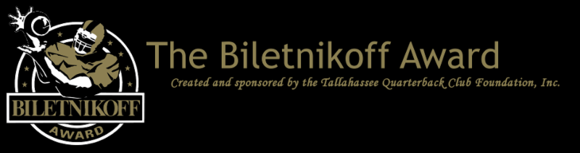

The Tallahassee Quarterback Club Foundation, the Creator and Sponsor of the Biletnikoff Award, Recognizing the College Football Season's Outstanding FBS Receiver Regardless of Position, Announces the 2019 Preseason Biletnikoff Award Watch List

  For Immediate Release: July 18, 2019
  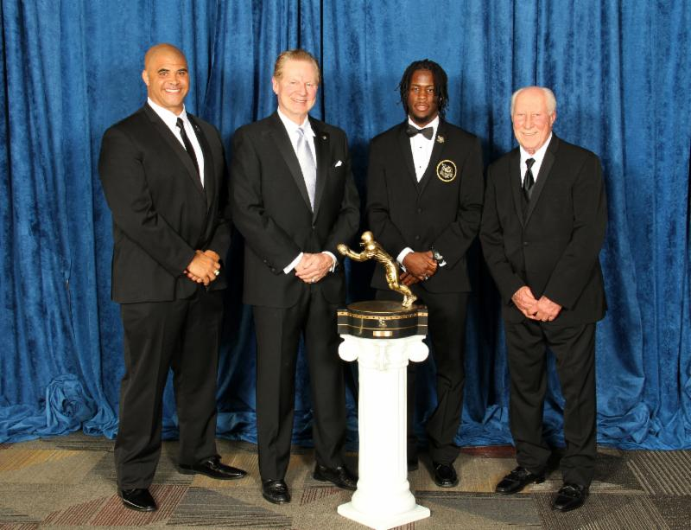
  Pictured above are Biletnikoff Award Banquet keynote speaker Aaron Taylor, Foundation Chairman & Founding Trustee Walter Manley II, 2018 Biletnikoff Award winner Jerry Jeudy, and Fred Biletnikoff
  Tallahassee, FL - The Tallahassee Quarterback Club (TQC) Foundation, Inc., the Florida-based creator and sponsor of the Biletnikoff Award, has released the 2019 Biletnikoff Award Preseason Watch List. The Biletnikoff Award annually recognizes the season's outstanding FBS receiver in college football. Any player, regardless of position (wide receiver, tight end, slot back, and running back) who catches a pass is eligible for the award. As such, the Biletnikoff Award recognizes college football's outstanding receiver, not merely college football's outstanding wide receiver.
  The award recipient is selected by the highly distinguished Biletnikoff Award National Selection Committee, a group of prominent college football journalists, commentators, announcers, Biletnikoff Award winners, and other former receivers. Foundation trustees do not vote and have never voted. For a list of voters, please see BiletnikoffAward.com/voters
  Receivers are frequently added to the watch list as their season performances dictate. Actual, not potential, performance is the basis for inclusion on the Biletnikoff Award Watch List.
  The Biletnikoff Award candidate eligibility and voting criteria, transparently explicit and detailed, are available for review at BiletnikoffAward.com/criteria.
  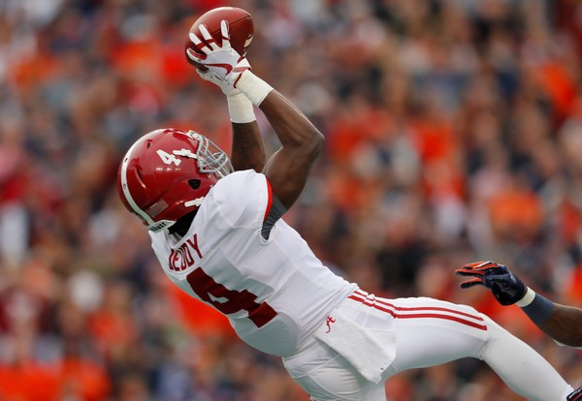
  2018 Biletnikoff Award winner Jerry Jeudy
  The 2019 Biletnikoff Award winner will be presented live on December 12, 2019, at the College Football Hall of Fame on The Home Depot College Football Awards presented by Gildan to be broadcast 7:00 - 9:00pm (EST) on ESPN.
  The correlation between Biletnikoff Award winners and stardom in the National Football League is nearly uniformly consistent. Past Biletnikoff Award winners include Calvin Johnson, Randy Moss, Michael Crabtree, Amari Cooper, Terry Glenn, and Larry Fitzgerald.
  The 2019 Biletnikoff Award winner will be presented the Biletnikoff Award trophy by TQC Foundation Chairman Steve Dobson, III, college and pro football hall of famer Fred Biletnikoff, and the dynamic and inspiring keynoter and college football hall of famer Lou Holtz before 550 patrons at the Biletnikoff Award Banquet at the University Center Club at Doak Campbell Stadium in Tallahassee on Saturday, February 15, 2020. The banquet was hailed by 2014 keynote speaker Dick Vermeil, as well as by 2013 keynoter Larry Csonka, as "the best banquet in college sports."
  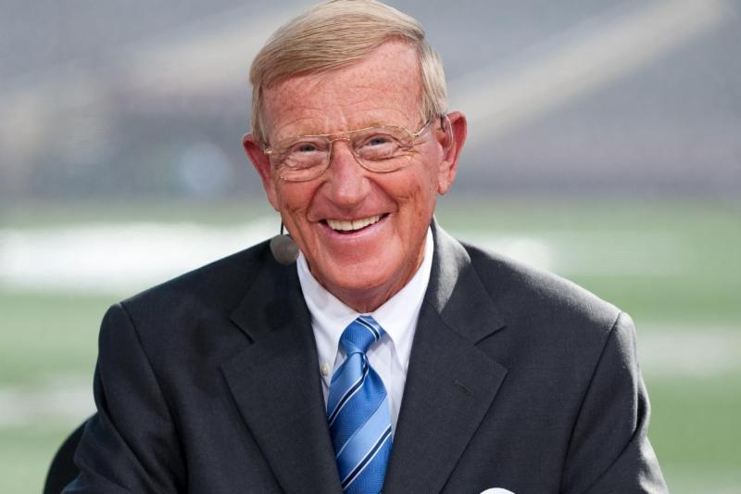
  2020 Biletnikoff Award Banquet keynoter Lou Holtz
  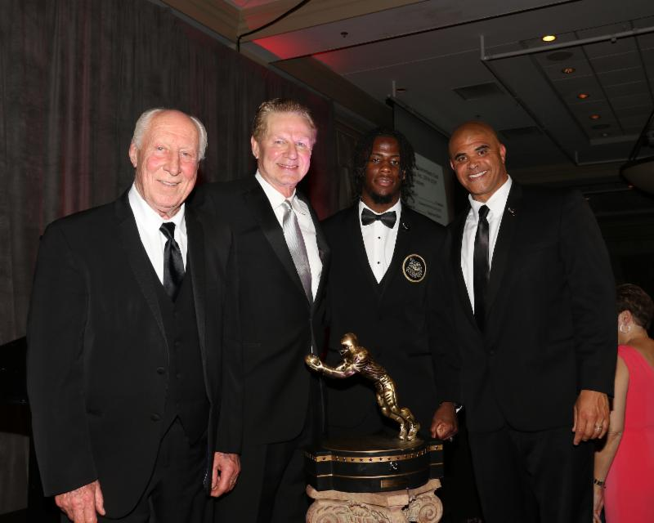
  The banquet has featured distinguished keynoters of profound character and accomplishments including the late Bart Starr, Dick Vermeil, Floyd Little, Larry Csonka, Steve Largent, Mike Ditka, Don Shula, Dan Reeves, Archie Manning, Ron Jaworski, Gene Stallings, Bob Griese, Bill Curry, Bobby Bowden, Jim Kelly, Jerry Kramer, Joe Theismann, Dan Fouts, and Aaron Taylor.
  The TQC Foundation's charitable mission is the provision of college and vocational scholarships to North Florida high school seniors who have overcome significant barriers to achieve at the highest academic and extracurricular levels. Participation in sports is not a requirement. The Foundation has provided many millions of dollars for several hundreds of scholarships and related benefits through 2019.
  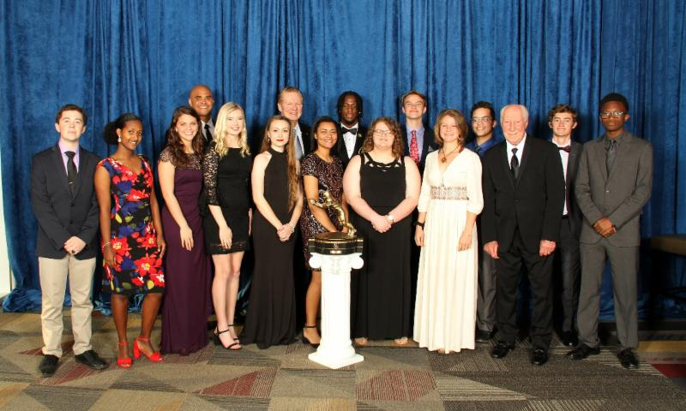
  2019 Scholarship recipients
  The Tallahassee Quarterback Club Foundation, Inc., will announce the ten Biletnikoff Award semifinalists on November 18, 2019, following the vote by the distinguished members of the Biletnikoff Award National Selection Committee. Likewise, the three finalists will be declared, following another vote, on November 25, 2019. For complete details and updates of interest, together with weekly statistics and timely, important news of the Biletnikoff Award candidates, as well as a fan vote and discussion board, please consult the Foundation's highly informative website at BiletnikoffAward.com.
  The name Biletnikoff is synonymous with the term receiver. Fred Biletnikoff, a member of the pro and college football halls of fame, was a consensus All-America receiver at Florida State University, and an All-Pro receiver for the Oakland Raiders. He caught 589 passes for 8,974 yards and 76 touchdowns in his 14-year Raiders career from 1965 through 1978. Fred was the Most Valuable Player of Super Bowl XI.
  The 2019 Biletnikoff Award Preseason Watch List
  (Other receivers will be added as their season performances dictate)
  NAME | SCHOOL
  Lynn Bowden, Jr. | Kentucky
  Rico Bussey, Jr. | North Texas
  Cedric Byrd | Hawaii
  Grant Calcaterra | Oklahoma
  Damonte Coxie | Memphis
  Gabriel Davis | UCF
  Bryan Edwards | South Carolina
  D'Wayne Eskridge | Western Michigan
  Aaron Fuller | Washington
  Antonio Gandy-Golden | Liberty
  KJ Hamler | Penn State
  Adrian Hardy | Louisiana Tech
  Damon Hazelton | Virginia Tech
  Tee Higgins | Clemson
  K.J. Hill | Ohio State
  Isaiah Hodgins | Oregon State
  Justin Jefferson | LSU
  Jerry Jeudy | Alabama
  Tyler Johnson | Minnesota
  Collin Johnson | Texas
  CeeDee Lamb | Oklahoma
  Ty Lee | Middle Tennessee
  Kalija Lipscomb | Vanderbilt
  McLane Mannix | Texas Tech
  Kirk Merritt | Arkansas State
  Riley Miller | Ball State
  Denzel Mims | Baylor
  Darnell Mooney | Tulane
  Rondale Moore | Purdue
  Albert Okwuegbunam | Missouri
  K.J. Osborn | Miami
  Dezmon Patmon | Washington State
  Jared Pinkney | Vanderbilt
  Michael Pittman, Jr. | USC
  James Proche | SMU
  Jalen Reagor | TCU
  Jared Rice | Fresno State
  Sean Riley | Syracuse
  Reggie Roberson, Jr. | SMU
  Justyn Ross | Clemson
  Henry Ruggs III | Alabama
  Laviska Shenault, Jr. | Colorado
  JD Spielman | Nebraska
  Amon-Ra St. Brown | USC
  Marquez Stevenson | Houston
  Tamorrion Terry | Florida State
  Jaylen Waddle | Alabama
  Tylan Wallace | Oklahoma State
  JoJo Ward | Hawaii
  Quez Watkins | Southern Miss
  The Biletnikoff Award
  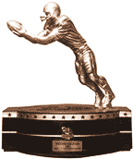
  The Biletnikoff Award is presented annually to the season's
  outstanding college football receiver regardless of position (the award defines receiver as any player who catches a pass; hence, tight ends, slot receivers and backs, inside receivers, wide receivers, split ends, and running backs are eligible)
  (BiletnikoffAward.com/about_award)
  The TQC Foundation, Inc., is an independent, charitable organization that was founded in 1994. Past and Current Chairman & Founding Trustee Professor Walter W. Manley II, Founding Trustee L. Thomas Cox, Jr., Founding Trustee Rocky Bevis, and Founding Trustee Bob Teel established the award and the TQC Foundation, Inc., that sponsors it. Many more trustees have contributed to its development as one of the most prominent awards in college football. The TQC Foundation, Inc., joined the idea of a college receiver's award to the organization's vision and created the outstanding award and dynamic organization.
  The trophy, presented to each winner, is the most beautiful in college football - it has won several national, juried competitions for design excellence and aesthetic appeal.
  Likewise, the website and printed banquet program have been cited nationally for excellence in design.
  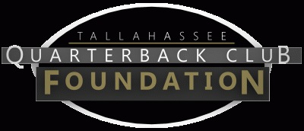
  The Tallahassee Quarterback Club Foundation, Inc., a 501(c)(3) organization, is the creator and sponsor of the Biletnikoff Award. The Foundation administers the Biletnikoff Award, its charitable activities, and the distinguished Biletnikoff Award National Selection Committee. Foundation Trustees are prohibited from serving on the National Selection Committee. For a full recounting of the Foundation's activities, please consult BiletnikoffAward.com.
  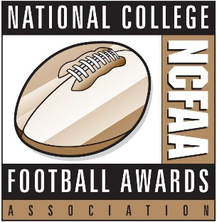
  National College Football Awards Association
  The Biletnikoff Award is a member of the National College Football Awards Association (NCFAA), which encompasses the most prestigious awards in college football. Founded in 1997, the NCFAA and its 25 awards now boast over 800 recipients, dating to 1935. Visit ncfaa.org to learn more about the association.
  The members of the NCFAA are unveiling their preseason watch lists over a two-week period this month. Sixteen of the association's 25 awards select a preseason watch list and the NCFAA has spearheaded a coordinated effort to promote each award's preseason candidates. Following is the complete 2019 preseason watch list calendar:
  Date | Award
  July 15 | Bednarik Award & Maxwell Award
  July 16 | Davey O'Brien Award
  July 17 | Doak Walker Award
  July 18 | Biletnikoff Award
  July 19 | John Mackey Award & Rimington Trophy
  July 22 | Butkus Award & Paycom Jim Thorpe Award
  July 23 | Bronko Nagurski Trophy & Outland Trophy
  July 24 | Lou Groza Award & Ray Guy Award
  July 25 | Paul Hornung Award & Wuerffel Trophy
  July 26 | Walter Camp Award
  Important Dates
  July 18, 2019:
  Pre-Season Watch List announcement
  September 23, 2019:
  FanVote opens
  November 11-17, 2019:
  Vote by the Biletnikoff Award National Selection Committee to determine 10 Semifinalists
  November 18, 2019:
  10 Semifinalists announcement
  November 19 - November 24, 2019:
  Vote to determine 3 Finalists
  November 25, 2019:
  3 Finalists announcement
  December 2-8, 2019:
  Final vote to determine Biletnikoff Award Winner
  December 12, 2019:
  Biletnikoff Award Winner announced on The Home Depot College Football Awards presented by Gildan
  The Home Depot College Football Awards airs live on ESPN December 12, 2019, 7 - 9pm (EST)
  The Biletnikoff Award Banquet
  honors the 2019 Biletnikoff Award Winner on Saturday, February 15, 2020
  University Center Club at
  Doak Cambell Stadium, Tallahassee, Florida
  Inquiries:
  Chairman of Selection:
  Professor Walter W. Manley II
  Founding Trustee & Past Chairman of the Tallahassee Quarterback Club Foundation, Inc.
  Creator and Sponsor of the Biletnikoff Award
  BiletnikoffAward.com/Manley
  Cell 850-766-0800
  prof.wwmii@comcast.net
  Deputy Chairman of Selection:
  Ritchie Pickron
  Cell 850-363-0174
  rpickron123@yahoo.com
  Website and Publicity Contact:
  Will Stewart
  biletnikoffaward@biletnikoffaward.com
  Website
  www.biletnikoffaward.com
  FanVote
  www.biletnikoffaward.com/fan-vote
  Important Links
  About Scholarships
  Scholarship Application
  Candidate Eligibility, Watch List Inclusion & Voting Criteria
  National Selection Committee
  Past Winners in Action
  Banquet Keynote Speakers
  For more useful links see
  BiletnikoffAward.com


  Biletnikoff Award, PO Box 10762, Tallahassee, FL 32302
  SafeUnsubscribe™ {recipient's email}
  Forward email | Update Profile | About our service provider
  Sent by biletnikoffaward@biletnikoffaward.com in collaboration with
  
  Try email marketing for free today!

