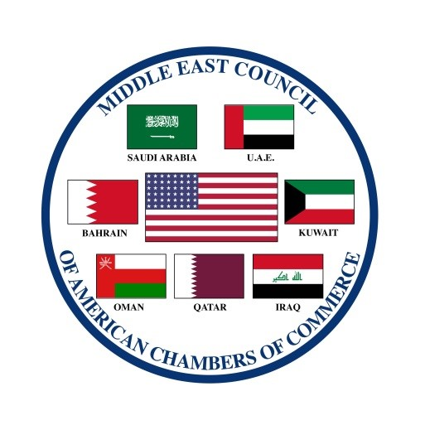

Door Knock 2020 Schedule

OVERVIEW: Door Knock provides MECACC members with an ability to personally meet with key decision makers in Washington, D.C. These meetings enable decision makers to gain perspective from our group as they go about the nation’s business. Your participation is important, most welcomed and vital to our lobbying strategy.

SUNDAY, March 29, 2020

Arrive in Washington, D.C.: Check into hotel

3:00PM – 5:00PM: Welcome and Briefing Session – Location: National Council on US/Arab Relations Conference Room – Location: 1730 M St. NW #503, Washington, DC 20036. THIS SESSION IS CRITICAL TO OUR MUTUAL SUCCESS – Please attend even if you are a seasoned Door Knocker

MONDAY, March 30, 2020

9:30AM - 11:30AM: National Council on U.S./Arab Relations / MECACC Joint Event/Door Knock Kick-Off Event – Location: 1875 K Street, NW-First Floor Conference Room (Business Attire)

12:00PM - 1:00PM: Lunch on your own

2:00PM - 3:30PM: United States Chamber of Commerce Roundtable Meeting – Location: 1615 H Street, NW

TUESDAY, March 31, 2020

8:00AM - 9:00AM: Morning Briefing - Location: Dubliner Restaurant, 4 F Street, NW (Business Attire)

9:30AM - 12:00PM: Door Knock meetings

12:00PM - 1:00PM: Lunch on your own

1:00PM - 4:00PM: Door Knock meetings

6:00PM: MECACC Group Dinner: The Army/Navy Club- 901 17th St NW, Washington, DC 20006

WEDNESDAY, April 1, 2020

10:00AM: (TENTATIVE) White House/Old Executive Office Building Briefing with OMB Director and Acting White House Chief of Staff Mick Mulvaney, National Security Council and United States Trade Representative - Location: Old Executive Office Building/White House Compound, 1650 Pennsylvania Ave. NW NOTE: All MECACC participants in this meeting must undergo a clearance with The Secret Service

11:30AM – 2:30PM: MECACC Steering Committee Meeting – Location: National Council on US/Arab Relations Conference Room. 1730 M St NW #503, Washington, DC 20036.

3:00PM - 5:00PM: Door Knock meetings/Embassy Meetings

THURSDAY, April 2, 2020

8:00AM - 9:00AM: Morning Briefing - Location: Dubliner Restaurant, 4 F Street, (Business Attire)

11:00AM - 12:00PM: Door Knock meetings

12:00PM - 1:00PM: Lunch on your own

1:00PM - 4:00PM: Door Knock meetings

FRIDAY, April 3, 2020

9:00AM - 12:00PM: Door Knock meetings

12:00PM - 1:00PM: Lunch on your own

Your Washington representative, The Capitol Capital Group (CCG) is at your service. CCG is available should you require any special assistance during your stay. Please feel free to contact Mike Jones at (202) 276-5984 or by email at mike@capitolcapitalgroup.com.

