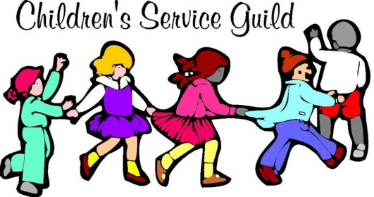
Spring is upon us; flowers and trees will soon be in bloom; birds will be singing their beautiful songs and butterflies will be flitting about. At this time, we’re reviewing our scholarship applications and will let you know who we are awarding College or Trade school scholarships to this spring. Many thanks to all of you who helped the High School Seniors complete their applications. We know they appreciate it as well as all of us at CSG.
On February 12, 2022, we hosted a Valentine’s cupcake decorating party for the kids in Child Haven. They had such a great time as each got to decorate their own 2 homemade cupcakes and then Melonie Maxwell, Cheryl Perry and Jasmine McCleod painted their wonderful faces.
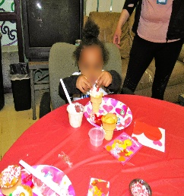
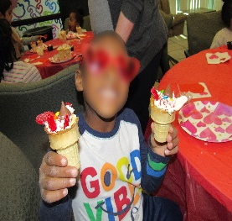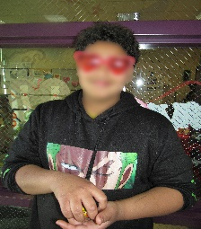
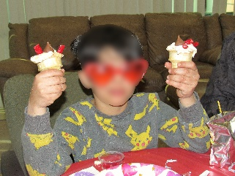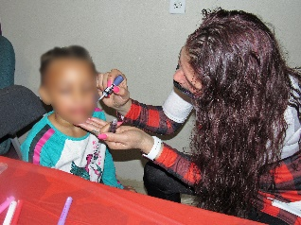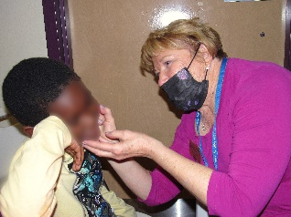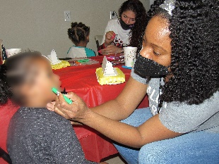
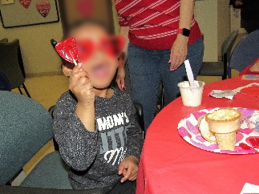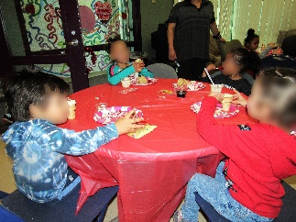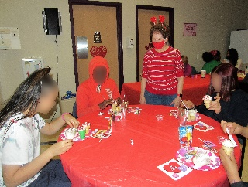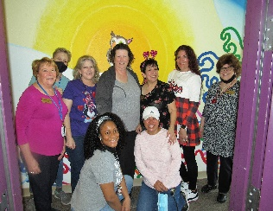
Lots of smiles, laughter and happiness filling the party!
Our next party for the campus is our Annual Easter party with an Easter egg hunt and pictures with the Easter Bunny. Always lots of fun.
If you or anyone you know, would like to join our organization, please contact Marsha Manning, Vice President and Membership Committee Chairwoman at manning.marsha@yahoo.com or 210-862-5493. If you or anyone you know would like to make a donation to us, please mail it to Children’s Service Guild, PO BOX 44309, Las Vegas, NV 89116. You can rest assured it will only be used for the children. You can view our website: www.childrensserviceguild.com and visit our Facebook page: Children’s Service Guild of Southern Nevada. Thank you for your continued support throughout the years. God bless you.

