NAME: SHELBY
- State: Nevada
- Birth Year: 2015
- Special Interests: Barbies, dancing and singing
- Ethnicity: Caucasian/White

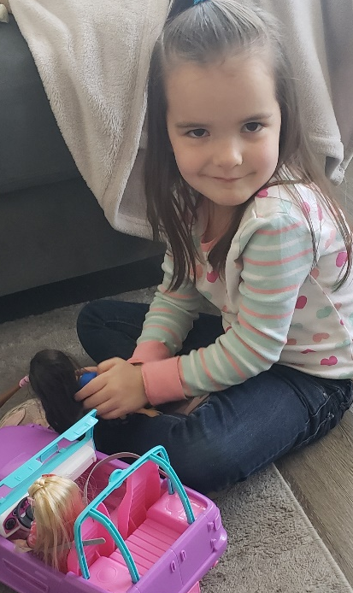

Meet Shelby
Age: 6
- Shelby is a lovable kiddo who loves to be the center of attention.
- Shelby enjoys cartoons and playing make believe
- She enjoys almost all snack foods and especially enjoys chicken.
- Shelby likes to trying new things.
- Shelby loves being outside and playing with her foster parents.
- Shelby can bond with adults and caregivers she trusts.
- Shelby is in the first grade.

Name(s): Shelby
Ages(s): 6 y/o
Emotional/Behavioral Level: Moderate
Grade(s): 1st
Legal Status: Legally Free
Recruiter: Liz Sanchez
Email: liz.sanchez@clarkcountynv.gov

