CHILD PASSENGER SAFETY TRAINING
2-Part Training for Foster Caregivers

A Foster Parent is REQUIRED to learn the best practices to keep a child riding safely in their vehicle and
complete the successful installation of a Child Passenger Safety Seat for a foster child ages 0-6 years old (or 60 pounds)

IMPORTANT INSTRUCTIONS: For completion of 2-Part Child Passenger Safety Training

Part 1 CHILD PASSENGER SAFETY TRAINING *Online
- Online Training Link: http://centervideo.forest.usf.edu/video/jit/florida/safeseat/start.html
- At Completion of Training PRINT “Part 1 Certificate of Completion”
- It is a REQUIREMENT to bring the “Part 1 Certificate of Completion,” to the scheduled Part 2 Installation date and provide copy to Certified Child Passenger Safety Technician (CPST)

Part 2 CHILD PASSENGER SAFETY SEAT INSTALLATION *In-Person
- To Schedule your Installation Appointment:
  - Contact (702) 455-7565, Fabiola Hernandez, Family Services Technician

How to Prepare for PART 2 INSTALLATION
- Participant must BRING the vehicle a foster child will use for transportation and an age-appropriate CHILD PASSENGER SEAT specific to the Foster Caregivers placement age
- Following successful completion of INSTALLATION, you will receive a “Part 2 Certificate of Completion” from a Certified Child Passenger Safety Technician (CPST)

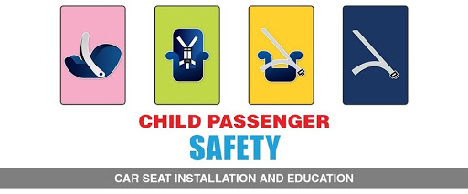

Provided by Clark County, Department of Family Services, Resource Development & Support Unit
Foster Care Information Line: (702) 455-0181
To Schedule an In-Person Child Passenger Safety Installation: (702) 455-7565

