NAME: Naila, nayana, taj
- State: Nevada
- Birth Year: 2013, 2015, 2018
- Special Interests: Bike riding and playing outside
- Ethnicity: African American


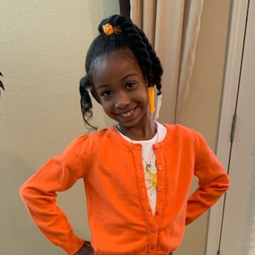

Meet Naila, Nayana, Taj
Age: 8, 7, 3
- Naila is an intelligent, outspoken, and inquisitive little girl.
- Naila enjoys drawing and has an active imagination.
- Nayana enjoys reading and enjoys discussing the story after reading.
- Nayana likes to try new foods.
- Taj likes to try new things.
- Taj loves being outside and playing with his foster parents.
- All three children can bond with adults and caregivers they trust.
- All three children enjoy riding bikes and going to church.
- Naila is in the second grade. Nayana is in first grade and Taj does not attend school yet.

Name(s): Naila, Nayana, Taj
Ages(s): 8, 7, 3 y/o
Emotional/Behavioral Level: Mild
Grade(s): 2nd and 1st grade
Legal Status: Legally Free
Recruiter: Melissa Salazar
Email: Salazarm@clarkcountynv.gov

