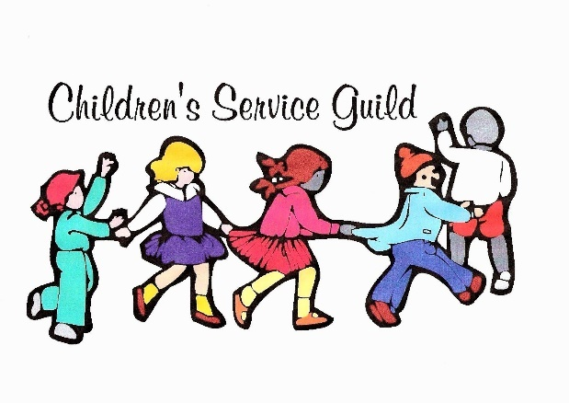
Happy New Year to all! It’s a new year and lots of great things are coming from CSG!
Our mission is and always will be the children and their many needs whom are touched by the Family and Juvenile Justice courts.
December 11, 2021, we had our 8th Annual Christmas Party for the children at Child Haven. 14 of us made 70 gingerbread houses the day before with lots of camaraderie and laughs! The kids got to decorate their own houses and had a great time! Santa Patrick was also there for pictures with each child, and they all received their own time-stamped picture as a memento.
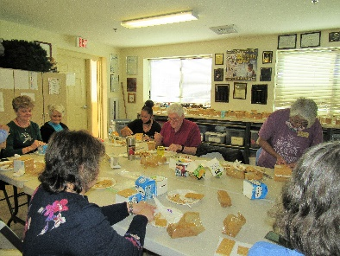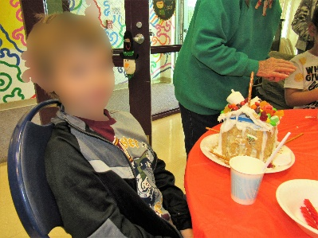
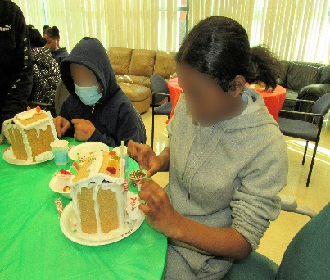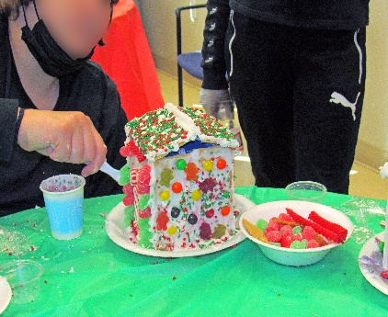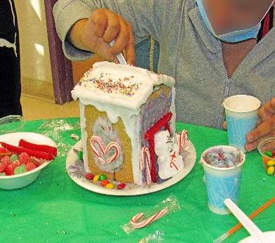
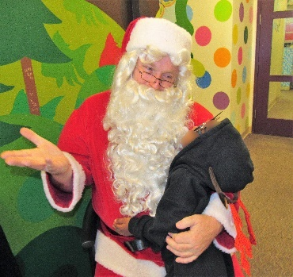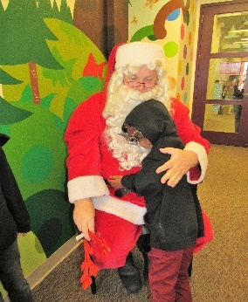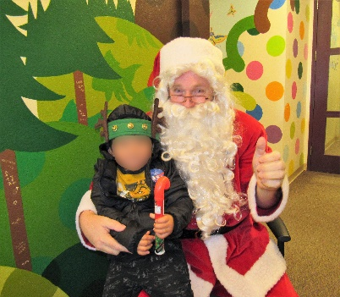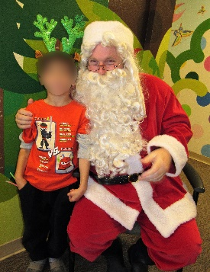
The party was so much fun for the kids and all of us! We’re so happy to be back!

Reminder about our Scholarship Program:
We are reaching out to you to inform you, the children and their parents that you work with, about our scholarship program. We are offering six (6) $2,500 scholarships for high school seniors who are going to attend a trade school or college. They must apply before their 18th birthday!! Applications can be filled out on-line starting October 1, 2021 thru January 31. 2022 with the Public Education Foundation Scholarship program.
To find the scholarship information and application go online to https://thepef.org/scholarships and locate the Children's Service Guild Scholarship. Requirements are that you are a senior in a public or private school in Clark County, Nevada. The student must have overcome personal challenge(s) and been touched by the court system (Department of Family Services and Department of Juvenile Justice Services). Applicants must plan to attend a trade school or college upon graduation from high school, have at least a 2.0 unweighted GPA and submit the application prior to their 18th birthday. They also must have two letters of recommendation from non-family members. One letter needs to be from a person involved with the family and juvenile justice system.
If you have any questions concerning this scholarship or filling out the application; please feel free to contact me, KarenZiegler
Scholarship Chairman kzcsguild@gmail.com
702-218-3739 or Kelsey Rodman the PEF Scholarship PLUS Director, at 702-799-1042 Ext. 7411, kelsey.rodman@thepef.org.
We are hoping that you know some hardworking teens that meet these criteria and would like a helping hand with continuing their education. We want them to succeed in life by giving them a good start! Deadline is January 31, 2022, please don’t miss this opportunity.
May God bless you all.

