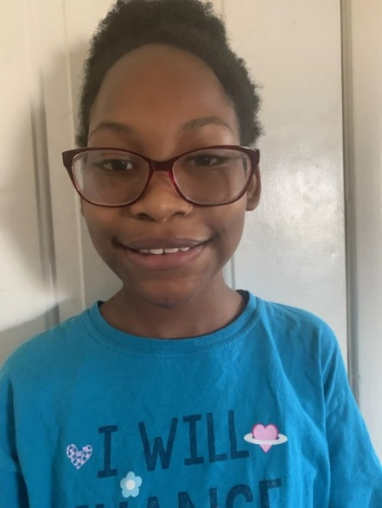

- Jaela dreams of a kitchen to learn how to bake!
- On top of thinking about baking yummy things, she enjoys reading comic books and watching Disney's Descendants.
- Playing with LOL dolls is something that is sure to bring out Jaela's smile.
- Outdoor activities tend to be a hit with this girl, and she is keen on attending cheerleading, dance, and theater club through her school.
- Pink and purple are the best colors for her at the moment.
- Buffets are a favorite of Jaela's as well as Buffalo Wild Wings. Everything from French fries, pizza, quesadillas, burgers, and Mexican food are things she will eat.
- Jaela likes to be a help in her foster home and does well with adults.
- She appreciates her friends at school and in her foster home.
- Jaela dreams of a trip to Disneyland-"I've never been, but I've heard a lot of cool facts about it."
- Science, math, and reading are all subjects this fourth grader enjoys.
- She was asked what some things are that she would like in a family (such as pets, other children, etc. and she answered, "A nice family. The other things don't matter."

Family Type Desired: All family types will be considered for Jaela. She has significant connections she will need to maintain following placement
DFS Adoption Recruiter:
Michelle Pollock
M1P@ClarkCountyNV.gov

