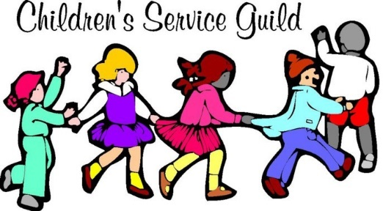
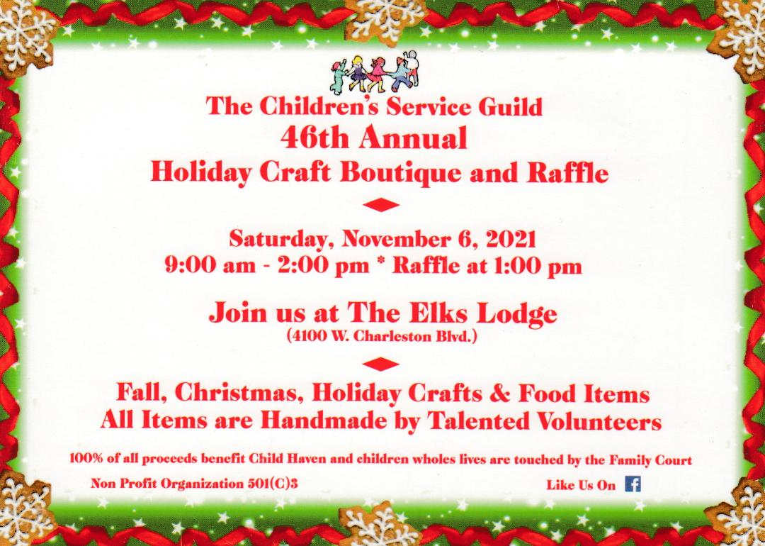
Hello everyone,
With just a little over a month away, excitement is abounding for us at CSG about this incredible, fun event. Please come with your family and friends plus spread the word about our fundraiser and thework we do for the children in SO. NV touched by the Family and Juvenile Justice Courts. Click on the link to see pictures of some of the handmade holiday items made by our wonderful members and friends. We hope to see you there with bells on! 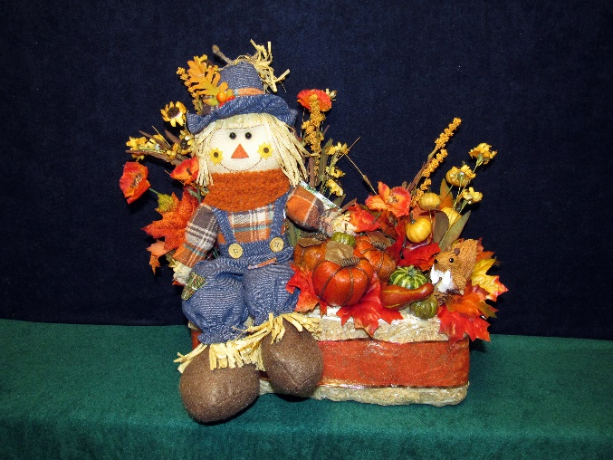 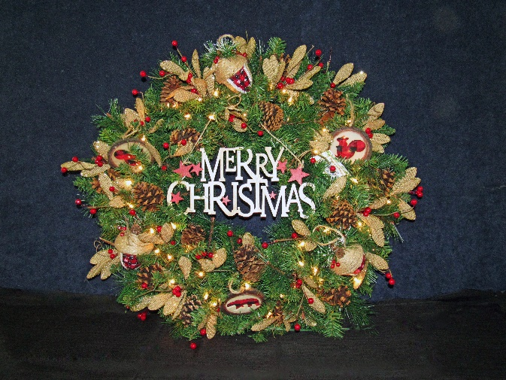Happy scarecrow for your fall décor! Beautiful lighted wreath for your home or office!
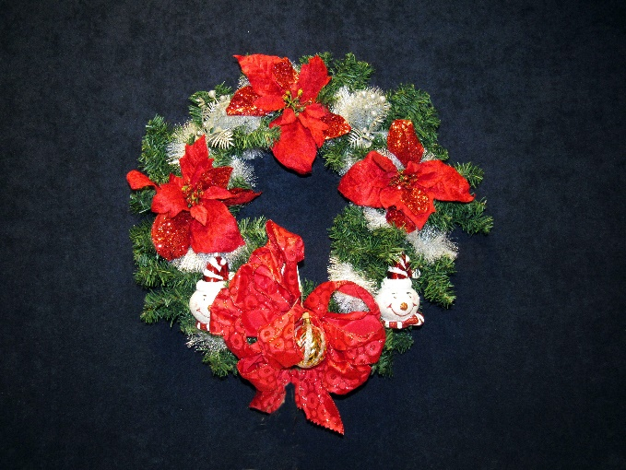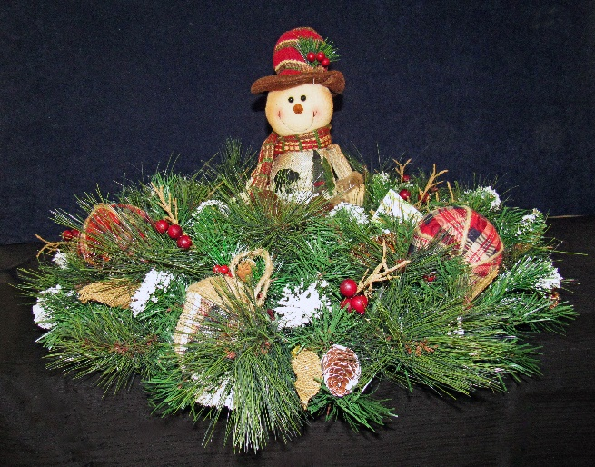
Another beautiful holiday wreath! Smilin’ snowman to brighten up the day!

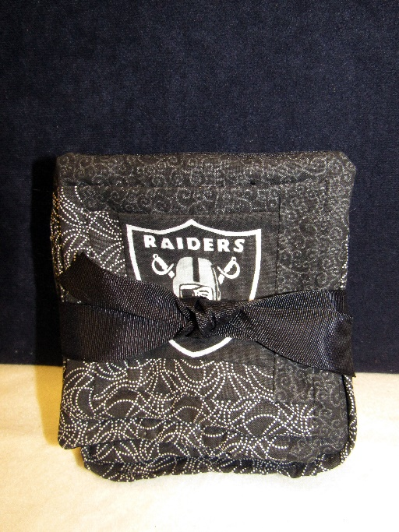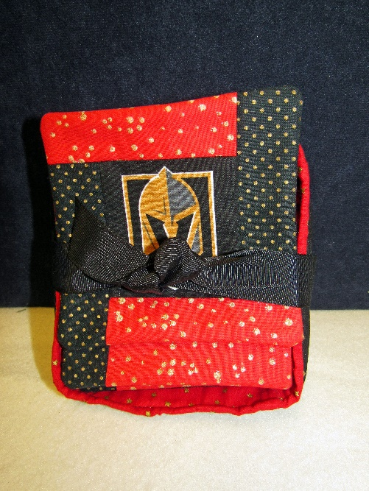
Raiders and Golden Knights coasters! Celebrating Vegas’ two home teams!
Plus, we have lots more, this is only the tip pf the iceberg! Lots of homemade kitchen goodies and an amazing raffle with lots of prizes like a big screen TV, cash, gift certificates for various businesses and more! And the Las Vegas high School Madrigal Choir will sing holiday songs throughout the event as they do every year! So come on down and kick off your holiday in a fun and festive way while helping us help the children!

