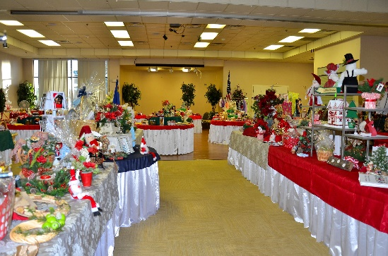
Annual Holiday Craft Boutique and Raffle
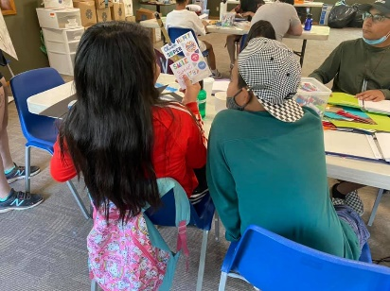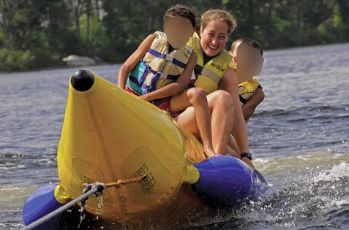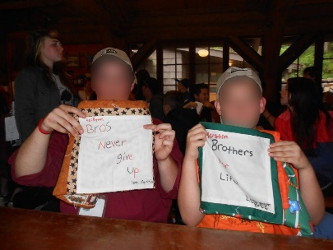
In June 2021, we sponsored 30-40 Foster Care Children to be able to attend Camp to Belong at the Pathfinder Ranch. We do this every year and it’s a week long adventure where siblings are reunited. We also make commemorative pillows for each one to sign for their sibling to take with them at the end of the week. Fun Times.
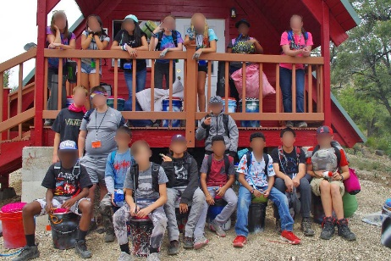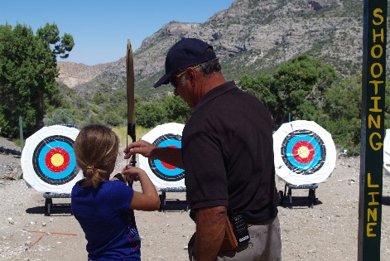
We also sponsor 30 kids to be able to go to Potosi Pines Camp every summer for a week to be with their siblings and have a grand old time!
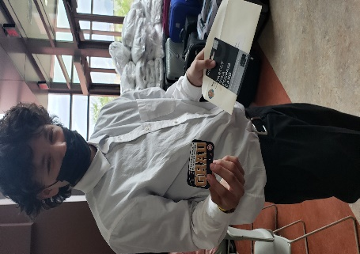 We also gave gift cards to 80 Foster Care Youth for their High School graduation! We are very proud of them.

