There are a ton more events but these listed have no entry fees
They may have food, Santa pics or games that cost but the viewing of the lights and entry is free.
Bellagio
The Bellagio Conservatory & Botanical Gardens will feature a winter wonderland available for viewing 24 hours daily from Dec. 7 through Jan. 4. Admission is free. bellagio.com
Boulder City
The annual Christmas tree lighting will feature entertainment, hot chocolate and more at 6 p.m. Dec. 6 at Frank T. Crowe Memorial Park, 640 Nevada Way. The Christmas Parade of Lights on Lake Mead, featuring decorated boats, will be 5 to 8 p.m. Dec. 7 at 322 Lake Shore Road. Santa’s Electric Night Parade, featuring Santa Claus, will be at 4:30 p.m. Dec. 7 at the Boulder City Historic District. visitbouldercity.com
The Christmas Express
Western Elite’s 10th annual Christmas Express celebration will be from 4:45 to 9 p.m. Dec. 6, Dec. 7 and Dec. 12-Dec. 14 at Western Elite’s Lincoln County Ranch, located 60 miles outside of Las Vegas. The free event features train rides, hay and carriage rides, lights, farm animals, Santa and Mrs. Claus, a nativity scene and more. westernelite.com/christmas-express
Clark County Museum
Heritage Street houses and buildings will be decorated for the holidays from Nov. 29 through Jan. 3 at 1830 S. Boulder Highway, Henderson. Self-guided tours require museum admission; $2 for adults and $1 for children. On Dec. 13-14, the museum will host its annual Heritage Holidays event, featuring Santa visits, strolling carolers, a craft tent and complimentary light snacks, from 5 to 8 p.m. Admission is free for the event. facebook.com/clarkcountymuseu
The District
A tree lighting event with a laser light show, falling snow, performances by the Henderson Symphony and the Las Vegas Young Entertainers, Santa and more, will be 6 to 8 p.m. Nov. 30 along Main Street at 2240 Village Walk Drive, Henderson. Santa photos will be offered daily from Nov. 29-Dec. 24 in the courtyard off Main Street. On Dec. 23, Chabad of Henderson will present the Grand Menorah Lighting event, featuring entertainment, dreidels, doughnuts and music at 5:30 p.m. shopthedistrictgvr.com
Ethel M’s Holiday Cactus Garden
Ethel M’s 3-acre cactus garden is decorated for the holidays and on display through Jan. 5, from 5 to 10 p.m. daily (closed Dec. 25; open until 8 p.m. Christmas Eve and New Year’s Eve) at Ethel M Chocolate Factory & Botanical Cactus Garden, 2 Cactus Garden Drive. The attraction also features food trucks, an outdoor movie theater playing holiday clips and selfie photo opportunities. Visits with Santa are 4 to 9 p.m. Fridays through Sundays through Dec. 22. Admission is free.
Fremont Street Experience
The annual Christmas tree lighting with Mayor Carolyn G. Goodman and Patrick Hughes, president of Fremont Street Experience, will be on Dec. 11. The 50-foot tree will be displayed below the 49.3 million energy-efficient LED lights of the renovated Viva Vision canopy. Santa photos will be available at the event, and the tree will be up through the holiday season. On Dec. 22, a 20-foot grand menorah will be lit at a ceremony led by Rabbi Shea Harlig from Chabad of Southern Nevada. The menorah will be up through the Hanukkah season. Admission is free to both events. vegasexperience.com
Lakes Festival of Lights
The 19th annual Lakes Festival of Lights Boat Parade event will be 5 to 7:30 p.m. Dec. 14 at Lake Sahara North Park, 2500 E. Lake Drive. The City of Las Vegas will provide entertainment, and the parade will begin at 6 p.m. Admission is free.
The Linq Promenade
“Holiday Magic” features festive decor, entertainment and more, from Nov. 26 to Dec. 25 at 3545 Las Vegas Blvd. South. The holiday show features seasonal songs, LED-costumed dancers, stunt acrobatics, street “elves,” and snowfall at the top of the hour from 6 to 9 p.m. Thursdays through Sundays (and Dec. 23-25). Strolling piano and entertainment will be 6 to 9 p.m. Mondays and Tuesdays. An interactive 12-foot tree also will be on display. thelinq.com
Night of Lights
St. Jude’s Ranch for Children invites families to its 13th annual Night of Lights from 5 to 8 p.m. Dec. 14 at 100 St. Judes St., Boulder City. The festive event includes hayrides, cookies and cocoa, entertainment, holiday music, games, Santa and more. Admission is free; wristbands for activities are $10. stjudesranch.org/events
Sam’s Town
Mystic Falls Park opens its 25th season with a tree lighting event honoring veterans and active duty service men and women on Nov. 27. The event begins at 4 p.m. with the lighting at sundown (around 4:30 p.m.). The attraction will feature seasonal decor, snow and a winter wonderland-theme and laser light show 5 to 10 p.m. hourly through Jan. 1. From Nov. 28-Dec. 22, Santa visits will be offered 4 to 8:30 p.m. Thursdays and Fridays and noon to 8:30 p.m. Saturdays and Sundays at 5111 Boulder Highway. Admission is free. samstownlv.co
Santa’s Wonderland’
Bass Pro Shops offers photos with Santa, games, crafts and activities daily at 8200 Dean Martin Drive. Hours vary. For details, visit basspro.com/shop/en/santas-wonderland.
Silverton
Beginning Dec. 7, Underwater Santa will be available for visits noon to 1:15 p.m. and 2 to 3:15 p.m. on Saturdays and Sundays through Dec. 22. silvertoncasino.com
WinterFest
Henderson hosts its annual event Dec. 13-14 at Henderson Events Plaza, 240 S. Water St. The festival opens 6 to 8 p.m. Dec. 13, with a tree lighting ceremony featuring Mayor Debra March and Santa, fireworks and entertainment. On Dec. 14, the festival features strolling carolers, entertainment, activities, a parade and more, 2 to 8 p.m. The WinterFest Evening Light Parade will start at 5 p.m. along Water Street. Admission is free. cityofhenderson.com
Wynn Las Vegas
The main atrium at the resort features holiday decor and intricately crafted villages inspired by “Gulliver’s Travels.” wynnlasvegas.com

See more on next page
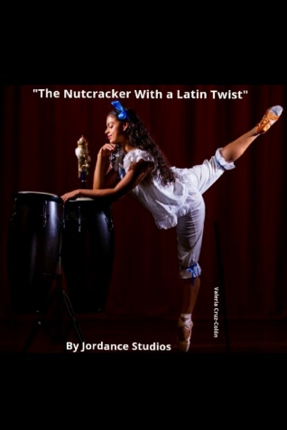
Jordance Studios Presents – “The Nutcracker with a Latin Twist” Jordance Studios masters in Ballet and Salsa proudly presents its unique annual production of "The Nutcracker With a Latin Twist" Keeping the classical integrity at the core of the performance and sparkled with a joyful and colorful Latin twist we strive to show that classical ballets are more than just an outdated art form, and they can be reimagined with an ethnically diverse background and new and interesting choreographic elements. A Holiday Classic to be enjoyed for all the family.
https://www.showtix4u.com/event-details/34830
$25 | $18 for children under 12 & seniors over 60
West Las Vegas Library 951 W Lake Mead Blvd. Las Vegas, NV 89106
Friday, 06 December 2019: 6 - 8:15PM
Saturday, 07 December 2019 12 – 2:15PM & 6 – 8:15PM

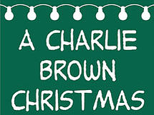
Rainbow Company Youth Center Presents – “A Charlie Brown Christmas”
A beloved holiday classic springs to life in this faithful adaptation of the TV special that debuted in December 1965. Join Charlie Brown, Linus, Lucy, Sally, Snoopy and friends as they embrace the holiday season with classic favorites like "Christmas Time is Here" and search for meaning among the holiday traditions. After the performance, gather in our indoor Winter Wonderland with family and friends to sing along - warm apple cider in hand - to your favorite holiday tunes accompanied by local choir groups.
https://ci.ovationtix.com/35056/production/1008469
$6
Charleston Heights Arts Center 800 S. Brush St. Las Vegas, NV 89107
Friday, 06 December 2019: 7PM
Saturday, 07 December 2019: 2PM & 7PM
Sunday, 08 December 2019: 2PM
Friday, 13 December 2019: 7PM
Saturday, 14 December 2019: 2PM & 7PM
Sunday, 15 December 2019: 2pm

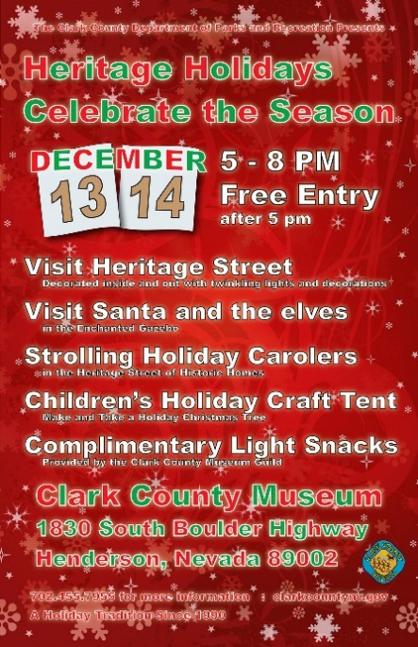
Heritage Holidays Celebrate the Season
Now in its ninth year, the Heritage Holidays event is the only time when the public can visit Heritage Street at night to see the museum's unique collection of houses lit up for the holidays. The two-night festival includes holiday music and strolling carolers from Green Valley High School's acclaimed Madrigals choir, a craft tent where children can make their own holiday decorations, visits with Santa, and plenty of hot cocoa.
http://www.clarkcountynv.gov/parks/Pages/clark-county-museum.aspx
Free
Clark County Museum 1830 South Boulder Highway Henderson, NV 89002
Friday, 13 December 2019: 5PM – 8PM
Saturday, 14 December 2019: 5PM – 8PM

Party at the Pearson: Ginger House Party
Parents can enjoy a night out, while the kids enjoy a fun night of games, craft project, dinner, and a movie. Dress up theme: Santa Hat or Ugly Sweater
http://www.clarkcountynv.gov/parks/events/_layouts/15/clarkcountysp/eventdetails.aspx?source=http://www.clarkcountynv.gov/parks/events/Lists/Events/month.aspx&id=2776
702-455-1220
$10 per child
Pre-register online or at front desk.
Must register one week prior to event.
Pearson Community Center, 1625 W. Carey Ave, N Las Vegas, NV 89032
Friday, 13 December 2019: 6PM

Magical Forest at Opportunity Village
What began as a modest holiday event to thank donors and in-kind contributors for helping build Opportunity Village’s West Oakey Campus has blossomed into the marquee holiday even in all of Las Vegas. 2019 marks the 29th season of Opportunity Village’s largest fundraiser. In 2018, Opportunity Village added over 1 million new lights to the Magical Forest and featured a synchronized music show with dancing lights that could be seen from any vantage poin tof the park. The Illumination Experience lighting spectacular will return in 2019 and run every 30 minutes from the time the Forest opens until it closes. Added bonus: Buddy the Elf and crew will be a part of Opportunity Village’s Magical Forest festivites this holiday season!
https://www.opportunityvillage.org/what-we-do/events/magical-forest
Passport Admission: $22 | General Admisson: $15 | ELF THE MUSTICAL: Guaranteed Seating: $2 | Four Pack – Magical Forsest Passports: $80 | Six Pack – Magical Forest Passports: $108 | Ages 3 and younger are free
6300 W Oakey Blvd Las Vegas, NV 89146
November 29-24
December 26-30
January 1-4
Opening Nightly at 5:30PM
ELF THE MUSICAL:
November 29, 30, 7, 14, & 21: 5:45PM & 8PM
December 1, 4-6, 9-13, 15, 18-20, 22-24, & 26-28: 545PM

Bass Pro Shops: Santa’s Wonderland There are A LOT OF details regarding this one. If it is not included, I totally understand.
Santa’s Wonderland is the ultimate free family Christmas event. The magic returns to Bass Pro Shops and Las Vegas families are invited to enjoy this enchanting Christmas village offering FREE 4×6 studio-quality photos with Santa and free family holiday activities including fun crafts and games.
Features include rustic Christmas cabins, holiday characters and live elves set amongst a dazzling backdrop of snow-covered hills and illuminated Christmas trees. The Santa’s Wonderland Christmas village offers remote control trucks, laser/ foam toy arcade, Lincoln Logs building area and much more. Kids can also enjoy free crafts, coloring stations and write a letter to Santa.
Guests can reserve their free visit and photo with Santa using the free Bass Pass system. Visit the Bass Pass Ticket Depot located at the entrance of Santa’s Wonderland to pick up a time-stamped pass. Guests can register online for a digital Bass Pass to see Santa, allowing them time to explore Santa’s Wonderland or shop while they wait. Updates and reminders will be sent via text messages.
In addition, Bass Pro Shops stores are designated toy drop-off stations for Toys for Tots. Families that bring a new toy to donate Saturday, November 30 and Sunday, December 1 will receive a FREE premium photo package valued at $20.
https://www.basspro.com/shop/en/santas-wonderland
Free
Bass Pro Shops, 8200 Dean Martin Dr. Las Vegas, NV 89139
November 16-December 24th

