Hi there everyone. Happy Mother’s Day to all!
What an exciting and sad month last month for us at CSG.

*We had our 6th Annual Easter Part on April 16, 2022, for the kids on Child Haven Campus. Tons of fun with an egg hunt, pictures with our Easter Bunny Evan, lots of treats and bubble wands for all! Kudos to all who work with the children and who helped with the party!
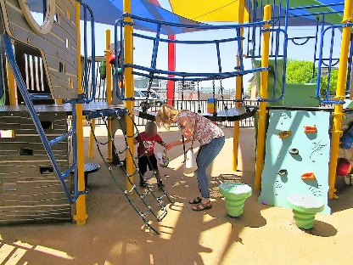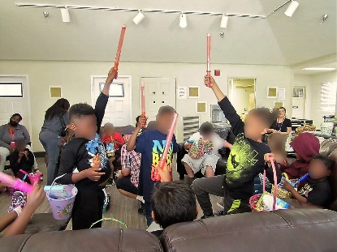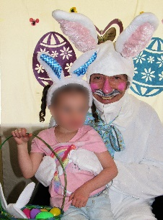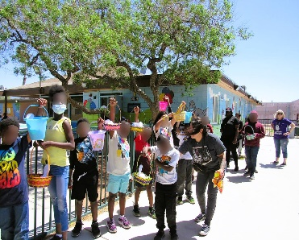
*We also funded DFS’ Easter Party on April 15, 2022, with baskets for 400 foster children plus Easter Egg Hunt supplies, gift cards for the teens and entertainment. The kids and everyone had a blast!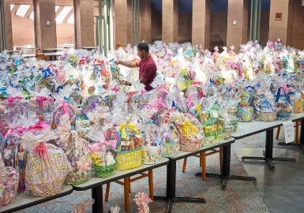 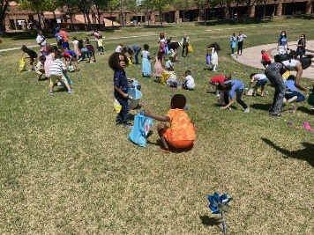 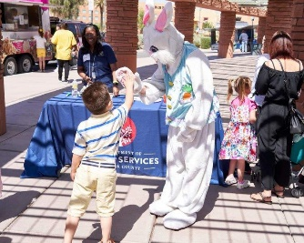 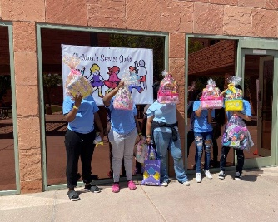
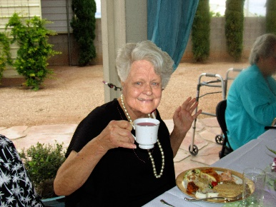
*With heavy hearts, we are sorry to bring news that our beloved friend, Guild member for 28 years and past President, Sharon Friend, passed away on April 13, 2022. So incredibly sad but all of us at the Guild and everyone she knew are very blessed to have had her in our lives. She was an extremely caring and loving gal who taught everyone how important life and helping others is. She was a strong, wonderful, artistic woman and always gave 100% in all she did. She loved the children we, the Guild, help and worked tirelessly for them to make their lives better. We will deeply miss you Sharon, but we know you are in God’s loving arms, and we will meet again.
If you would like, Sharon and her family requests that in lieu of flowers, you can donate in Sharon Friend’s name to:
The Children’s Service Guild of Southern Nevada P.O. Box 44309 Las Vegas, NV 89116.

