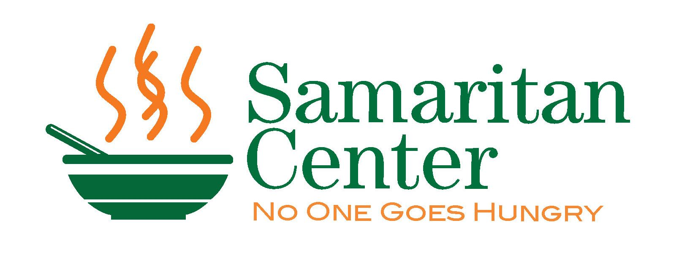
Annual Samaritan Center
Soup Bowl Open Golf Tournament

We are pleased to invite you to the 18th Annual Samaritan Center Soup Bowl Open Golf Tournament, which is being held on Monday, August 9th 2021. Through your participation in this tournament we hope to raise over $30,000 to support the Samaritan Center. Beginning as a brown bag lunch program thirty-eight years ago, the Samaritan Center now serves hot meals 365 days. Our guests include both the young and the not -so- young, those who are well-educated and those who are not, individuals and families, people who are well and those who face the challenge of illness...men, women and children who have in common their humanity, their poverty and their sincere gratitude for a place of safety, warmth, and nutritious meals offered every day of the year. More than 90% of the money that is used to support the Samaritan Center comes from local sources and the proceeds from fundraising events such as the Soup Bowl Open. We depend on people like you to support the work we do. Below are some quick details about the tournament.

- The Links at Erie Village, East Syracuse, NY
- Monday, August 9th, 2021
- Registration and lunch starting at 11:30 am
- Use of the driving range and practice facilities
- Shotgun start 1 pm
- Four-person captain and crew
- Dinner immediately after golf (depending on COVID-19 regulations)
- Long drive, closest to the pin, hole in-one, team prizes and raffle prizes
- We will be following all COVID safety procedures and guidelines

To register, please return the registration page of this letter along with your check made payable to The Samaritan Center. Please respond by July 1st. Space will be filled on a first come, first serve basis. For more information, call the Samaritan Center at 315-472-0650 ext. 204.
The Samaritan Center is a tax-exempt organization.

We look forward to seeing you on August 9th, 2021

Kindest regards,

The Samaritan Center Soup Bowl Committee
Annual Soup Bowl Open Golf Tournament

Monday August 9th, 2021
To reserve a spot/team, please send this registration form by July 1st with a check made payable to The Samaritan Center. The earlier you return this form with your payment the more likely you are to assure yourself/team a spot in this year’s tournament. We register teams on a first come, first served and we will cut-off registrations at 32 teams.

Name: ________________________________________________________________________________
Company: ________________________________________________________________________________

Address: ________________________________________________________________________________

Email Address: _____________________________________________________ Phone #: ___________________
Double Eagle Sponsor – Your company receives a foursome in the event - please complete team names on the back of this form; one tee sponsorship; your company’s banner displayed at the event; listing on the program, Samaritan newsletter, web page and marketing materials; table cards displaying your logo on each dining table at lunch and dinner; ability to display company materials at the event and special recognition at lunch and dinner. | $3,000
Eagle Sponsor- Your company receives a foursome in the event – please complete team names on the back of this form; a tee sponsorship; listing in the event program; Samaritan newsletter, web page and marketing materials. | $2,000
Cart Sponsor - Your company receives one hole sponsorship; your logo displayed on each cart during the tournament; listing in the event program and on the web page | $1,500
Welcome Gift Sponsor – Your company’s logo will be printed on the welcome gift distributed to registered players the day of the event. | $1,500
Dinner or Lunch Sponsor - Your company receives a hole sponsorship; your company’s logo displayed during dinner or lunch; table cards displaying your logo on each dining table; listing in the program and on web page and special recognition at dinner or lunch. | $1,000
Business Sponsor – Your company receives a tee sponsorship and a foursome registration. Please complete team names on the back of this form. | SOLD OUT! | SOLD OUT!
Captain a Foursome -. Your company receives a foursome registration – please list team names on the back of this form; lunch and dinner included for each participant. | SOLD OUT! | SOLD OUT!
Tee Sponsor– Your company’s name or logo displayed at a tee on the golf course and listed in the event program. | $250
Individual Golfer Registration - Individual registration with lunch and dinner. | SOLD OUT! | SOLD OUT!
Donation –Sorry I can’t make it but I would like to donate unrestricted funds to help underwrite the costs of the golf tournament. | $______
 | Total

If you plan to captain a foursome, please list the names, addresses and phone numbers of the members of your foursome below. If spots are unfilled but you plan to fill them before the tournament, mark in the name space(s) “TBA”. If you’d like us to help fill your foursome, mark the name space(s) “HELP”.

Name | Address and Email Address | Phone Number
1.
2.
3.
4.

Please mail this form along with your check payable to The Samaritan Center – 215 N. State Street Syracuse NY 13203 www. samcenter.org - 315-472-0650
Or complete payment information below

Name on Credit card ___________________________________________________________
Credit Card number____________________________________________________________
Expiration________________ CVC Code_______________________ Zip Code_____________

Thank You for your support!!

