CUSTODIAL REQUEST (Give to Administrator)

TO: ____________________________________________ TODAY’S DATE: __________________________________

FROM. _____ BEST CONTACT NUMBER: ___

EVENT DESCRIPTION/TITLE: _______________________________________________________________________

PROGRAM/GROUP NAME: _________________________________________________________________________

APPROX # EVENT
ATTENDING. DURATION _________________________

EVENT EVENT
DATE. TIME______________________________

SET UP DATE & TIME: ____________________________________________________________________________
ROOMS NEEDED:
ADDITIONAL NEEDS:

MICROPHONE/ HANDHELD MICROPHONE
DVD
CHURCH LAPTOP (POWERPOINT ONLY)

EASEL
LECTERN
NUMBER OF TABLES (ROUND LG RECTANGULAR SM RECTANGULAR)

NUMBER OF CHAIRS PER TABLE

FOOD (TABLE SIZE/LOCATION.

COFFEE (TABLE SIZE/LOCATION.

MEMORIAL SERVICE (CHAPEL SANCTUARY )

INURNMENT (NICHE. GROUND )

DO YOU REQUIRE A CUSTODIAN ON DUTY? YES____ NO

Diagram FLOOR PLAN SET-UP on the reverse side for Lindsay Hall.

Administrator Custodian

. Check with the office to see which custodian will be on duty

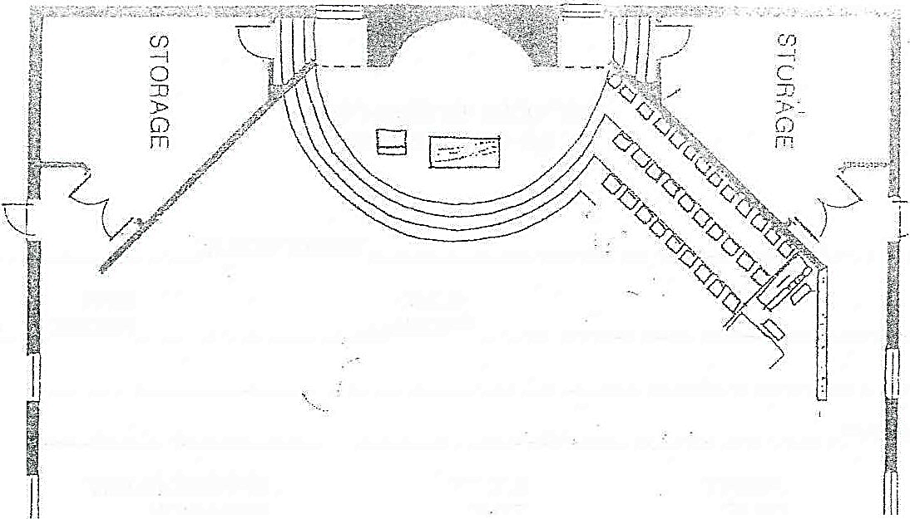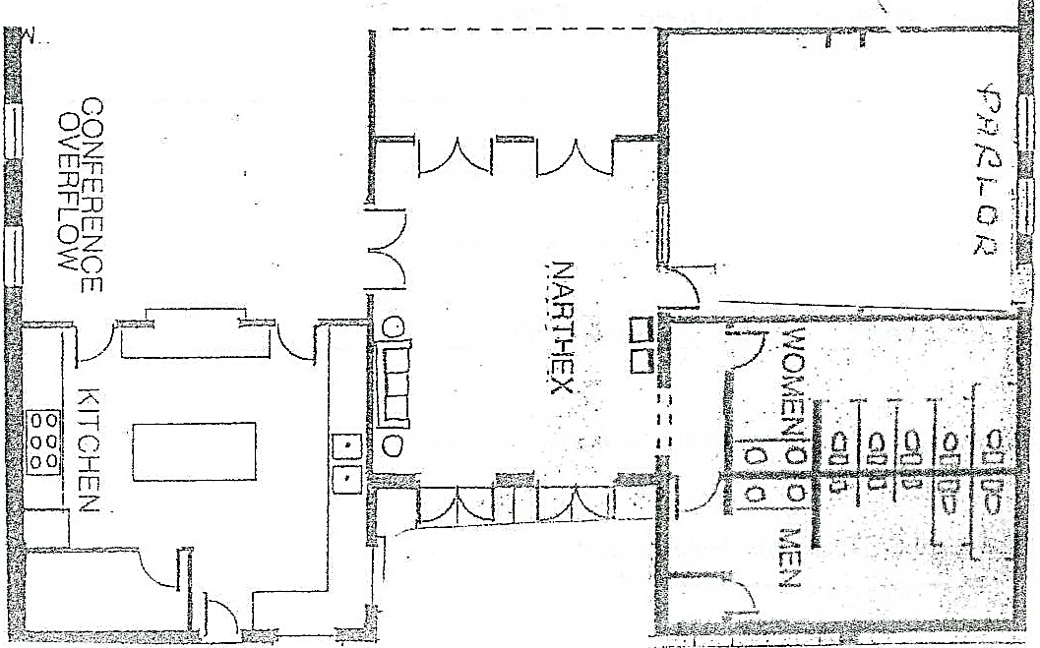
I
J
l·MI: -+- -
-----
- - - -

Table Sizes: 6 ft Round; 6 ft Rectangular; 4 ft Rectangular

