Reflections from our Executive Presbyter
~Deb’s Deliberations ~
Recipes for Congregational Health

- Release traditions that are limp or lifeless.
              - Know that Grief will be involved!

- Avoided Grief calcifies into Bitterness and Blame

- Acknowledged Grief opens us up, creates insight,
and eventually blossoms into Growth and
Gratitude

- Honor traditions without being defined – or
confined – by them.

Remember that…
We are defined by our connection with Jesus Christ our Savior and Lord.

Deep Listening (not to be confused with placid agreement!) = Holy Love
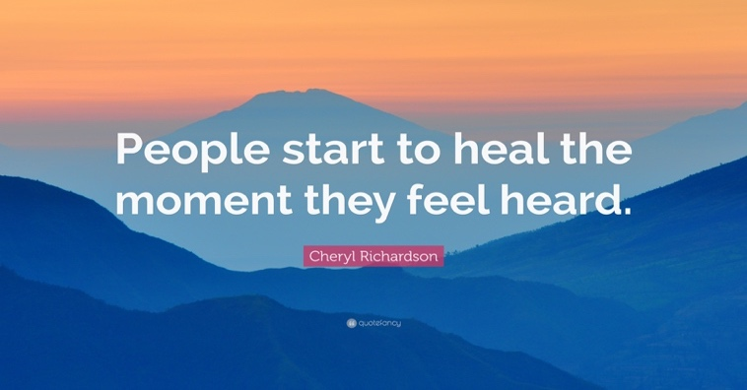
Trust + Relationships = Holy Space

New possibilities
and fresh mission opportunities
grow and blossom in this sort of culture!

What does “Holy Space” look like in our Congregations?

- Clear Sense of Purpose
  - What does your particular congregation offer to the world beyond its members that no other body can offer? How does your congregation share the love of Jesus Christ in concrete ways?

- Flexible Mindset
  - Are you willing to change your worship time for the sake of local outreach and collaboration? Are you willing to experiment with worship, education, and mission/outreach events to see what works -- and what does not -- so you can best be a vibrant mission outpost in your community?

- Gratitude

- Generosity

Our vulnerabilities and mistakes provide opportunity for God to work among us, teaching and strengthening us for the sake of our witness to the kingdom – here and now!

“No one is brought to life through curses, gossip, accusations, or blaming.” -Henri Nouwen

We have two choices: transmit pain or transform it!

Will we be vessels of blinding bitterness
or open-eyed blessing?

Every day of our lives,
God is quietly – and relentlessly -- working,
bringing us out of a Desert of Terror, Fear,
and Anxiety into a Pasture of Wide-Eyed
Wonder, Joy, and Creativity.

When we trust that our unknown future is BLESSING rather than BURDEN, we will see the way in which God paints vibrant possibilities into our personal and public lives!

- How will we, as disciples, give voice to gratitude as we learn to trust?

- How will we resist grumbling?

- How will we build one another up without offering mindless platitudes?

We are not called by God to be a perfect people.

We are being perfected—drawn into God’s kingdom – by becoming a called people.

