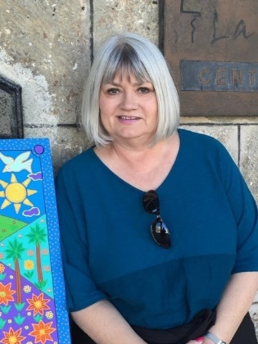
Marilyn Borst is Associate Director for Partnership Development of The Outreach Foundation, a Presbyterian mission agency which celebrates its 40th anniversary this year. She works with churches around the USA to help them discern God’s call to global engagement while connecting them to that work alongside the global church in Africa, Latin America and the Caribbean, Asia and the Middle East. She travels extensively, nurturing relationships with church leaders, assessing ministry initiatives and leading short-term vision teams especially to Cuba, Lebanon, Iraq, Egypt, Syria and Israel/Palestine. Her heart for the church in difficult places has also brought her to Iran, Pakistan and North Korea. Prior to joining The Outreach Foundation staff, Marilyn served for over 6 years as Director of Global Ministry at Peachtree Presbyterian Church in Atlanta where she oversaw the international partnerships of this 8,000-member congregation in over 33 countries. Marilyn holds a B.A. in Classical Studies from Calvin College (Grand Rapids, MI), an M.A. in Art History from Michigan State University, and an M.A. in Theology from St. Thomas University (Houston). She has participated in four archeological digs in Jordan and Egypt and taught as adjunct faculty at the University of Houston for 20 years. She is ordained as an elder and has been married to Mark Borst for 40 years. The Borsts reside in Atlanta where they are endlessly entertained by the antics of their precocious cats, Anthony and Cleopatra.
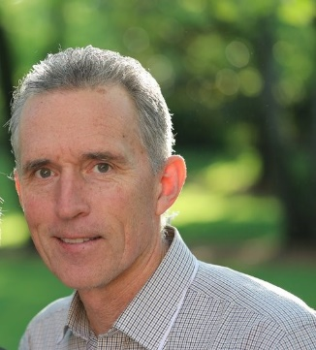
Rev. Dr. Mark Mueller serves The Outreach Foundation as Director of Development. After working for ten years as a teacher and school administrator, Mark heard God’s call to pastoral ministry, and he served congregations for twenty-three years. Mark earned a B.A. from the University of Arizona, a M.Ed. at BYU, a M.Div. at Louisville Theological Seminary and a D.Min. at Columbia Theological Seminary with an emphasis on Evangelism and New Church Development. Mark and his wife, the Rev. Dr. Toby Mueller, have two married daughters and one grandson.

