Ruby C. Castilla-Puentes, MD, DrPH, MBA

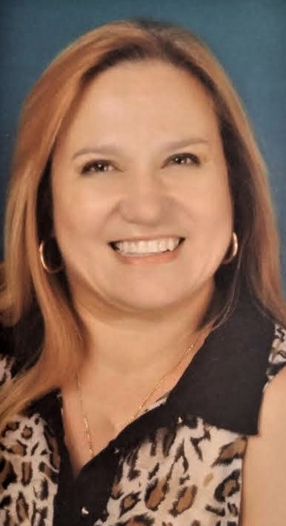

Ruby Castilla-Puentes MD, DrPH, MBA became Director, Clinical Research supporting Neuroscience Division of Janssen, Johnson & Johnson Pharmaceuticals, as well adjunct professor of Pharmacoepidemiology and Epidemiology at Temple and Drexel Universities of Philadelphia in February 2007. Dr Castilla-Puentes was born in Colombia, SA. She earned her medical degree from the Universidad Industrial de Santander. Her postdoctoral trainings included a residency in Psychiatry at the Xaverian University, fellowships in Child Psychiatry at Western Psychiatric Institute and Clinic, and in Psychiatric Epidemiology at the Graduate School of Public Health (Master and Doctorate Programs), University of Pittsburgh. Dr Castilla-Puentes also obtained an MBA degree from the Katz School of Business, with a concentration in Global and International Business.

Dr Castillla-Puentes was the Director of the Psychiatric Department of a public university hospital - Santa Clara Hospital, Bogota focusing on the development of new treatment options for psychotic disorders. She implemented a renovation process of the psychiatric inpatient unit resulting in her unit being one of the most efficient and state of the art treatment units, for this type of patients. She is also Founder member of the Colombian College of Neuropsychopharmacology (CCNP) and a longtime member of many associations, including the American Psychiatric Association, and the American Medical Association. Her research interests are new treatment development, pharmacoepidemiology, psychiatric epidemiology (in Latin American countries), and the use of Artificial Intelligence and Big Data. Her educational and training interests involve lecturing medical students, residents and graduate students, as well as participating as a graduate faculty in psychiatric-epidemiology and psychopharmacology (including University of North Carolina at Chapel Hill, University of Pennsylvania, Temple and Drexel in Philadelphia).

Dr Castilla-Puentes dedicated her career to addressing the health of the underserved, particularly racial and ethnic minority populations, and patients with psychiatric conditions. She is serving as the President of the American Society of Hispanic Psychiatry from 2020-2022 (http://www.americansocietyhispanicpsychiatry.com/meet-the-officers/) and Leading Medical Strategies at the Hispanic Organization for Leadership and Achievement (HOLA) and Mental Health Diplomats, J&J employee resources groups. She is one of the founders of “WARMI” (woman in Quechua), a network dedicated to promoting women's mental health https://www.warmimentalhealth.com

Dr. Castilla-Puentes is a longtime member of many global associations and the author/co-author of many scientific publications. In August 2020 published the book “Quijotes de la Psiquiatria.” The book pays tribute to Hispanic psychiatrists who have contributed to the progress of mental health in the US and around the world https://www.amazon.com/Quijotes-Psiquiatria-Lideres-Hispanos-Latinos/dp/B08F6R3TBD.

