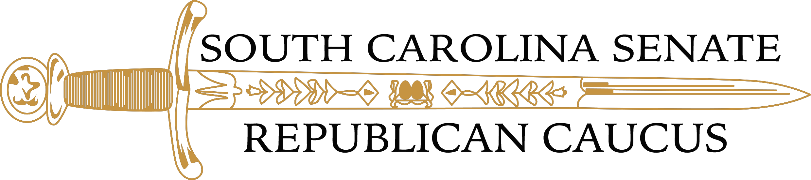
South Carolina Senate Majority
Weekly Legislative Summary

WEEK IN REVIEW: MARCH 28 – APRIL 1, 2022

Passed Third Reading, Sent to the House
S.295 – Denial of License Based on Criminal Conviction: A bill to provide that professional boards and commissions may not solely deny a license application based upon an applicant’s prior criminal conviction unless the conviction directly to the duties and responsibilities for the occupation or license being sought. Boards and commissions shall identify crimes that would lead to automatic disqualification and obtain a determination from the appropriate board of commission whether the criminal conviction is a disqualifying conviction.

S.935 – Education Scholarship Accounts: A bill to establish an Education Scholarship Trust Fund and afford certain students scholarships to use for enhanced educational opportunities. The SC Department of Education (SDCE) has responsibility for developing and administering the program. An eligible student includes a state resident who must have either attended a public school in South Carolina the previous school year, be of age five or have received a scholarship the prior year; and be Medicaid eligible, have an IEP or have a sibling in the same household wo receives a scholarship. Enrollment shall begin with School year 2023-2024 and is capped at 15,000 participating students, phased in over three years in 5,000 student increments statewide. Home school students may not participate in the program. The initial scholarship around will be $6,000 adjusted annually to reflect percentage increase per pupil, and funding will be in the annual appropriations act. Three percent of the scholarship may be held by SCDE to cover the costs of overseeing and administering the program. The scholarship may be used for educational services to educational service providers must be approved by the SCDE. Examples may include public schools, charter schools, private schools and could be used for tuition and fees, tutoring services, textbooks, approved educational materials transportation services, computer hardware or technology, examinations, or other approved educational expenses. The bill sets a window for scholarship applications and process for application and provides that parents must sign an agreement of their duties and understandings of their right being given up under IDEA, and other provisions.

S.1095 – Clemson University Regulatory Powers: A bill to establish a process with Clemson University’s organization and powers under regulations promulgated by the Division of Regulatory and Public Service Programs be in accordance with the Administrative Procedures Act. Under certain circumstances, the Division may promulgate emergency regulations to expire 180 days after filing unless the regulation expires while the General Assembly is not in session. If the filed emergency regulation expires while the General Assembly is not in session, the Division may refile the emergency regulation.

The information contained herein is prepared by the staff of the South Carolina Senate and is not the expression of the Senate. It is strictly for the internal use and benefit of members of the Senate and is not to be construed by a court of law as an expression of legislative intent. This is a compilation derived from committee staff summaries and meetings.

