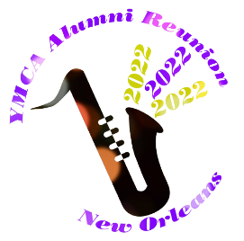
Reunion Schedule
Subject to change

Wednesday, Nov. 2, 2022

1:00 Hotel Check-in & Registration
1:30 – 3:00 Expo / Tables: Travel Club, NAYDO, YMCA Hall of Fame (Springfield College), EAF, WBF, ISC, WFYR, Secours Speciaux, World Service, National Service Project
3:00 – 3:30 Welcome & Schedule Review
3:30 – 4:00 National Service Project
4:00 – 4:15 F. William Stahl Award Presentation
4:15 – 4:45 YMCA Retirement Fund Update
5:30 – 7:00 Complimentary Embassy Suites Evening Reception
7:15 – Opening Night Dinner: Mulate’s Restaurant

Thursday, Nov. 3rd

6:30 – 9:30 Complimentary Breakfast Embassy Suites
7:30 – 8:45 General Council Meeting
9:30 – 2:00 City Tour and visit to Mardi Gras World
2:00 – 5:00 Options – World War II Museum, Cajun Cook Class, Garden District Tour, etc.
5:30 – 7:00 Complimentary Embassy Suites Evening Reception
7:30 – Option; “Dinner with Friends” or dinner on your own

Friday, Nov. 4th

7:30 – 10:30 Complimentary Breakfast Embassy Suites
Sightseeing Options: World War II Museum, Garden District, French Market, Bourbon St., French Qtr., Cajun Cooking Class
3:30 – 4:00 Celebration of Service
4:00 – 4:30 State of YMCA Alumni national update
4:30 – 5:00 YMCA of the USA update
5:00 – 5:30 Reunion Wrap-up & Evaluation
5:30 – 7:00 Complimentary Embassy Suites Evening Reception
7:30 – Option “Dinner with Friends” or dinner on your own

Saturday, Nov. 5th

7:30 – 10:30 Complimentary Breakfast Embassy Suites or (option at 10:15)
10:00 Hotel Check-Out
10:15 Optional Farewell Brunch at Brennan’s Restaurant (Reservations Required)
Remainder of day: Have a safe trip home if you are leaving us
5:30 – 7:00 Complimentary Embassy Suites Evening Reception

Sunday, Nov.6th
7:30 – 10:30 Complimentary Breakfast Embassy Suites
10:00 Hotel Check-Out

