October 24-26, 2022, YMCA Alumni Fall Festival
Blue Ridge Assembly YMCA
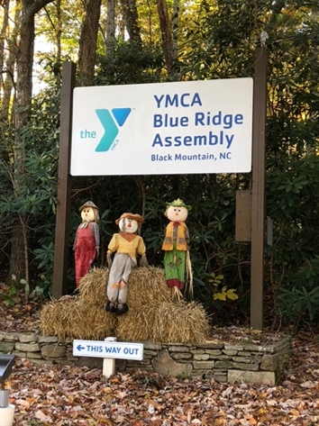
Black Mountain, North Carolina
Registration Form
Names:_______________________________________________________
Address:______________________________________________________
City & State: ___________________________________________________
Zip code:____________________ Phone: ___________________________
E-mail address for confirmation: ___________________________________
New attendee to our Fall Festival? Please check here: _____

Please select your Tuesday Afternoon free time activities: See the event newsletter for more details.
- Free time on your own
(Jigsaw puzzles will also be set up so you can relax, chat and play)
- 12:30 – 5:00 – Golf – organized by Ed Ryszkiewicz. (Email Ed.ryszkiewicz@charter.net to sign up)
- 1:30-5:00 pm Pickle Ball
Do you want to _____Learn _____Play _____Help teach new players?
(Email Charlie Glass cglass@mac.com to reserve your spot)
- 1:30-2:30 Nature Hike – led by Betty King
- 1:00 – 2:45 Black Mountain Escape $26 per person (add to registration fee). Limited to the first 15 who sign up. (Email Laura Kamperman Lkamperman1@hotmail.com to sign up)
- 3-5 pm Wine Tasting (price of admission: your favorite bottle of red wine (per couple or single) Limited to the first 20 people who sign up. (Email Kristine at kvanvon@gmail.com to reserve your spot.)

Fall Festival Registration Fee: $60.00 per person. Registration fee includes Monday night dinner at the Red Rocker Inn, Black Mountain, NC and Tuesday evening entertainment.
Registration deadline: Friday, September 30, 2022--Be sure to also make activity contacts.

Please make checks payable to “YMCA Alumni -Weatherford Chapter”.
Mail check and registration form to:
Laura Kamperman
24 Falcon Trail
Somerset, KY 42503
If you have any questions, call Laura at: 606-678-2515 or e-mail Laura at: Lkamperman1@hotmail.com.
Accommodations and Meals
Please check off if you are staying on campus at Blue Ridge Assembly, or off campus and complete the following information:

On Campus _____

Name(s)________________________________________________________

REMEMBER to make reservations at YMCA Blue Ridge by calling 828 669-8422

Let them know you are with the YMCA Alumni Weatherford group!!!

Accommodations will be $89.00/per room, per night plus tax
plus your meals and facility fees: 1 Lunch, 1 Dinner and 2 Breakfasts - $56 per person

Please indicate any dietary restrictions or food allergies:

___________________________________________________________________

Off Campus _____

Name(s) ___________________________________________________________________

Meals and facility fees for those staying Off-Campus can be purchased by calling Blue Ridge at 828-669-8422. Breakfast: $9, Lunch $11, Dinner $13 – facility fees will be charged.

