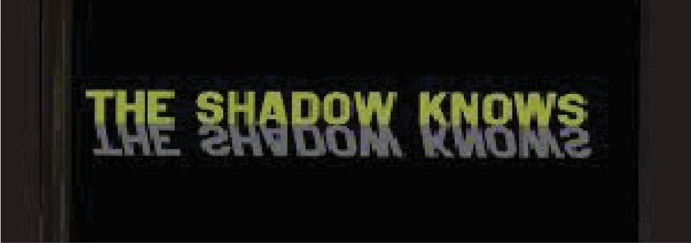

In astronomy an eclipse occurs when one celestial object passes into the shadow of another.

In astrology an eclipse is a dramatic tool the Universe uses to get our attention.

.

March Mojo Madness 2025:

Guidance for Personal Well-being During Cosmic Confusion & Chaos
From Earth, we can see, and therefore track, two types of eclipses: Lunar and Solar. In this month of March we have both of these eclipses at play. Eclipses have long been seen as powerful omens of transformation, disruption, and revelation. Given that we are in chaotic political times, the upcoming Lunar Eclipse on March 13-14 and the Solar Eclipse on March 29 symbolize deep shifts on both personal and collective levels.
The Beginning of the Beginning of March: Venus Turns Retrograde (3/1/2025)
Venus is the planet of love. This includes self-love. The human race is being catapulted into a time of great change. On average most humans tend to not like change. However, currently we don’t get to choose. It is in our faces. The retrogradation of a planet influences us to rethink the sign and domain of the planet. The current Venus retrograde sign is Aries and, and as already stated, the domain love. I encourage you to take seriously the need to engage in wise self-care putting self-care front and center in your life. The theme of Aries is self. Loving self-care is a topic that could unto itself take up pages of content. For now, I will be intentionally brief and also relevant to Jill DiSalvo’s intent in offering this newsletter as a service. Vibration 432, Inc is the name she chose to describe her humanitarian, non-profit concerns. Vibration 432 hz. is the vibration of love. The spreading of loving energy is a reflection of her intent. A no cost, easy, way to uplevel your self-love is to listen to the ambient sound of Vibration 432 hz. A free hour of listening to Vibration 432 can be found @ https://www.youtube.com/watch?v=4uR5yfLkxjA&t=16s.

Lunar Eclipse (3/13-14/2-25) – Release & Revelation
Lunar eclipses are often associated with culmination, endings, and revelations. They illuminate hidden truths and bring emotional intensity. Given the current political climate, this eclipse may trigger:
- Exposure of hidden agendas – Secrets or unresolved tensions in leadership, governance, or institutions might surface.
- Public emotional reactions – People may feel a sense of disillusionment, frustration, or a need to demand justice.
- Personal reflection – On an individual level, people may feel the urge to let go of past burdens, reassess their values, or end cycles that no longer serve them.
This eclipse suggests that something needs to be uncreated before something new can emerge. It could bring a moment of reckoning before moving forward.
Mid-March Madness: Mercury Retrograde (3/15/2025)
Immediately following the eclipse on 3/15/2025 Mercury turns retrograde. Similar Venus this Mercury retrograde is also in Aries. It promises to generate re-thinking of our personal identities. Thus, you may find yourself re-thinking who you are and who you want to be. March is an excellent and recommended time to engage in self-reflection.

Solar Eclipse (3/29/2025) – New Beginnings & Power Shifts
Solar eclipses represent fresh starts, resets, and bold changes. They are times of realignment, often bringing sudden shifts in leadership, policies, or collective direction. Given the unstable political landscape, this eclipse could coincide with:
- Unexpected leadership changes or decisions – Political figures may rise or fall, new policies might be introduced, or global events may take a surprising turn.
- A sense of fate or destiny – People may feel a push toward decisive action, whether in politics, personal life, or activism.
- Personal empowerment – This eclipse invites individuals to step into new roles, take risks, and shape their futures rather than being defined by past mistakes.

How These Universal Energies Will Affect You
For the average person, these retrogrades and eclipses may bring feelings of uncertainty, urgency, and transformation. It’s a time to remain adaptable, avoid making impulsive decisions out of fear, and trust that shifts—though chaotic—the times are leading toward change. Just as in the cycle of creating and uncreating, something must be dismantled (Lunar Eclipse) before something new can be built (Solar Eclipse).
In essence, these eclipses signal a turning point—both in the world and within ourselves. Those who resist change may feel lost, while those who embrace transformation will find new pathways opening. Support yourself to find new pathways remember to listen to Vibration 432. If you want to learn more about eclipses I recommend https://www.astrologyzone.com/all-about-eclipses-a-guide-for-coping-with-them. This is an article written by internationally well-respected astrologer, Susan Miller. Alternatively, if you find you are curious about the benefit of metaphysically inspired consultations, this March is an excellent time to seek guidance. Should you wish to know more about how the March eclipses will impact you I am available to “read” your astrology chart. To learn more about the logistics and also what you will gain personally e-mail me at Hattie@HattieParker.com. Use the subject line “March 2025 Eclipse Season”. I will contact you to explain various options for upgrading your cosmic self-understanding.
In closing I repeat you will serve your well-being while being vigilant in your commitment to personal self-care and love. These are challenging times. The more you mobilize the grit to be resilient the better able you will be ]to navigate confusion and chaos.

