AAUW Austin Public Policy
Advocacy Alert 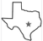 June 5, 2026
Meet the 2026-27 Branch Public Policy Leadership Team
Mary Ellen Scribner, Chair. Focus and Subcommittee Chair: Public Education – PreK-12 & Higher Education
Jackie Hardee, Focus and Subcommittee Chair: Elections and Voting (Also monitor state and federal voting rights legislation)
Suki Steinhauser, Focus and Subcommittee Chair: Women’s Health and Economic Issues Organize presence at marches & rallies)
Save the Date: An organizational meeting for the 2026-27 committee will take place on
Thursday, August 27, 2026, at 10 a.m. via Zoom.

Vote NO on SAVE Act 2.0
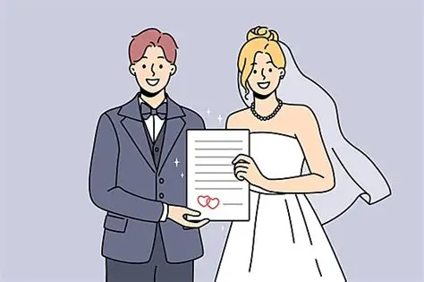
The SAVE Act 2.0 will add hurdles for voters, especially women. It will require
voters to prove they are US citizens by providing documents each time they vote or
re-register to vote. The names on the required documents (e.g. birth certificate or
passport) must match their names on the voter registration records. This may be
difficult for women who changed their name upon marriage, or for those that have
moved away from their state of birth. People with disabilities and citizens who law-
fully immigrated to the US may have trouble obtaining the necessary documents in a timely fashion.
AAUW is in opposition to the passage of the Act and encourages us all to contact our US Senators to vote “No”. But we need to move quickly, because the ACT has already passed the US House. AAUW members and non-members alike can use this quick and easy link [ctrl _ click] to voice your disapproval of this act:
https://www.aauw.org/act/two-minute-activist/
Then select the button that is labeled: Senate: Vote NO on the SAVE Act 2.0
Jackie Hardee
Share this link with family and friends!

Call on Congress to Support the Dream Act
We face the most dangerous moment in DACA’s history, but our power has never been stronger. June 15 will mark 14 years of DACA, yet the future of hundreds of thousands of our neighbors has never felt more uncertain. Without a pathway to citizenship in place, the affected families will continue to see their safety and future at stake. And, millions of working people who rely on DACA recipients, as our teachers, nurses, neighbors, will pay the price too. Now is our time to unite and urge our members of Congress to pave a pathway to citizenship that will protect the lives of working people. Will you join thousands of us in taking action to call on Congress to support the Dream Act? The more of us who take action, the harder it will be for Congress to ignore our demands.
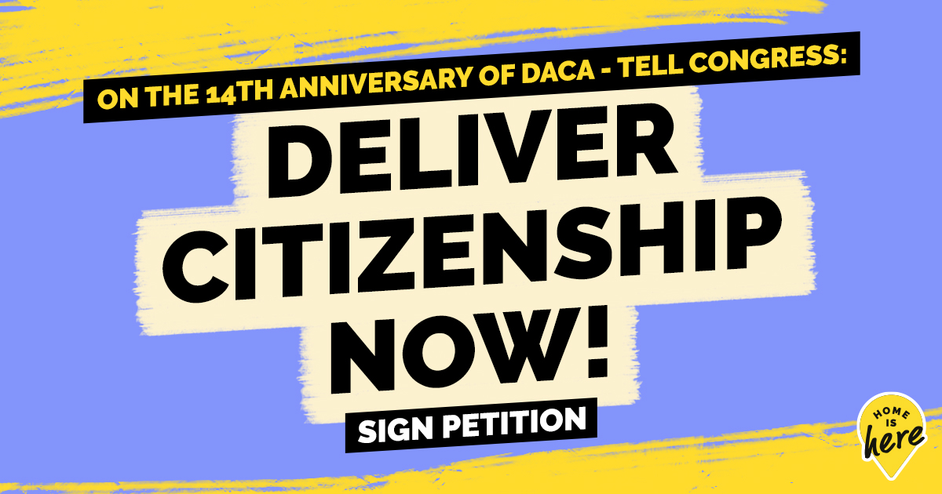

👉 Send Your Letter 👈

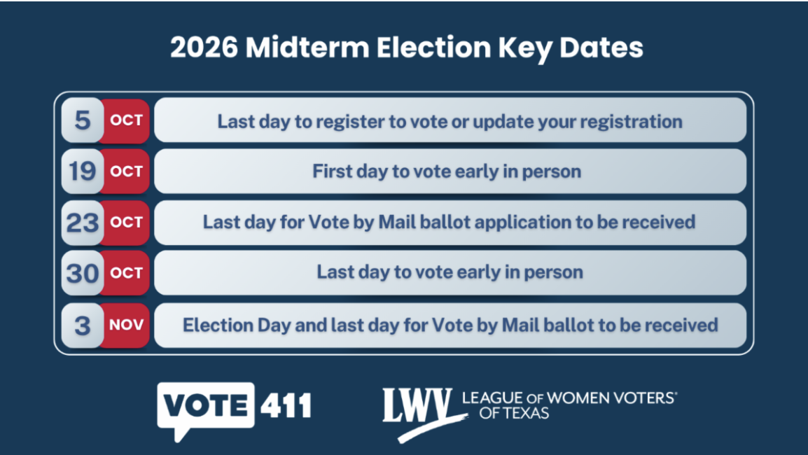

Have You Submitted Comments t0 the SBOE on Social Studies
TEKs and the Mandated Literary List?

The public comment period on the proposed revisions closes June 15th at 5:00 p.m. CST. The Texas SBOE is scheduled to vote on the final adoption of revised K–12 social studies Texas Essential Knowledge and Skills (TEKS) and a list of mandated reading for K-12 students during its June 22–26, 2026, meeting. If adopted, the new standards would take effect in the 2030–31 school year for the next 10 years.
SUBMIT PUBLIC COMMENTS ON THE SOCIAL STUDIES TEKS
In the section where you're asked to "Select one proposed SBOE rule action," choose "Proposed New 19 TAC Chapter 113, Texas Essential Knowledge and Skills for Social Studies, Subchapter A, Elementary, Subchapter B, Middle School, Subchapter C, High School, and Subchapter D, Other Social Studies Courses." 👉 Submit your comments here! 👈

You can submit public comments to the State Board of Education (SBOE) regarding the mandatory reading list (literary works lists) by visiting the SBOE Informal Comments Jotform or the Proposed State Board of Education Rules portal. The public comment period for these proposals is open until 5:00 p.m. CT on June 15.
You can also write emails to individual SBOE members. Email addresses are available in the last advocacy alert or can be found on TLO (Texas Legislature Online).

Some LWVUS Action Alerts

- Tell Congress No More ICE and CBP Funding
- ﻿Thank Senators Who Opposed the SAVE Act
- Unite and Rise to Defend Democracy
- ﻿Oppose the SAVE Act Suite of Bills

