AAUW Austin Public Policy
Advocacy Alert  August 25, 2026
Mary Ellen Scribner, Chair. Focus and Subcommittee Chair: Public Education – PreK-12 & Higher Education
Jackie Hardee, Focus and Subcommittee Chair: Elections and Voting (Also monitor state and federal voting rights legislation)
Suki Steinhauser, Focus and Subcommittee Chair: Women’s Health and Economic Security
Ann Berasley, Legislative Advisor

Court Allows Trump to Pursue Mail Voting Limits, for Now
The administration asked the court to clear the way for President Trump’s order that creates “state citizenship lists” and directs the Postal Service to decide who gets a mail-in ballot. https://www.nytimes.com/2026/08/24/us/politics/supreme-court-trump-mail-ballots.html?unlocked_article_code=1.8FA.Qk4V.zEFSrG7dEKhK&smid=url-share {NYT headline today}

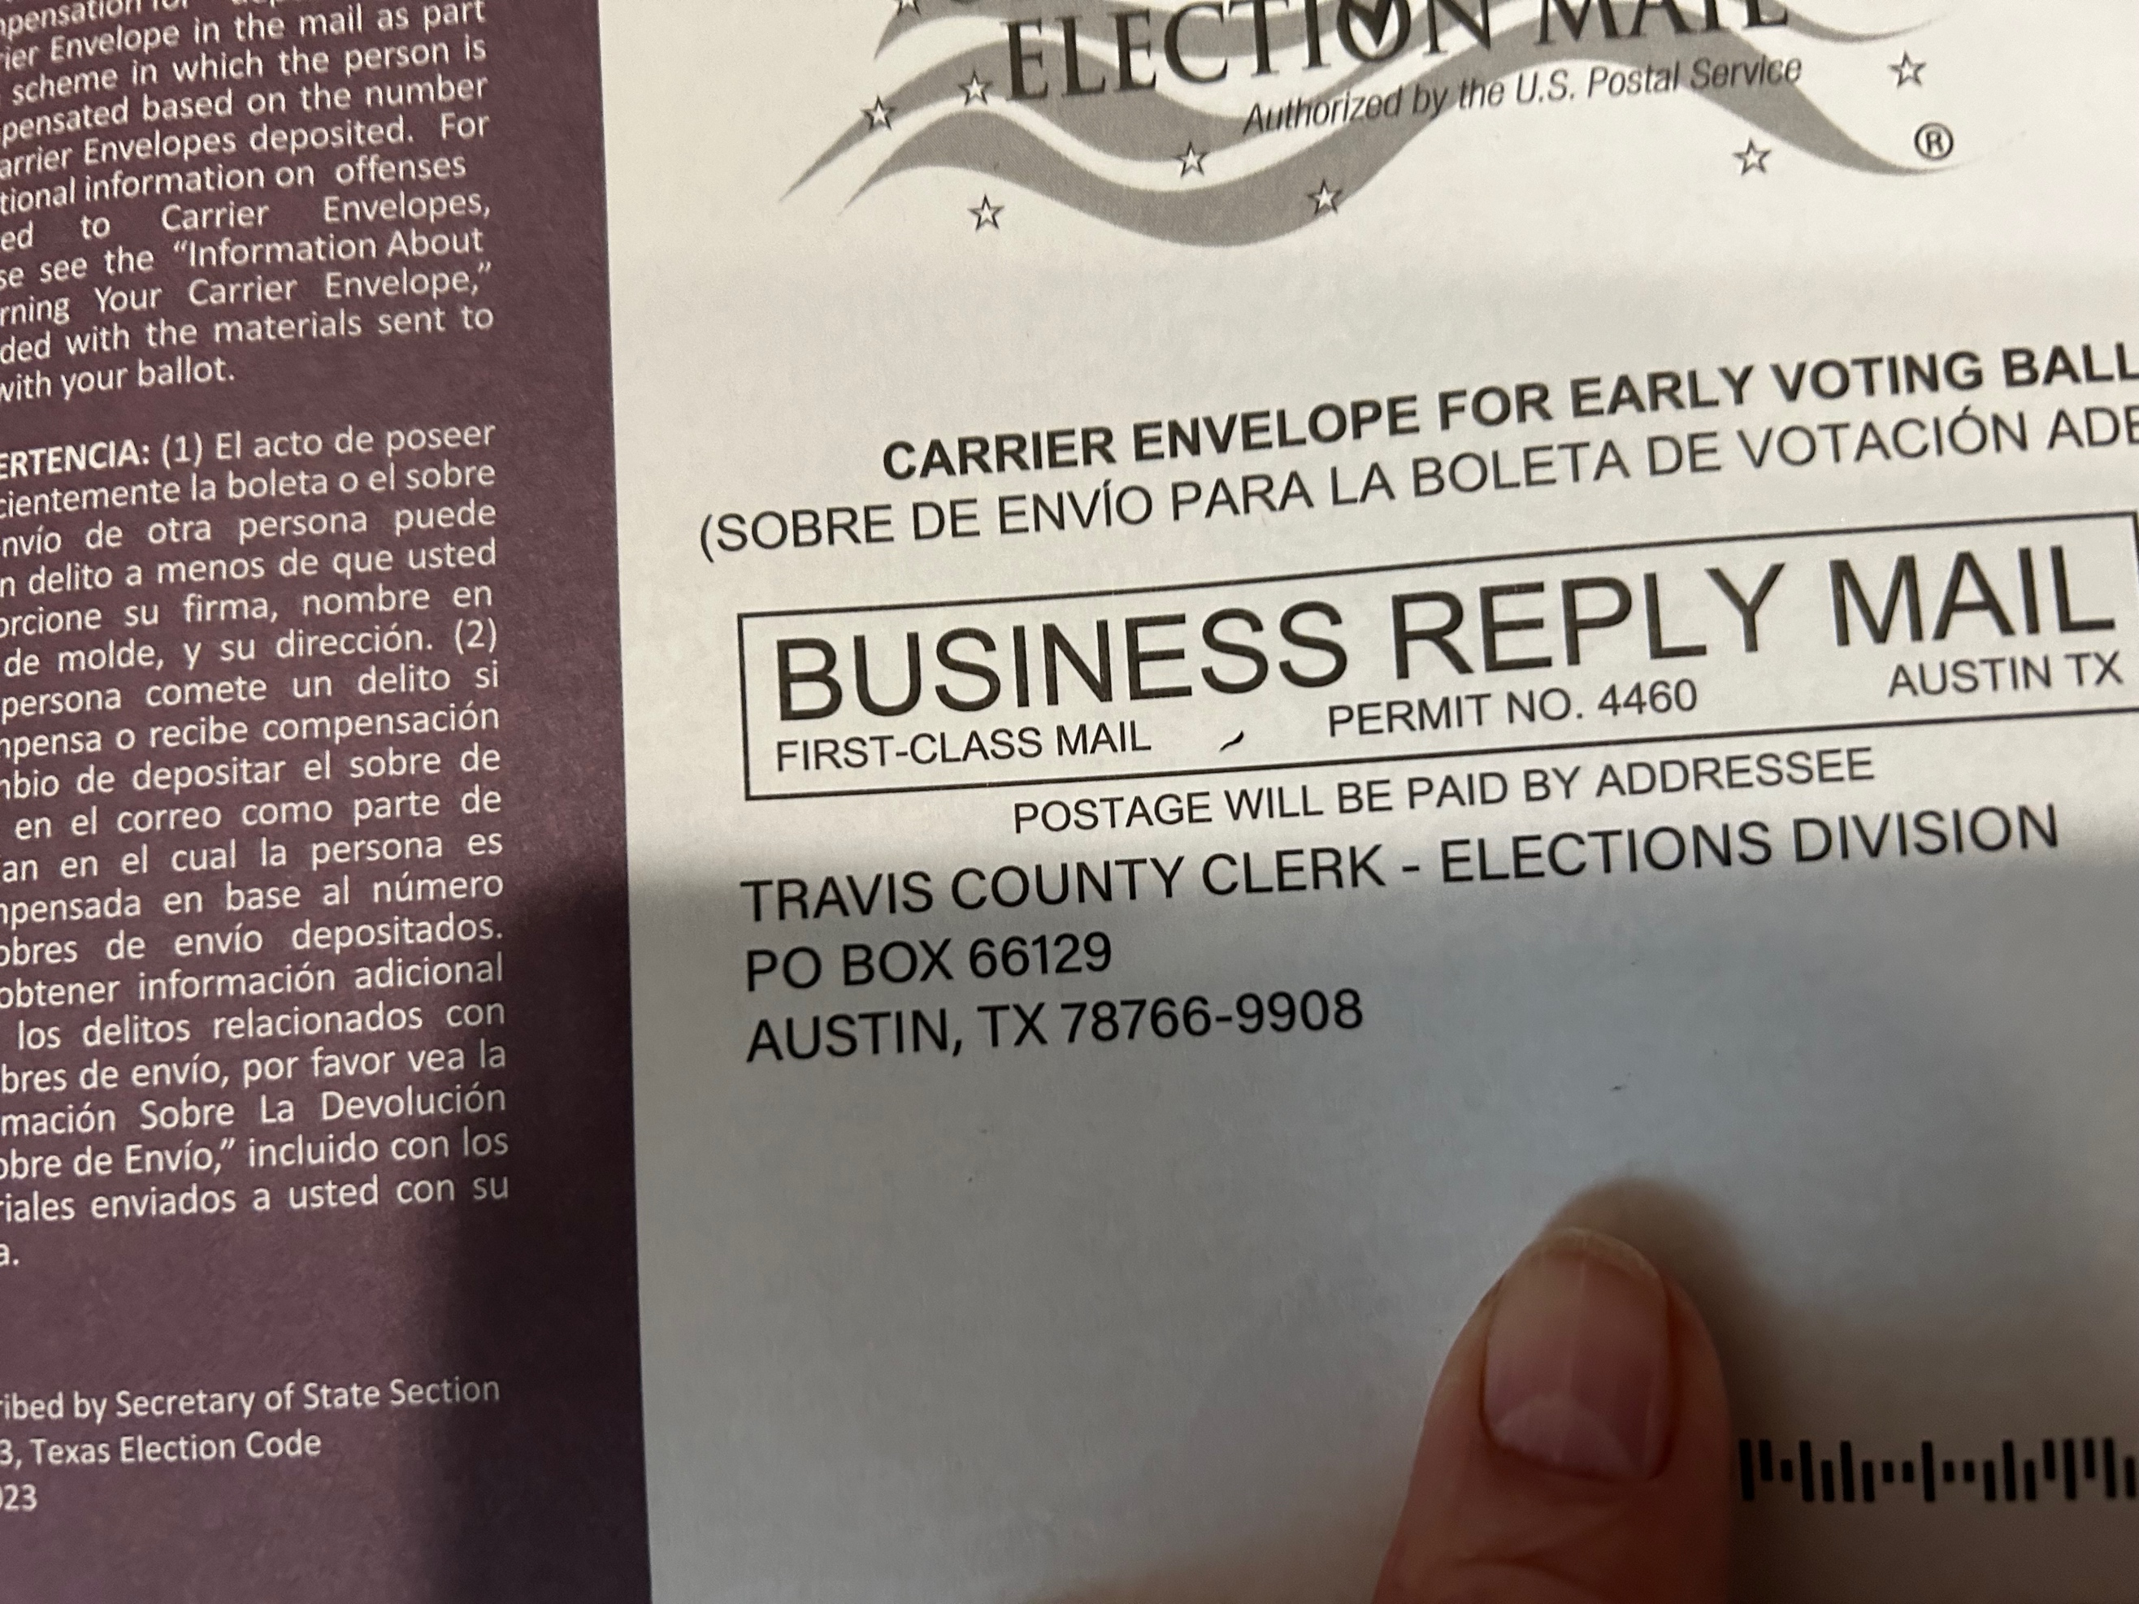

URGENT MESSAGE FROM MEGHAN KISSELL, AAUW SENIOR DIRECTOR OF POLICY AND MEMBER ADVOCACY
As you may have seen, in a procedural vote, the Supreme Court allowed the Trump administration to keep working on its plan to have the Post Office decide who receives a ballot.
Let’s be clear: today’s ruling does not affect any voter’s ability to cast a mail ballot. The Court did not rule that the President has any power over our elections, or that this executive order is legal. It simply decided that the lower court’s decision blocking these new restrictions came too early — a question about timing, not about power. States — not Trump or the USPS — are granted power by the Constitution to run elections.
The headlines generated by this step demonstrate how important it is that Branches and all AAUW members engage in your communities to help ensure that people have factual information about voting deadlines and procedures in your state, information about what's on your ballots, and encouraged to make a plan to vote!

AAUW Austin has been working hard for ever so long at getting voters registered, and now that the mid-term election is just over two months away, we have refocused our efforts to GOTV (Get Out The Vote). We want all those registered voters to cast a ballot! We will be unveiling a plan/manual for that this week, but we are already at work and urge you to join us by keeping the pressure on our congressional representatives and senators. The House resumes this week, and the Senate will reconvene on September 16. Staff members never left town and are logging emails and calls daily, so let’s make sure our Texas legislators retum to Washington and find overloaded communications logs and inboxes!

📢 Take Action!
Read What the SAVE Act means as the 2026 midterms approach
"For voters, the coming weeks are especially important. The November election is approaching, and if Congress manages to pass any version of the SAVE Act before then, voter registration and how voters cast a ballot could change dramatically, with very little time for voters and election administrators to adjust."
Tell Congress to reject anti-voter policies.
LWVUS Newsroom LWVUS Blog Take Action With LWV
❤️ Take a minute for our beloved Big Bend National Park! The Greater Big Bend International Dark Sky Reserve is the world’s largest protected dark sky reserve on Earth, at more than 9 million acres. It’s bigger than Yellowstone, Denali and Glacier Bay combined. Public land is managed by the Texas Parks and Wildlife Commissioners, and the Texas Parks and Wildlife Department has a statutory responsibility to manage and conserve Texas natural and cultural resources for the use and enjoyment of present and future generations. Urge Governor Greg Abbott and state officials to oppose border barrier construction on TPWD-managed lands in the Big Bend area and to use every legal and procedural tool available to protect this public trust.
Take Action Today!

